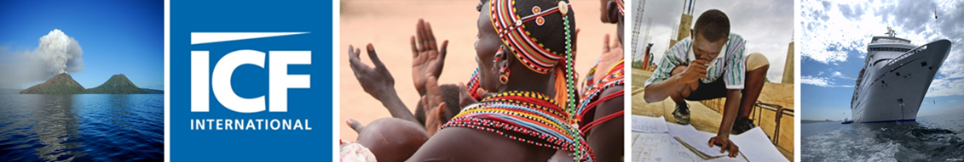
Assessment of the Economic Impact of Cruise Tourism in Papua New Guinea and Solomon Islands
Final Report
J60300074
28 April 2016



Assessment of the Economic Impact of Cruise Tourism in Papua New Guinea and Solomon Islands
Final Report

A report submitted by ICF Consulting Services Hong Kong Limited
in association with
TNS Australia and Seaports Group
Date: 28 April 2016
Job Number 60300074
ICF Consulting Services Limited
19/F, Heng Shan Centre
145 Queen's Road East
Wanchai
Hong Kong
T +852 2868 6980
F +852 2530 4302
jonathan.beard@icfi.com
www.icfi.com

Document Control
Document Title | Assessment of the Economic Impact of Cruise Tourism in Papua New Guinea and Solomon Islands
Job No. | 60300074
Prepared by | Mark Peacock, Martina Kadunc, Timothy Chu, Xinxi Wang, David Wignall
Checked by | Jonathan Beard
Date | 28 April 2016
This report is the copyright of International Finance Corporation (IFC) of the World Bank Group and has been prepared by ICF Consulting Services Hong Kong Ltd under contract to IFC of the World Bank Group. The contents of this report may not be reproduced in whole or in part, nor passed to any other organisation or person without the specific prior written permission of International Finance Corporation of the World Bank Group.
ICF has used reasonable skill and care in checking the accuracy and completeness of information supplied by the client or third parties in the course of this project under which the report was produced. ICF is however unable to warrant either the accuracy or completeness of such information supplied by the client or third parties, nor that it is fit for any purpose. ICF does not accept responsibility for any legal, commercial or other consequences that may arise directly or indirectly as a result of the use by ICF of inaccurate or incomplete information supplied by the client or third parties in the course of this project or its inclusion in this project or its inclusion in this report.

Contents
Executive summary 2
Glossary 17
1 Introduction 18
1.1 Background 18
1.2 Approach and methodology 19
1.3 Limitation of this study 21
1.4 Comparison with/lessons from other studies 22
1.5 Structure of this report 22
2 Direct Economic Impact 24
2.1 Cruise passenger expenditure 26
2.2 Cruise crew expenditure 36
2.3 Direct expenditure of the cruise company 38
2.4 Comparison of key indicators 40
3 Indirect Economic Impact 42
3.2 Overview 43
3.3 Indirect impact by industry 44
3.4 Leakage and informal economy 46
3.5 Employment impact 46
4 Opportunities for increasing the economic impacts of cruise tourism in Papua New Guinea and Solomon Islands 50
4.1 Barriers to cruise tourism economic impacts 50
5 Opportunities for increasing the economic impacts of cruise tourism in Papua New Guinea and Solomon Islands 58
5.1 Introduction 58
5.2 Solomon Islands 59
5.3 Papua New Guinea 65
5.4 Concluding remarks 71
Annex 1 Methodology 78
Annex 2 Quantitative analysis of passengers’ spending drivers 81
Annex 3 Cost Structures and Assumptions 82
Annex 4 Assumptions for Cost Benefit Analysis 89
Annex 5 Long List of options 99

Table of tables
Table 2.1 Total estimated direct spend per average call PNG 2015 ($AUD) 24
Table 2.2 Total estimated direct spend SI 2015 ($AUD) 25
Table 2.3 Assumed share of crew going ashore per size of port 37
Table 2.4 Comparison of main findings among different cruise ship studies 40
Table 3.1 Key findings of economic impact analysis of tours and entertainment services 44
Table 3.2 Key findings of economic impact analysis of transport services 45
Table 3.3 Key findings of economic impact analysis of specialist tourist retail services 45
Table 3.4 Key findings of economic impact analysis of food and beverage service industry 46
Table 3.5 Key findings of economic impact analysis of general retail industry 46
Table 3.6 Average number of jobs per $10,000 of revenue per sector and estimated job impact in PNG and SI 2015 47

Table of figures
Figure 1.1 Data collection cruise itineraries and ports of call 19
Figure 2.2 Average passenger spend by port ($AUD) 27
Figure 2.3 Breakdown on Average Spend by Port ($AUD) 27
Figure 2.4 Proportion of passengers going ashore and not spending ($AUD) 30
Figure 2.5 Average time spent ashore (for passengers going ashore) 30
Figure 2.6 Time ashore and mean spend 32
Figure 2.7 Variety of things to see and do and mean spend 33
Figure 2.8 Share of passengers who were very or extremely satisfied with the current variety of things to see and do 33
Figure 2.9 Share of passengers who were not very or not at all satisfied with the current variety of things to see and do 34
Figure 2.10 % passengers who would have spent more if more were available 35
Figure 2.11 % passengers who would have spent more, by country 35
Figure 2.12 Pre-booked tours and mean spend 36
Figure 2.13 Pre-booked tours and mean spend on key items 36
Figure 2.14 Crew Expenditure Breakdown 37
Figure 2.15 Average cruise company expenditure per call (Thousand $AUD) 39
Figure 2.16 Comparative example of fees paid by a large cruise ship (2,000 pax) at ports (Thousand $AUD) 39
Figure 3.1 Indirect expenditure breakdown per sector in PNG (left) and per type of impact (right) (%) 42
Figure 3.2 Indirect expenditure breakdown per sector in SI (left) and per type of impact (right) (%) 43
Figure 3.3 Total employment opportunities by country by sector 48
Figure 3.4 Total employment opportunities by port 48

Executive summary
The Australian Department of Foreign Affairs and Trade (DFAT), the International Finance Corporation (IFC) and Carnival Australia have partnered in an effort to provide baseline data on the cruise sector’s impact on the economies of Pacific Island Countries (PICs). Given the importance of tourism to the economies of many Pacific Islands, and the growth of cruise tourism, this is an opportunity to support further strategic, targeted development of cruise tourism, and increase its impact.
ICF Consulting Services Hong Kong and TNS Australia were commissioned to conduct this economic impact study on Papua New Guinea (PNG) and Solomon Islands (SI). PNG received 136 cruise ship calls at various ports in 2015, similar to 137 in 2007. While SI receives a more limited number of cruises, it is also experiencing an upward trend in cruise tourism. Both countries are experiencing an increase in the number of calls from larger cruise ships of 2,000 passengers or more. This study attempts to quantify the current direct and indirect economic impacts of cruise visits to both countries. In so doing, the study considers the potential of the cruise tourism industry to continue to contribute to economic development. The study concludes by identifying the opportunities and investments required to realise this potential.
Key Definitions
- Direct impact is the total expenditure of cruise passengers, crew members and cruise ship operators on goods and services in each country, including on ship supplies, handicrafts, tours, transport, food and beverages.
- The flow of direct expenditure through the economy of each country is captured by the indirect impact. When cruise passengers purchase a tour, the tour business purchases petrol and materials, in additional to hiring transport and staff from the local economy. The expenditure of the tour operator going to suppliers and employees in the wider economy is the indirect impact.
In this study, the direct and indirect impacts are aggregated across the whole economy to measure the total impact of cruise tourism on the whole economy. Three groups are defined who receive the benefits:
  - Local beneficiaries - business and individuals who receive income from cruise tourism expenditure, the supply of goods and services, wages, rental income and profits;
  - Government beneficiaries - local and national government and agencies which receive taxes, duties and port fees from cruise tourism expenditure; and
  - Foreign based beneficiaries , also referred to as leakage as monies received from direct expenditure are spent on foreign goods and services which are imported (ie. Insurance, fuel, new vehicles). This also includes the flow of profits where businesses are foreign owned.
- The multiplier in this study is a measure of the stimulus impact to businesses from cruise tourism expenditure. If $1 of direct expenditure by cruise passengers, results in $0.5 of additional expenditure by private beneficiares (by ordering additional supplies or increasing investment), then we say the multiplier is 1.5 (i.e. the benefit to private beneficiaries is 1.5 times the initial direct expenditure input). This is consistent with the 2014 Vanuatu study, and differs from a classical understanding of multipliers as it excludes government beneficiairies. Income multipliers are also presented which conform to the classic understanding of the impact on the whole economy.
- Value added is a measure of the returns made by private beneficiaries in excess of the cost of the providing the good or service concerned. In short it is the sum of the wages and profits that direct and indirect expenditure generates.
- Employment Impacts are calculated based on the ratio of reported employment (full time and part time employment) to turnover by sector. This ratio is then multiplied by estimated cruise tourism revenue for each sector to estimate the impact. For instance, if the sector employs 1 worker per $10,000 of turnover, then $20,000 of direct and indirect cruise tourism expenditure in the sector is estimated to generate 2 jobs.

Throughout the report, monetary values are reported in Australian Dollars (AUD $), unless otherwise stated.

Methodology
The study is based on primary quantitative and qualitative data gathered from the passengers and crew on two cruises in November 2015 and January 2016:
Cruise 1: November 2015 Pacific Dawn with 2020 passenger and 690 crew capacity visited five ports in PNG (Alotau, Kitava, Rabaul, Kiriwina and Doini Island);
Cruise 2: January 2016 Sea Princess with 2272 passenger and 875 crew capacity visited five ports in PNG (Alotau, Doini Island, Kiriwina, Kitava, Rabaul) one port in SI (Honiara) and one port in Vanuatu (Port Villa).
The study also made use of interviews with businesses serving the cruise tourism sector at the visited ports as well as administrative data from Carnival Australia and shipping and logistics companies handling cruise ships in PNG and SI. The study methodology is closely aligned to the approaches adopted in earlier studies, in particular the 2014 study on the cruise tourism sector in Vanuatu. The four core task completed are:
Direct economic impact analysis based on the expenditure data of 2,254 cruise passengers who completed a short survey at five PNG ports and one SI port and administrative data from Carnival Australia and shipping and logistics companies.
Indirect economic impact analysis is based on the cost structure of businesses (and their suppliers) based on face-to-face interviews with businesses and in-country expert assessment.
A list of opportunities to develop cruise tourism in SI and PNG is based on qualitative research with passengers at surveyed ports (focus groups, face-to-face interviews) and businesses, as well as in-country workshops with stakeholders. They were asked to provide personal views on barriers and opportunities regarding cruise tourism at particular ports or PNG and SI in general.
A Cost Benefit Analysis (CBA) of a shortlist of opportunities to improve cruise tourism impacts in the relevant economies, to help prioritise future actions.

Economic impacts of cruise tourism expenditure
This summary presents two estimates of cruise tourism expenditure:
- The economic impact on the five researched ports (Alotau, Rabaul, Kiriwina, Kitava and Doini Island) in PNG and one port in SI (Honiara). These estimates are based solely on the data obtained from the two cruises, scaling up by the number of times cruise ships of this size are scheduled to call in these ports in 2016.
- The economic impact on the whole country of PNG and SI, accounts for the fact that mainly smaller cruise ships call at ports other than the researched ports in PNG and SI. To do this, assumptions were revised to reflect the lower port fee paid by smaller ships, the lower number of passengers per ship arriving in each port and the frequency of port calls. Extrapolation on this basis provides a first estimate of the total economic impact of cruise tourism on each economy.

Unless otherwise stated, the impacts reported are based on the economic impact of the researched ports, due to insufficient data being available to estimate the country wide impacts, other than in aggregate.

Direct economic impact
In total, cruise companies, passengers and crew are estimated to spend $5.7 million in PNG in 2015 in the five researched ports. On average, each cruise ship call contributed between $24,000 and $160,000 to the local economy depending on the port.
Extrapolating to the entire country, the total direct economic impact of cruise tourism in PNG is estimated at some $6.3 million, with the researched ports receiving 89 per cent of the total.
The leading source of expenditure is cruise companies (which account for 54 per cent of total expenditure) mainly through a variety of fees paid to ports, government agencies or communities. The remaining expenditure comes from passengers (43 per cent) mainly through purchases of tours, with crew expenditure representing 3 per cent of the total.
The distribution of expenditure among ports differ. The majority of expenditure in PNG benefits Alotau (42 per cent) and Rabaul (41 per cent) as these are entry and most developed ports for tourism. A summary of total expenditure and a breakdown by port in PNG is provided in Table ES1 and Figure ES1.The total number of calls assumed for the impact assessment in PNG in 2015 is 60 for the five researched ports. There were an additional 76 calls made at mainly smaller island destinations, by cruise ships of a smaller average size (between 150 – 300 passengers). It is estimated that these additional calls contribute much less to the total cruise tourism impact in PNG (11 per cent). The five researched ports which are the focus of the study are considered representative of total cruise tourism impact on this basis.

Table ES1 Total estimated direct spend PNG 2015 ($AUD)
 | Calls | Total Passenger Spend per call | Total Crew Spend per call | Total Cruise Line Spend per call | TOTAL Spend per call | TOTAL
Alotau | 15 | 50,113 | 4,706 | 104,167 | 158,986 | 2,384,789
Doini Island | 11 | 20,782 | 505 | 22,000 | 43,287 | 476,159
Kiriwina | 10 | 17,112 | 511 | 12,000 | 29,623 | 296,226
Kitava | 8 | 11,546 | 462 | 12,000 | 24,008 | 192,065
Rabaul | 16 | 79,546 | 4,607 | 57,000 | 144,903 | 2,318,447
TOTAL 5 Researched Ports | 60 |  |  |  | 94,461 | 5,667,686
TOTAL PNG (Extrapolated) | 136 |  |  |  | 46,782 | 6,362,304
Figure ES1 Breakdown of direct spend PNG 2015 ($AUD)
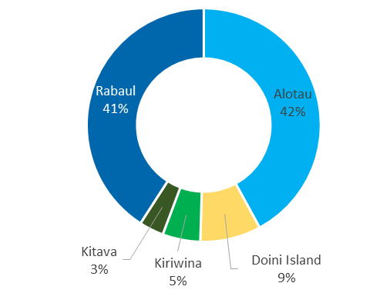 | 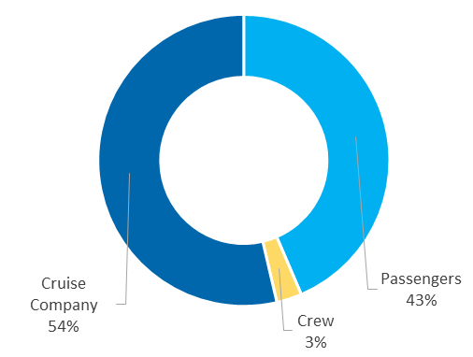

The total direct economic impact to the port of Honiara in SI in 2015 is estimated at $0.6 million. On average each cruise ship call contributes $46,169 to the Honiara economy.
If this data is extrapolated, as in PNG to account for the smaller cruise ships and other SI ports of call, the total direct economic impact of cruise tourism is estimated at $0.9 million.
The majority of the expenditure comes from cruise companies (65 per cent of total expenditure). The remaining expenditure comes from passengers (31 per cent) and crew (4 per cent). Table ES2 provides a summary of headline expenditure, with Figure ES2 providing a breakdown of its source.

Table ES2 Total estimated direct spend SI 2015 ($AUD)
 | Calls | Total Passenger Spend per call | Total Crew Spend per call | Total Cruise Line Spend per call | TOTAL Spend per call | TOTAL
TOTAL 1 Researched Port (Honiara) | 13 | 14,052 | 1,908 | 30,210 | 46,169 | 600,201
TOTAL SI (extrapolation) | 47 |  |  |  | 19,165 | 900,768
Figure ES2 Breakdown of direct spend SI 2015 ($AUD)
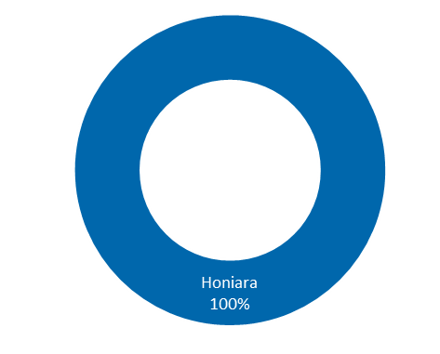 | 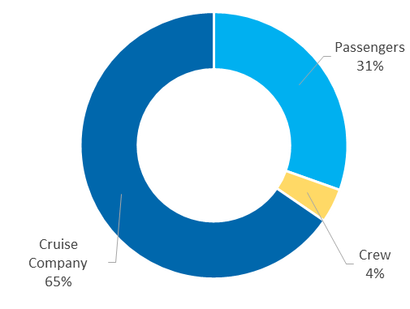

Passenger expenditure
Average passenger expenditure is estimated between $7 and $76 per day in PNG depending on the port. Average passenger expenditure in SI is estimated at $28 per day in Honiara.
Passengers’ expenditure varies significantly due to large differences in spending opportunities (For example, pre-booked tours through cruise companies are only available in Rabaul and Alotau) and other factors such as the availability of ATMs, foreign currency exchange, shaded areas and toilets ashore, which makes venturing ashore more attractive.
Figures ES2 and ES3 provide a summary breakdown of expenditure by port and expenditure type for PNG and SI respectively
Figure ES2 Average passenger expenditure by port and type in PNG ($AUD)
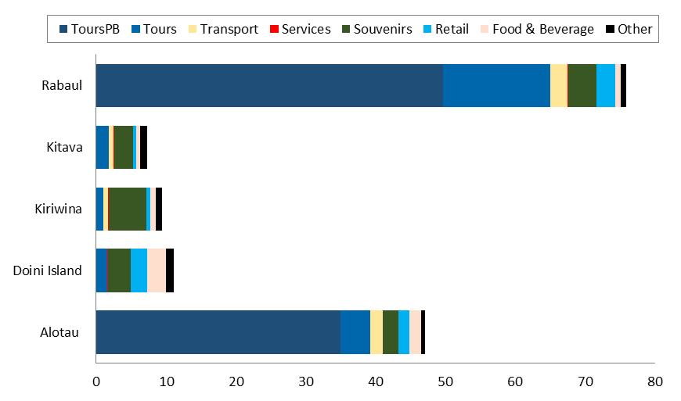

Figure ES3 Average passenger expenditure by port and type in SI ($AUD)
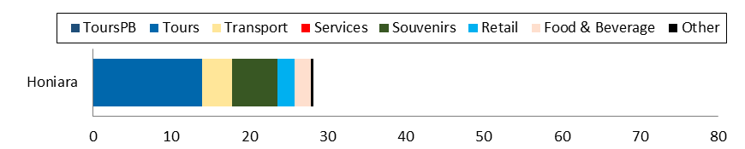

Key drivers of passengers spend:
 | Time passengers spend on shore: Passengers who spend more time ashore also spend more. Results are consistent among countries and different studies.
 | Passengers’ satisfaction with the variety of things to see and do: If passengers think there is a greater variety of things to see and do, they also spend more. However, correlation with other indicators measuring passengers’ satisfaction varies depending on the country and study (i.e. satisfaction with shopping opportunities and likelihood of returning in next three years). A majority of passengers that spent in PNG and SI would spend more on clothing, watches/jewellery and handicraft/souvenirs if more options was available independent of the country
 | Availability of pre-booked tours: Passengers who pre-booked tours spent significantly more (on average $79 in PNG and SI) than those who did not pre-book tours (on average $21). Relative to other goods and services currently available, pre-booked tours are the most costly (up to $130), and when available, many passengers purchase them (47% of passengers in Alotau and 48% of passengers in Rabaul). Passengers with pre-purchased tours spend less on transport and more on souvenirs.

Crew expenditure
Due to a small number of survey responses from crew members, the estimates of crew expenditure are based on the Vanuatu 2014 Study. Ports were classified into two groups: small port (Doini Islands, Kiriwina and Kitava) and medium port (Alotau, Rabaul and Honiara). The analysis assumes crew members on average spend $5 per day at small ports and $28 per day at medium ports. A breakdown of this expenditure by port type is provided in Figure ES4.
Figure ES4 Crew Expenditure Breakdown
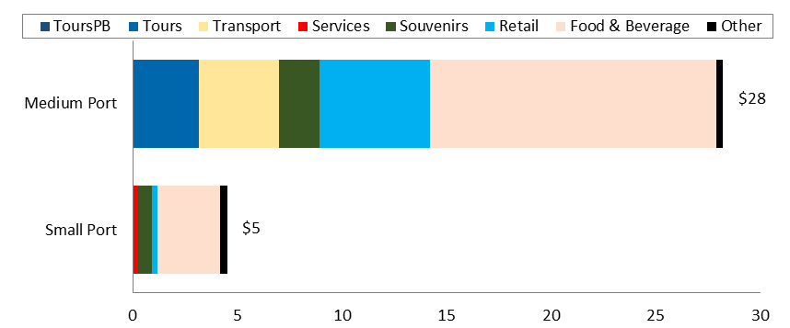

PNG and SI lack pull factors for crew members to go and spend ashore. Based on global studies, crew members go ashore to access low cost communication services (internet and phone as on-board alternatives are expensive), food and beverage at restaurant and bars, entertainment/night clubs and transportation to take them from the ship to these amenities. They also tend to spend on clothes and electronics. All those facilities/products are scarce or not available in PNG and SI.

Cruise line expenditure
The majority of cruise company expenditure per call relates to fees that directly flow to the government. These fees differ significantly by port as shown in Figure ES5. This breakdown is not provided in similar studies such as Vanuatu 2014. Consequently it is difficult to provide a comparison of these fees with those of other pacific island ports.
Port fees charged at the port of entry into the country (i.e. Alotau and Honiara) are higher, due to national customs and immigration fees paid on entry into a country. Port fees also differ by vessel size. For the five researched ports in PNG, the average size of a cruise ship per call was is between 1,300 and 1,900 passengers, compared to 530 passengers in Honiara.
Other company expenses on goods and services include port agent fees and corporate expenditure for operations.
Data for this assessment is based on Carnival Australia internal estimates. Care was taken to verify and triangulate information with stakeholders in PNG and SI, including ship agents, however a comprehensive overview proved difficult.
Figure ES5 Cruise company expenditure per call

Indirect economic impact
The multiplier effect of cruise ships tourism on the economy of each country is estimated at 1.43 in PNG and 1.27 in SI. The 2014 estimate for Vanuatu was 1.49. The multiplier impact on businesses is relatively consistent with Vanuatu. However the results do illustrate there is scope for improvement in PNG and SI. This point is more clearly illustrated by the income multipliers, which take into account non-private beneficiaries. The estimates are 1.04 for PNG and 1.07 for SI, reflecting the larger role the informal economy plays in both tourism economies, limiting the indirect benefits to the wider economy. Comparative figures were not estimated for Vanuatu. Total indirect economic impact in PNG is estimated at $ 5.9 million or 0.03 per cent of GDP. Value added from cruise tourism in PNG in 2015 is estimated at $1 million.
The total in SI is estimated at $ 0.6 million or 0.04 per cent of GDP. Value added is estimated at $0.09 million.
The analysis finds that 43 per cent (PNG) and 27 per cent (SI) of direct expenditure from cruise tourism benefits local private beneficiaries. Governments receive 51 per cent (PNG) and 63 per cent (SI) of expenditure. Estimated leakage (i.e. money leaving the economy for instance through imports – insurance, fuel costs, profits to foreign beneficiaries) is 6 per cent (PNG) and 10 per cent (SI).
This is largely a result of the following assumptions regarding the structure of the economies:
Impact on government is high because of a high share of collected port fees relative to other expenditure.
Impact on private beneficiaries is high since the expenditure from cruise industry predominantly flows into tours operators and handmade souvenir businesses. Those sectors are labour intensive, locally owned and almost independent from imports.
The impact on private beneficiaries is further increased because a large share of the economy in each country is considered informal (businesses do not pay tax). It is assumed that the entire expenditure at Doini Island, Kiriwina and Kitava flows in to such subsistence economies.
Figures ES6 and ES7 present a schematic version of indirect expenditure in PNG and SI.
Figure ES6 Direct and indirect expenditure breakdown per sector in PNG (left) and per type of final impact (right) (%)
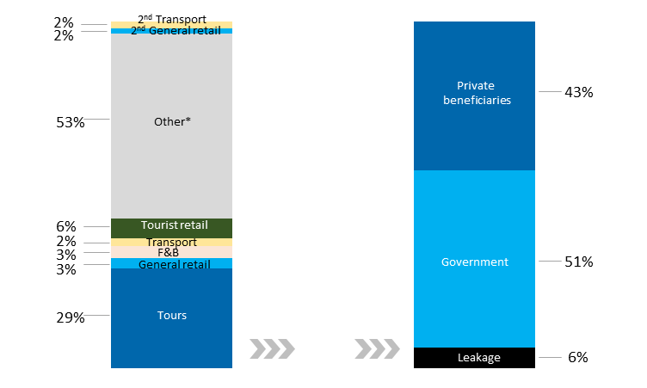
Figure ES7 Direct and indirect expenditure breakdown per sector in SI (left) and per type of final impact (right) (%)
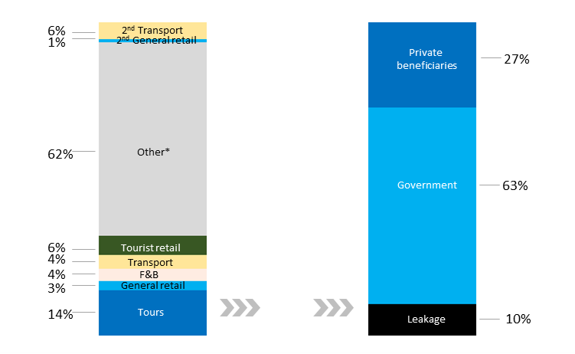
Note: * Other includes port fees paid by cruise operators as well as other sectors of passengers’ and crew expenditure such as services (e.g. hair braiding and massage) and other (e.g. donations).
2nd annotates impact on second round of suppliers.

Employment impacts
The employment impact of cruise tourism industry in PNG is estimated at around 203 employment opportunities (0.6 per cent of working age population of the five researched ports). In SI, cruise tourism generates 21 employment opportunities in Honiara (or 0.06 per cent of working age population). Figure ES8 presents the estimated cruise tourism impact on employment opportunities in PNG and SI by sector and by port.
The impacts are not full time equivalent (FTE); rather they indicate the number of jobs (a mixture of full time and part time/ad hoc employment depending on the sector) that cruise tourism generates. The estimates are calculated based on a ratio of reported employment to turnover for each sector. The data was obtained during interviews with businesses.
In line with the approach adopted in Vanuatu 2014 Study, the employment impact does not include employment resulting from fees paid by cruise operators at ports and other tax and duty collections. But given the significant size of this expenditure relative to other spent in PNG and SI, some employment impact is likely to occur.
Specialist tourist retail sector (i.e. handicrafts and souvenirs) benefits the most in terms of total employment opportunities despite the fact that this sector receives only about 6 per cent of total direct and indirect impact in both PNG and SI. Handicraft and souvenir business have many ‘employees’ and are mainly family run but the intake from cruise tourism is low and not consistent (businesses sell only when cruise ships arrive). For instance, based on qualitative research there are many handicraft sellers at Kiriwina, however the majority of sellers are subsistence farmers. Hence, the employment opportunity generated from cruise tourism seems large in number but is infrequent, lasting only for the day the cruise ship is in port. There were only 10 cruise ships calling at Kiriwina in 2015. The potential for cruse tourism to create a higher number of and more permanent employment opportunities is significant in the future, for both economies.
Figure ES8 Impact on employment opportunities in PNG and SI by sector and by port
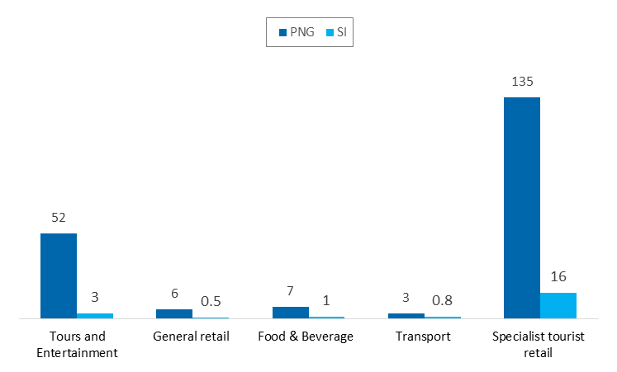
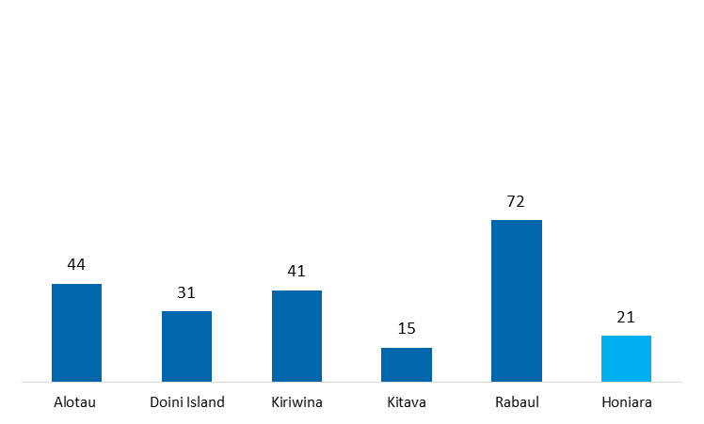

Comparison of key indicators
Table ES3 compares key indicators among PNG, SI and Vanuatu studies.
Table ES3 Comparison of key indicators among PNG, SI and Vanuatu
Indicator | PNG | SI | Vanuatu
Number of researched ports | 5 | 1 | 3
Number of calls at researched ports per year | 60 | 13 | 201
Average number of passengers per call | 1311 - 1927 | 530 | ~ 2081
Average number of crew per call | 641 - 872 | 260 | -
% passengers going ashore | 93% - 97% | 94% | 91% - 97%
Average time spent ashore (hours) | 3.4 – 4.3 | 3.7 | -
Average passengers spend per call ($) | 7 - 76 | 28 | 11 - 96
Average crew spend per call ($) | 5-28 | 28 | 19 - 70
Direct expenditure of cruise company per call ($) | 12,000 – 104,167 | 30,210 | 20,000 – 38,000
Average total direct expenditure per call | 41,675 | 46,169 | 164,000
Total direct expenditure per year at researched ports ($) | 5,667,686 | 600,201 | 33,000,000
Benefit to private beneficiaries (as a % of in direct and indirect impact) | 43% | 27% | 49%
Benefit to government (as a % of in direct and indirect impact) | 51% | 63% | 11%
Leakage (as a % of direct and indirect impact) | 6% | 10% | 41%
Multiplier (on private beneficiaries) | 1.43 | 1.27 | 1.49
Value added ($ million) | 1 | 0.09 | 8.4
Employment opportunities | 203 | 21 | 3,250

Summary of opportunities for improving the impact of cruise tourism
To support the efforts of stakeholders to improve the economic impacts of cruise tourism in PNG and SI, 12 options (six each for PNG and SI) comprising of groups of preferred actions were subjected to a Cost-Benefit Analysis (CBA). The CBA uses the best available information and data from Carnival Australia, Seaport and published sources, triangulated and validated for robustness. Where assumptions are made they are set out in Section 5 of the report (and accompanying annexes).
The development of the options considered a long list of actions gathered from businesses, in-country workshops and consultations with DFAT, Carnival Australia and PHAMA. The actions were then screened for feasibility, before packaging the remaining shortlist as options to benefit from synergies, for the CBA.
The purpose of the CBA is to help identify priority actions based on their anticipated benefit cost ratio. A summary of the results is provided in Table ES4. The headline findings are:
Providing an ATM at or near the wharf in Alotau, the first port of call for many cruises, is found to have the highest benefit-cost ratio. In short, it was found that the Papua New Guinean Kina (PGK) is not a frequently available currency for tourists visiting PNG and many traders in PNG do not accept alternative currency (i.e. AUD$). Without currency exchange facilities on the cruise ship, this resulted in many passengers finding themselves unable to make purchases when visiting PNG ports, reducing the economic impact. The low fixed cost of providing this facility is easily offset by increased passenger expenditure for the 10 years assessed.
In the same vein, improving information provision to passengers in both PNG and SI is estimated to have a large positive net impact, as it is a relatively low cost exercise to provide a 3 minute quarantine video, update destination materials and provide a map of the ports to encourage cruise passengers to explore each port visited and to better navigate attractions and amenities. These actions also give confidence to passenger to purchase handicrafts, ultimately resulting in higher expenditure. Based on in-depth interviews passengers wanted to spend more, but lack the opportunities and confidence to do so, reducing the economic impact.
Increased cooperation and coordination between businesses, local communities, government and cruise operators, in particular in the development of future tours and excursion offers (which are the highest expenditure items for passengers), is also anticipated to generate significant net benefits. Businesses should be better prepared for cruise ship arrivals, have an improved range of products to offer to passengers, which are better prices and coordinated and thus improving the passenger experience and expenditure. Key to this option in PNG and SI is the establishment of more formalised cruise committee in each port with assigned roles and responsibilities. For example, it is assumed these committees will take the lead in the broadcasting the arrival of cruise vessels to local businesses and will submit destination information to cruise operators, ensuring information given to passengers is relevant and up to date.
Improvements to customs and immigration procedures in PNG are estimated to generate significant benefits as speeded up and less onerous procedures frees up additional time for passengers to spend ashore. Benefits are estimated proportional to the extra time spent ashore, when more goods and services are to be purchased.
Improving port amenities, such as the provision of shaded areas and seating, sanitation blocks and litter bins in many destinations is shown to have a significant net positive impact. The option makes the port area more attractive to passengers considering a trip ashore. When disembarked it also increases the time passengers are willing to spend ashore, with a proportional increase in expenditure assumed in the analysis.
Opening up cruise destinations such as Gizo and Tavanipupu in SI, require significant upfront investments at high cost. For example, this includes jetties, upgrades to wharfs and hydrological surveys to be carried out before larger cruise ships can operate efficiently at these ports. However, over time the improvements enable increased levels of expenditure from a higher frequency of calls and numbers of passengers.

The new wharf at Honiara is already under construction and provides net benefits in a timeframe of 25 years. The benefits to freight shipping from a new wharf are however not quantified and are considered significant as the largest users of the infrastructure.

In conclusion, the CBA highlights the importance of capacity building, improved communication and information options for facilitating higher cruise tourism expenditure. They also contribute to supporting tourism economic development, where a limited formal economy currently exists in many smaller destinations. Often low cost to implement, these options ensure local communities, businesses and government realise the potential of cruise tourism, for economic growth and employment. With significant benefit, these options achieve the highest benefit-cost ratios.

Infrastructure investments are also important for the longer term prospects of these infant cruise tourism economies. High in upfront costs, the benefits may seem low in the assessment, but they are essential prerequisites for future economic development. As without a new wharf in Honiara or similar infrastructure at other destinations, cruise tourists will not visit these countries in the numbers expected, consequently reducing the economic impact.

Table ES4 Summary of the costs and benefits of the proposed options (top three are shaded)
Option | Details | Present Value ($ million) |  | Net Present Value | Benefit-cost ratio
Option | Details | Costs | Benefits | Net Present Value | Benefit-cost ratio
Solomon Islands
Option 1: Upgrade Honiara’s port infrastructure | - Construct a wharf capable of handling future cruise ships of up to 264m in length, and current ships of 220m in length (already in construction); and  - Provide water supplies to WHO standards of 50 tonnes per hour. | 48.5 | 49.3 | 0.7 | 1.02
Option 2: Upgrade Honiara’s port amenities | - Construct and maintain a sanitation block;  - Provide covered areas, including seating for passengers, considered important to provide shade and cover in times of inclement weather;  - Improve signage to enable cruise passengers to navigate from the port area to leading attractions and points of interest; and  - Provide litter bins and port beautification actions to make the area more attractive for cruise passengers | 0.3 | 0.5 | 0.2 | 1.8
Option 3: Development of product offer in Honiara | - Establish a more formalised cruise committee; and  - Develop more tours and excursions. | 0.1 | 1.58 | 1.47 | 15
Option 4: Development of the Solomon Islands cruise offer | - Opening Gizo as destination for large vessels, requiring:  - A hydrographical study for the destination;  - Additional bollards/large cleats to be added adjacent the sloping concrete ferry wharf at Gizo to permit ship tenders to safely berth alongside;  - The red and white navigational beacon's and green starboard hand buoy as marked on official chart BA 1735 to be replaced to IALA standards at Gizo. This will assist ship tenders (lifesaving appliances) in making safe entrance/egress from the port area.  - Encourage and support SIMSA to ensure the maintenance of navigational aids and an effective Marine Safety Information (MSI) system as required by IMO SOLAS.  - Opening Tavanipupu as destination for large vessels, requiring:  - Preliminary weather monitoring  - Hydrological survey of reef entrance to Tavanipupu;  - Destination impact study  - Landing facilities (i.e. jetty)  - Beach shelters /huts | 1.5-2.6 | 4.5-12.7 | 3-10.1 | 1.7-8.6
Option 6: Improving information provision to passengers | - Providing quarantine videos and leaflets to passengers;  - Updating destination information provided by cruise operators to passengers;  - Develop and provide maps of the port, city centre and areas of interest; and  - Inform passengers of the opportunity to make donations. | 0.1 | 0.7 | 0.6 | 6.7
Papua New Guinea
Option 1: Infrastructure improvements to existing ports of call | - Extension of a jetty in Kitava to enable disembarkation of two tenders simultaneously to facilitate the more efficient transportation of passengers to and from larger cruise ships.  - Alotau provision of fresh water supplies for cruise ships to WHO standards. As the first port of call for cruise ships from Australia, development of this capability is considered a priority for cruise development in the region.  - Madang reinforcement and extension of the port berth to enable more regular and larger ships to dock in port. Based on the assessment of DWA marine engineer this would entail construction of two sinker blocks and upgrades to fenders. | 0.7 | 3.1 | 2.4 | 4.3
Option 2: Upgrade port amenities in PNG | - Construct a sanitation block near or at the wharf area in Kitava, Kiriwina;  - Provide covered areas, including seating for passengers in Kitava, Kiriwina  - Clear signage to enable cruise passengers to navigate from the port area to leading attractions and points of interest In Alotau and Rabaul. Although amenities exist, passengers do not know where to go to reach them (i.e. currency exchange and banks). | 0.2 | 1.6 | 1.4 | 7.6
Option 3: Improvements to customs and immigration procedures | - Legislative change to enable the cruise operators to use non proclaimed ports for clearance to plan itineraries more effectively and increase cruise frequency. This could be done by increasing the number of proclaimed entry/exit ports or using procedures like other Pacific island countries where they allow the operator to bear the cost of using immigration services at non proclaimed ports. Most of the costs associated with the new procedure (i.e. to fly customer officer to the non-declared port of entry) would be borne by cruise operators directly.  - Improve the process of clearing passengers in line with processes used in other Pacific countries. Currently the immigration process takes a long time (requiring passport copies to be taken for all passengers, which is cumbersome as passenger passports have to be collected by crew) and it reduces on shore time for the passengers who must wait for their passports to be returned before disembarking | 0.1 | 0.9 | 0.8 | 13.8
Option 4: Increased provision of foreign exchange services | - Providing ATM near or at the wharf in Alotau | 0.03 | 1.9 | 1.87 | 57
Option 5: Development of product offer in PNG | - Establish a more formalised cruise committee  - Develop tours and excursions at smaller islands (Kitava, Kriwina) | 0.2 | 3.1 | 2.9 | 13.1
Option 6: Improving information provision to passengers | - Providing quarantine videos and leaflets to passengers;  - Updating destination information provided by cruise operators to passengers;  - Develop and provide maps of the port, city centre and areas of interest; and  - Inform passengers of the opportunity to make donations | 0.1 | 3.2 | 3.1 | 27

Glossary
$ Australian Dollar
DFAT Australian Department of Foreign Affairs and Trade
IFC International Finance Corporation, of the World Bank Group
NSO National Statistical Office, Papua New Guinea
PNG Papua New Guinea
SI Solomon Islands
SINSO Solomon Islands National Statistics Office
TPA Papua New Guinea Tourism Promotion Authority

Introduction
This is the Final Economic Impact Report prepared by ICF, in association with TNS Australia and Seaport Group for an “Assessment of the Economic Impact of Cruise Tourism in Papua New Guinea and Solomon Islands” (the Study).
The fourth deliverable of the study, this report provides a preliminary economic impact assessment, which covers:
- A quantification of direct expenditures injected into port of call economies from cruise passenger spending, operator spending and any other direct expenditure flows;
- Mapping of the flow of the expenditure through the economy of each country, through two rounds of suppliers (indirect impacts), documenting the effects of leakages as well as employment impacts of cruise expenditure; and
- The identification of opportunities to expand cruise tourism and its economic impacts.

Background
In recent years cruising has become one of the fastest growing segments of tourism industry. Globally, the Pacific Islands account for a small fraction of the cruise industry (around 2 per cent in 2015), but in the coming years the expected growth is high. Given the proximity, Australia and New Zealand are the most important source markets for the region.
The Australian Department of Foreign Affairs and Trade (DFAT), the International Finance Corporation (IFC) and Carnival Australia have partnered in an effort to provide baseline data on the cruise sector’s impact on the economies of Pacific Island Countries (PICs). Given the importance of tourism to the economies of many Pacific Islands, and the growth of cruise tourism, there is opportunity to support further strategic, targeted development of cruise tourism and increase its positive impacts.
The focus of this study is on Papua New Guinea (PNG) and Solomon Islands (SI). PNG received 136 cruise ship calls at various ports in 2015, similar to 137 in 2007. However whereas the average passenger capacity of cruise ships in 2007 was 347 passengers, in 2015 average passenger capacity was 705 passengers. The trend indicates and increase in large cruise ships in recent years. While SI receives a more limited number of cruises, it displays an upward growth projection. This study attempts to quantify the current impacts of cruise visits on the economies of both countries. In so doing, the study also considers the potential of cruise tourism sector to grow and further contribute to economic development. The potential is recognised by the governments and the Pacific Island Countries recently developed a Pacific Cruise Tourism Development Strategy (PCTDS) 2015 - 2019 to set out the priority strategies for the industry in the next few years.
The study contributes to a wide body of evidence on the tourism sector in the pacific islands and the strategies and initiative proposed to support growth. To enable comparison of results between parallel studies, this study has taken into account the methodological approach adopted in earlier studies, in particular the 2015 study on the cruise tourism sector in Vanuatu.

Approach and methodology
The study follows a data driven approach, which includes primary data collection from cruise passengers, crew, and operators, and tourism related businesses in PNG and SI. This data was collected through surveys, focus groups and interviews on-board two separate cruises in November 2015 and January 2016. The ports of call on each cruise are summarised in Figure 1.1.
          - Data collection cruise itineraries and ports of call
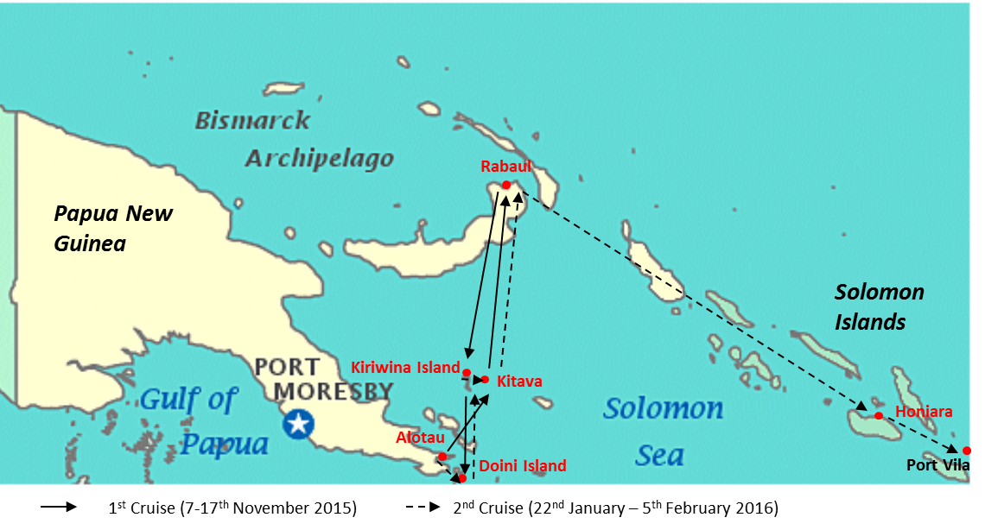
The approach and methodology used for the economic impact assessment of the cruise tourism industry on the economies of Papua New Guinea and Solomon Islands is in line with the global cruise industry studies conducted by BREA as well as the previous Vanuatu 2014 Study:
Direct impact on the economies is estimated with total direct spent of passengers, crew members and cruise ship operators on goods and services. Data was gathered through survey with passengers and crew members as well as information received by cruise industry.
Indirect impact is calculated by simulating the flow of this direct spent into the economy through the value chain. Cost structure of businesses (and their suppliers) was estimated with the use of secondary data review, face-to-face interviews with businesses and in-country experts.
Aggregation categorises direct and indirect impacts into three groups: local beneficiaries (goods and services supplied by local suppliers, wages, rent, profits assumed by locals etc.), government (tax, duty collection etc.) and leakage (money spent on foreign goods and services or a foreign based beneficiary).
Employment Impact is estimated as a ratio of total employment to turnover by sector. Information was obtained from face-to-face interviews with businesses, in-country experts and secondary data review.

A total of 2,254 passenger responses were collected. Average passengers’ response rate was 8% per port (344 passengers per port), but passengers reported on average for 2.03 persons, in line with other studies. If compared to Vanuatu study, sample sizes are smaller but this was expected because of limited number of cruise ships surveyed (only 2 ships surveyed) and higher number of ports surveyed at each cruise ship (six ports). However, the achieved sample sizes are big enough to provide statistically robust results.
The survey was complemented with four focus groups and several in-depth interviews with passengers on-board to build an in depth understanding of their spending behaviour and drivers.
In addition, 36 face-to-face interviews were conducted with businesses operating in the Study ports. The aim of the interviews was to collect data on the basic cost structure, levels of employment and main suppliers. 29 businesses were interviewed in Papua New Guinea and 7 businesses in Honiara, Solomon Islands. Due to smaller sample size data was analysed in aggregate and triangulated with secondary literature and in-country expert opinion.
Draft results of the economic impact assessment and underlying assumptions were presented and discussed at the in-country workshops in Papua New Guinea and Solomon Islands in March 2016.
The study is based on in-depth qualitative and quantitative research conducted at five ports in PNG and one port in SI
 | Alotau with population of some 12,000 is one of the bigger urban ports in PNG and the capital of Milne Bay Province. Cruise passengers could pre-book the biggest variety of tours combining war, history and culture tours. A good range of places are available for food and drinks.
 | Doini is a privately owned island and resort with less than 100 inhabitants. Business activities include a restaurant serving food and drinks, a pleasant beach, available for activities such as fishing, boat trips, and self-guided walks around island, kayaking, dancing and singing performances. There were no pre-booked or local tours available.
 | Kiriwina with a population of 37,000 is one of the largest and most populated islands of the Trobriand Islands. Natives live a self-sustained lifestyle. It is renowned for the wood carvings and snorkelling. Many handicraft vendors line up by the footpaths at the beach to sell their goods to cruise tourists. No pre-booked tours were available on board of cruise ships but local guides can be hired for a walk to the village, in exchange for a donation.
 | Kitava is a small tropical island with some 2,000 – 3,000 inhabitants. It is part of the Trobriand islands where the natives live a self-subsistent lifestyle. Cruise passengers can purchase a diverse type of goods including wood carvings, crafts, shells, jewellery and coconut. No tours were available to pre-purchase on the cruise ships. However, there are local tour guides offering skull cave visits and boat tours.
 | Rabaul with population of some 8,000 is an urban port in East New Britain province. It is popular for its volcanoes, scuba diving, snorkelling sites, World War II history and cultural life. A variety of businesses serve cruise passengers including local tour operators, souvenir and handicraft vendors, supermarkets and local markets. Tours were available either to pre-book on cruise ships or to purchase directly from local operators.
 | Honiara with some 65,000 inhabitants is the capital city of Solomon islands. When large cruise ships arrive local businesses set up a craft and souvenir market at the wharf, offering a variety of handicrafts. Tours were not available to pre-book on cruise ships, but local operators were accessible at the wharf.

Limitation of this study
While every effort has been made to ensure that the sample of data collected is representative of the population, and that the methods used in collection and analysis are robust, there are a number of limitations to the study:
Study does not estimate induced impacts. Induced impacts, defined as the impacts of expenditure from private beneficiaries of indirect cruise ship tourism spending (i.e. household expenditure from employees of cruise tourism benefiting businesses) have not been considered as part of this study. To do so, would require an understanding of how private beneficiaries spend the income they received from cruise ship tourism.
Sample is based on data collected on two large cruise ships, smaller expeditionary cruise ships were not surveyed. Data collection was undertaken on two large cruise ships visiting PNG and SI with the most comprehensive itineraries, during the months of November 2015 and January 2016. The cruise tourist population on-board both cruises is considered representative of the larger vessels visiting PNG and SI in 2015/16. As the popularity of cruise tourism to PNG and SI continues to expand, the demography of tourists and their spending patterns are likely to change. The study, therefore only provide a snapshot of expenditure and its impacts in 2015/2016. Although PNG and SI are also visited by a number of smaller cruise vessels and private yachts, it was not feasible to survey these passengers and crew within the scope of this study.
Sample data to estimate expenditure of crew members was low. On each cruise ship, a survey of crew expenditure was carried out. However, the response rate from those who disembarked at each destination was very low. Several factors contributed to this outcome: I) crew have limited time-off from their duties while on-board, in which case they are reluctant to spend that time completing a questionnaire; ii) very few crew members were found to leave the ship at each destination, other than at larger ports; and iii) there is a high level of survey fatigue as many crew have encountered such surveys before on other cruise trips. In response, informal interviews were held between the researchers on-board and crew members to find out about their spending patterns and motivations for expenditure, which are included in our assessment. Nevertheless the amount of quantitative information obtained remains negligible. To account for such a small sample size, care has been taken to validate the results by reviewing the estimated expenditure with researcher’s on-board the cruise to ensure it mirrors their general observations and experience of crew spending patterns. Secondly, the result have been compared to crew expenditure in other studies. As crew incomes and hours worked are similar across different cruises, it is reasonable to assume expenditure is similar.

Economic impacts of cruise tourism expenditure
This summary presents two estimates of cruise tourism expenditure:
- The economic impact on the five researched ports (Alotau, Rabaul, Kiriwina, Kitava and Doini Island) in PNG and one port in SI (Honiara). These estimates are based solely on the data obtained from the two cruises, scaling up by the number of times cruise ships of this size are scheduled to call in the these ports in 2016.
- The economic impact on the whole country of PNG and SI, accounts for the fact that mainly smaller cruise ships call at ports other than the researched ports in PNG and SI. To do this, assumptions were revised to reflect the lower port fee paid by smaller ships, the lower number of passengers per ship arriving in each port and the frequency of port calls. Extrapolation on this basis provides a first estimate of the total economic impact of cruise tourism on each economy.

Unless otherwise stated, the impacts reported are based on the economic impact on the researched ports, due to insufficient data being available to estimate the country wide impacts, other than in aggregate.

Comparison with/lessons from other studies
It is natural to compare the results of this study with similar studies conducted in other Pacific Islands or similar island tourist destinations in the Caribbean. However, care should be taken in comparing countries and their economies, as eluded to above, PNG and SI differ significantly from other Pacific Islands for the following reasons:
- PNG and to a lesser degree SI are highly undeveloped tourism destinations, in terms of the number of cruise and other tourists visiting these countries and the tourism infrastructure available to them, including road transport, cultural and retail destinations and awareness of tourism as an important source of revenue among businesses. Numbers of visitors are increasing and improvements are being made infrastructure, although it will take time to reach the numbers seen in similar Pacific and Caribbean tourist destinations.
- Cruise ship tourism in PNG includes stops at otherwise hard to reach and largely unspoilt destinations. While this is ultimately the attraction of ports like Kiriwina, Kitava, and Doini Island, commercial business is limited. Many local people are employed in subsistence farming and fishing. Cruise tourism provides a supplementary source of cash income, in which products and services are sold from no fixed premises or registered business to visiting tourists. This informal economy is difficult to capture and has limited indirect impacts as revenue is kept by the family producing the good or service. Cash income contributes directly to the household budget in such cases. This informal economic activity is much more pronounced in PNG and SI than in other tourist destinations and should be taken into account when interpreting the expenditure findings.
Taking into account these differences, levels of passenger and crew spend are broadly aligned with the results seen in Vanuatu and elsewhere. A change in the itinerary in the second cruise also enabled the expenditure surveys to be completed for Port Vila in Vanuatu. The results obtained from Port Vila confirmed broad alignment of the results of this study. Regarding the family (informal) component of many local economies, this study, in contrast to many similar studies, accounts for these effects in the quantification methodology of indirect impacts. Further, the assumptions used have been tested with tourism representatives in each country and with the researchers who visited each port of call.

Structure of this report
The remainder of this report follows the logical sequence of impacts:
- Section 2: provides a quantification of the direct expenditure impacts;
- Section 3: presents the quantification of indirect economic impacts, including on employment and leakage from each countries’ economy; and
- Section 4: identifies the barriers to and opportunities for further economic development from cruise tourism.
Technical Annexes are also provided supplementing the main report:
- Annex 1: Methodology;
- Annex 2: Quantitative analysis of passenger’s spending drivers;
- Annex 3: Cost structures and assumptions;
- Annex 4: Assumptions for the Cost Benefit Analysis; and
- Annex 5: Long list of actions.

Direct Economic Impact
PNG Summary
In total, cruise companies, passengers and crew spent $5.7 million in PNG in 2015 in five researched ports (Alotau, Rabaul, Kiriwina, Kitava and Doini Island). On average, each cruise ship call brought between $24,000 and $160,000 depending on the port.
If this data is extrapolated, total direct economic impact of cruise tourism in PNG is estimated at some $6.3 million.
The major source of the expenditure is cruise companies (which account for 54 per cent of total expenditure) mainly through a variety of fees paid to ports, government agencies or communities. The remaining expenditure comes from passengers (43 per cent) mainly through purchases of tours. Crew expenditure accounts for only 3 per cent.
The distribution among ports differ. The majority of expenditure in PNG benefits Alotau (42 per cent) and Rabaul (41 per cent) as these are entry ports and are more developed ports. Total and breakdown of expenditure by port in PNG is provided in Table 2.1.
The total number of calls assumed for the impact assessment in PNG in 2015 is 60 at five researched ports. There were additional 76 calls at other mostly small island destinations with significantly smaller average vessel size (between 150 – 300 passengers). It is estimated that this additional calls bring a marginal share (11 per cent) to total cruise tourism impact in PNG. As a result, the five researched ports in focus of this Study, provide a good insight.
            - Total estimated direct spend per average call PNG 2015 ($AUD)
 | Calls | Total Passenger Spend per call | Total Crew Spend per call | Total Cruise Line Spend per call | TOTAL Spend per call | TOTAL
Alotau | 15 | 50,113 | 4,706 | 104,167 | 158,986 | 2,384,789
Doini Island | 11 | 20,782 | 505 | 22,000 | 43,287 | 476,159
Kiriwina | 10 | 17,112 | 511 | 12,000 | 29,623 | 296,226
Kitava | 8 | 11,546 | 462 | 12,000 | 24,008 | 192,065
Rabaul | 16 | 79,546 | 4,607 | 57,000 | 144,903 | 2,318,447
TOTAL 5 Researched Ports | 60 |  |  |  | 94,461 | 5,667,686
TOTAL PNG (extrapolation) | 136 |  |  |  | 46,782 | 6,362,304
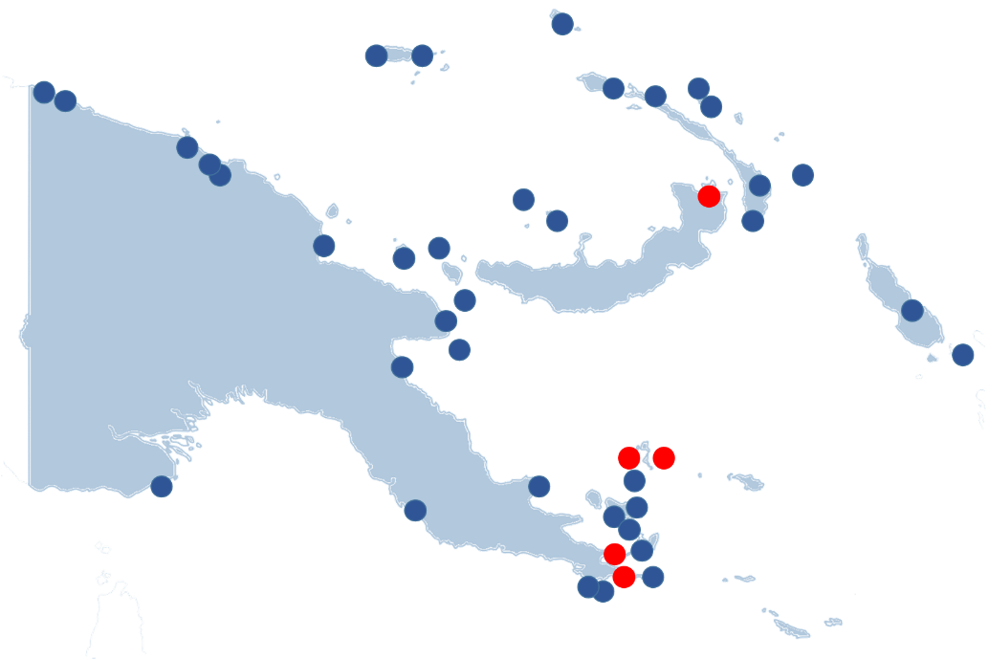
Note: Blue dots mark ports were cruise ships called in PNG in 2015. Red dots mark ports of Alotau, Doini, Kiriwina, Kitava and Rabaul; researched ports in this study.

SI Summary
The direct economic impact to the port of Honiara in SI in 2015 is estimated at $0.6 million. On average each cruise ship call brings $46,169 to Honiara.
If this data is extrapolated, total direct economic impact of cruise tourism in SI is estimated at some $0.9 million.
The majority of the expenditure comes from cruise companies (65 per cent of total expenditure) mainly through different fees paid to ports, government agencies or communities. The remaining expenditure comes from passengers (31 per cent) and crew (4 per cent).
            - Total estimated direct spend SI 2015 ($AUD)
 | Calls | Total Passenger Spend per call | Total Crew Spend per call | Total Cruise Line Spend per call | TOTAL Spend per call | TOTAL
TOTAL 1 Researched Port (Honiara) | 13 | 14,052 | 1,908 | 30,210 | 46,169 | 600,201
TOTAL SI (extrapolation) | 47 |  |  |  | 19,165 | 900,768
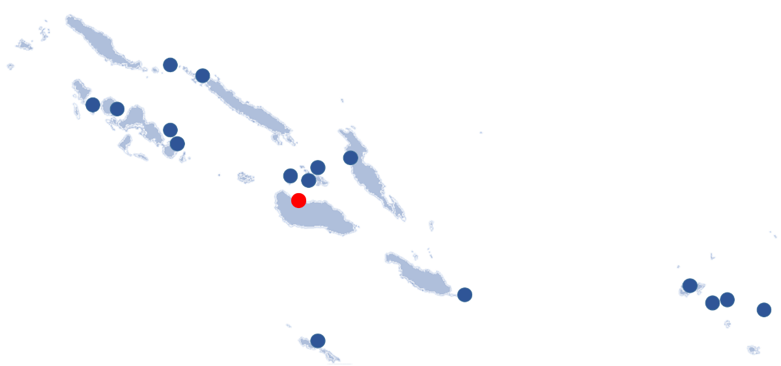
Note: Blue dots mark ports were cruise ships called in SI in 2015. Red dot marks port of Honiara; sampled port in this study.

Cruise passenger expenditure

Headline expenditure
The aim of the passenger survey was to estimate the average onshore expenditure of cruise passengers at different ports of call in PNG and SI. This expenditure includes pre-booked tours, purchases of handicrafts and other products. The data obtained from the survey is used as the basis for direct impact modelling assumptions.
Passengers’ expenditures varies significantly among the surveyed ports due to differences in spending opportunities (e.g. availability of pre-booked tours) and other factors such as the availability of ATMs, currency exchange services, shaded areas and toilets ashore.
On average, passengers spend $76 per day in Rabaul, $47 in Alotau and between $7 and $11 per day in smaller ports (i.e. Doini Island, Kiriwina or Kitava). In Honiara, passengers spend $28 on average per day.
The global average passenger spent is much higher, estimated in the region of $179. The Vanuatu 2014 Study estimated passengers spend $96 in Port Vila, $45 in Lungaville, and $11 in the Mystery Islands.
          - Average passenger spend by port ($AUD)
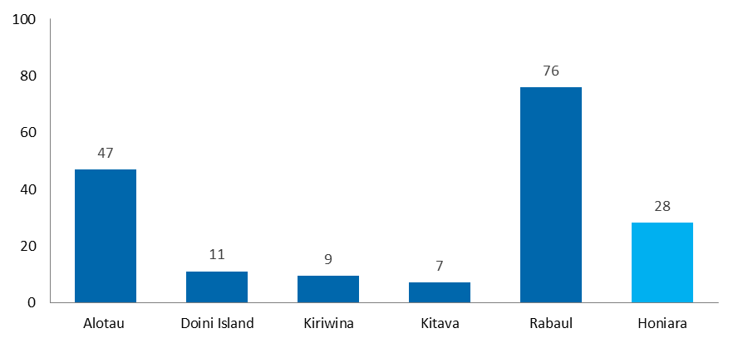
As shown in Figures 2.3, the breakdown of spending on different categories indicates further differences between the ports:
- The average passenger spends a significant amount on pre-booked tours, where available ($50 in Rabaul and $35 in Alotau). Pre-booked tours are not available in Honiara, Doini Island, Kiriwina and Kitava.
- Passengers spend much less on tours purchased directly at ports ($15 in Rabaul and $4 in Alotau). Only between half a dollar and one dollar is spent on tours in smaller ports.
- Two to six dollars are spent on souvenirs, mostly wood carvings and other local handicrafts.
- Up to four dollars are spent on food and beverage, retail or transport depending on the port.
- A large share of ‘Other’ expenditure of around one dollar in smaller ports is spent as a donation to the island communities.
There are no duty free shops in PNG and SI. Services are limited to hair braiding.
          - Breakdown on Average Spend by Port ($AUD)
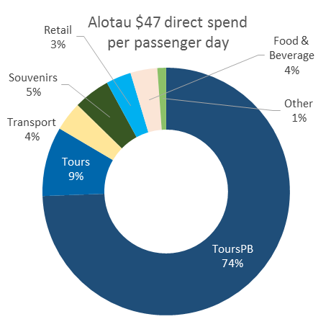 | 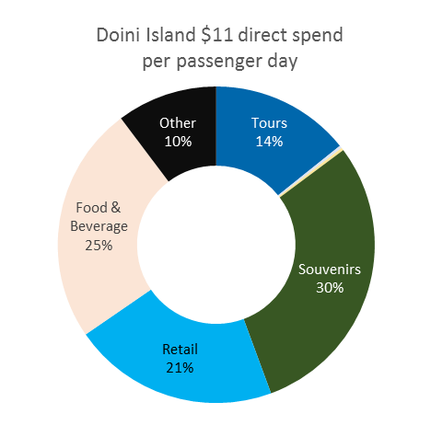
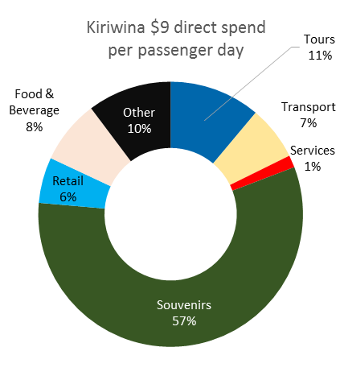 | 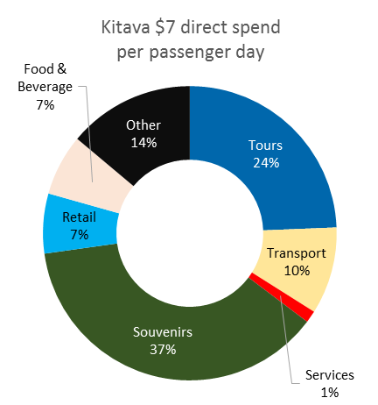
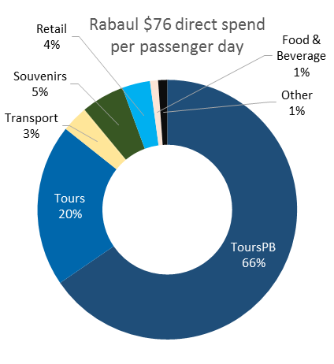 | 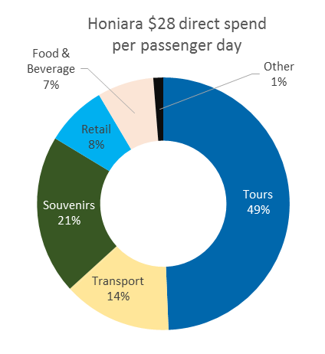

Key findings

 | Qualitative research found passengers are often not expecting many services and don’t particularly want them; people are mostly interested in and surprised by the beautiful unspoilt locations, the friendliness of the locals and the rich culture and history.
 | There was a consensus among passengers interviewed that not much money is needed to have a great time at these locations - the main expectation from passengers is to be able to relax and enjoy these pristine places.
 | Quantitative analysis confirms that on average passengers spent little ($7 to $11) at small island destinations (Doini Island, Kitava, and Kiriwina).
 | Passengers’ expenditure of the entire trip (in PNG) is lower or equal to what they expected to spend. Passengers expected to spend between $150 and $200 in total at the five visited ports (P&O amount suggested at money exchange points). Based on the quantitative analysis, average expenditure was $150 at five ports in PNG per passenger.
 | Passengers would like to contribute more to the local communities, through spending (quantitative data show most would spend more on entertainment, tours, clothing, watches/jewellery and handicrafts if more were available) or donations (both monetary and material).
 | Average passengers spent a significant amount ($35 to $50) on pre-book tours if those were available on cruise ships  - Pre-book tours were not available on board of cruise ships for Honiara, Doini Island, Kitava and Kiriwina. Pre-booking of tours will be available on Carnival cruises in Honiara from May 2016 onwards.  - Discussions in focus groups highlighted that some passengers preferred to pre-book tours through cruise operators, however others would like to book directly with local tour operators. There is a perception those tours are cheaper with more money going straight to the community.

The proportion of passengers going ashore is high. Based on survey results, between 93 per cent (Kitava) and 97 per cent (Doini Islands) of passengers went ashore at the surveyed ports. This is consistent with the Vanuatu 2014 Study and the global average of 94 per cent.
Once ashore, passengers spend between 3.4 and 4.3 hours discovering destinations before returning to the cruise ship, depending on the port. Globally, the average number of hours ashore is 4.4 hours.
Among the different ports, Kiriwina Island and Kitava attracted the least number of passengers. A large proportion of passengers did not spend while ashore at these destinations (between 39 and 40 per cent of passengers didn’t purchase anything). In contrast, Rabaul attracted a high amount of passengers ashore (96 per cent), and only 6 per cent of them chose not spend, with the average passenger returning to the cruise ship after 4.3 hours. A breakdown of passengers going ashore by port and their spending pattern is provided in Figure 2.4.
          - Proportion of passengers going ashore and not spending ($AUD)
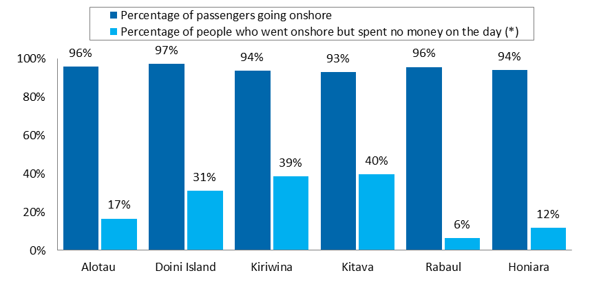
The proportion of passengers going ashore is high, but some passengers still prefer staying on board.
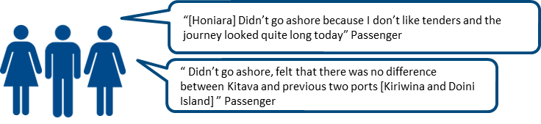
Box below provides detail on observed average time spent ashore by port.
          - Average time spent ashore (for passengers going ashore)

Average time passengers spend ashore is lower than global average. Qualitative research found this is partly due to: heat, lack of basic facilities and a lack of food that is perceived to be safe to consume. Time spent on tours also influences the time spent ashore. A prominent pattern observed by researchers was that after a few hours of a full day stop spend ashore, many passengers return to the cruise ship for lunch and are unlikely to return, choosing to stay aboard the ship during the remainder of the day. On average passengers spent:
- 3.4 hours at Kiriwina: Passengers returned to boat fast. Some felt overwhelmed by too many vendors, there was not enough shade, no places to sit, and the beach was not pleasant. Passengers also mentioned locals “begging”.  - 3.6 hours at Kitava: Passengers preferred Kitava over Kiriwina and stayed there longer. It had nice seating areas and shade. Vendors and locals were less “pushy”.  - 3.7 hours in Alotau: Extreme heat and humidity prevented passengers to spend more hours ashore. Some passengers perceived Alotau as quite raw and dirty. Some rest areas were available for passengers but there was no clear signage so most passengers did not use this. Many passengers went on tours, those last 2 hours.  - 3.7 hours in Honiara: Port was visited on a Sunday, many businesses were closed. Lack of facilities (toilets). | 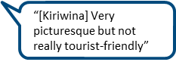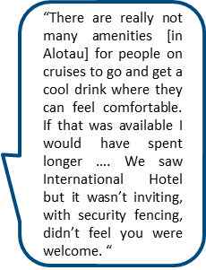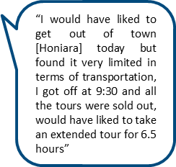
- 3.8 hours at Doini Island: Resort bungalows were available for cruise passengers to use. There were appropriate facilities, shade, restaurant with food and drinks available for passengers.
- 4.3 hours in Rabaul: Longer stay on shore because most passengers went on tours (volcanoes and WWII history) which last between 3.5 and 4 hours.

Drivers of expenditure
This section identifies potential drivers of passengers’ on shore expenditure (average spend). The following potential drivers were explored through quantitative analysis (passengers’ survey) by calculating correlation coefficients: household income, passengers’ satisfaction levels, availability of options and whether or not passengers pre-purchased tours.
The factor that is strong and positively correlated to mean spend indicates (but does not establish with certainty) that the factor causes more spending. The analysis was conducted separately for PNG and SI where possible. Due to small sample size, availability of options and pre-purchased tours were explored in aggregate.
Three key drivers of passengers spend:
Time passengers spend on shore: Passengers who spend more time ashore also spend more. Results are consistent among countries and different studies.
Passengers’ satisfaction with the variety of things to see and do: If passengers think there is a greater variety of things to see and do, they also spend more. However, correlation with other indicators measuring passengers’ satisfaction varies depending on the country and study (i.e. satisfaction with shopping opportunities and likelihood of returning in next three years). A majority of passengers that spent in PNG and SI would spend more on clothing, watches/jewellery and handicraft/souvenirs if more options was available independent of the country
Availability of pre-booked tours: Passengers who pre-booked tours spent significantly more (on average $79) than those who did not pre-book tours (on average $21). Relative to other goods and services currently available, pre-booked tours are expensive (up to $130) and when available, many passengers purchase them (47% of passengers in Alotau and 48% of passengers in Rabaul). Passengers with pre-purchased tours spend less on transport and more on souvenirs.

          - Time ashore and mean spend
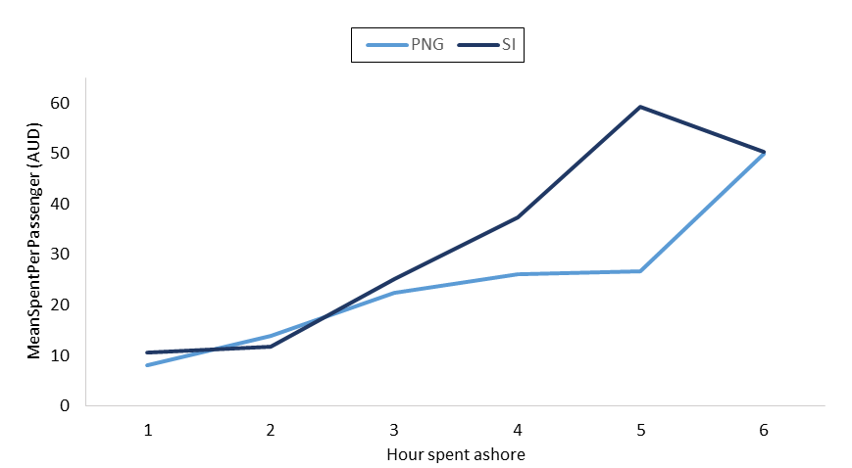
N=2061
There is a positive correlation between mean spend and time ashore up to 6 hours for PNG and 5 hours for SI.
In terms of satisfaction, there is a strong positive correlation between “variety of things to see and do” and total spend in both PNG and SI. Those passengers who are not at all satisfied with the variety of things to see and do on average spent only $13 and those who were extremely satisfied on average spent $34.

          - Satisfaction with variety of things to see and do and mean spend
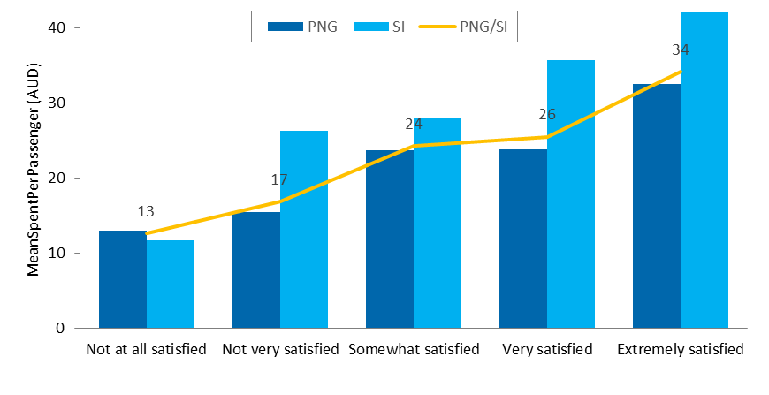N=2061

More than half of passengers were very or extremely satisfied with the current variety of things to see and do at most ports especially at Doini Island, Kitava and Rabaul (Figure 2.8):
- Doini Island rates the highest. It offers fishing, boat trips, self-guided walks around island and kayaking. There are many different groups performing cultural dances and songs. Less availability of crafts. Some passengers pointed it felt more commercial, less authentic and more in line with other Pacific Islands.
- Kitava is liked for being authentic, untouched and un-touristy. Passengers can purchase handicrafts, do tours with local tour guides to the top of the hill for the lookout and “King Cameron’s Grave” and skull caves, take a “raft-boat” to a deserted island and purchase food and drinks (coconut) from stalls.
- In Rabaul many passengers go on tours (volcanoes and WWII history), the selection of handicrafts is good and includes local products as well as commercial “made in China” products.

          - Share of passengers who were very or extremely satisfied with the current variety of things to see and do
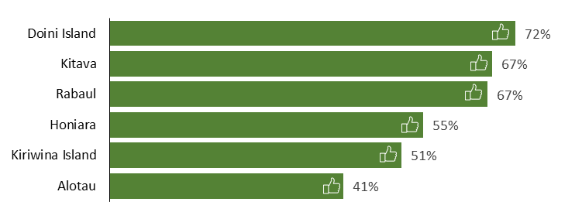
N=2090
Around a fifth of passengers were not very or not at all satisfied with the variety of things to see and do in Alotau, Honiara and Kiriwina Island (Figure 2.9).
- The main town of Alotau is about 30 min walk from the port and especially passengers on tours rarely make it into the town centre. Tourist offer close to port is limited, there is no information desk or local tour operators at the port and signage is poor. Alotau has a good range of places available for food and drinks, however souvenirs and woodcarvings are less obvious to buy. Tourists can purchase a variety of tours such as Ahoima traditional cultural experience: meet my family, Alotau history tour, The Battle of Milne Bay tour and traditional cooking class.
- Kiriwina Island has the highest number of local people servicing cruise tourists. It is renowned for the wood carvings and spectacular snorkelling. But passengers commented there is not enough variety of handicrafts. Some passengers were concerned that crafts are imported. There were local tour guides available for village tours, but passengers were not aware of this offer. Passengers also expressed concerns over animals; locals were encouraging passengers to pay for photos with parrots and turtles.
          - Share of passengers who were not very or not at all satisfied with the current variety of things to see and do
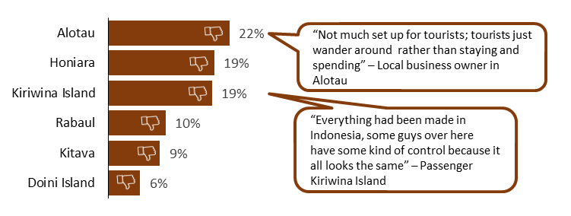
N=2090
Cruise passengers were asked whether they would spend more if more options were available. The answer was much more likely to be “Yes” for passengers who spent. More than 50% of passengers who spent would have spent more on entertainment activities, clothing, watches/jewellery and handicrafts, if more were available.
Passengers who did not spend would most likely spend more on tours on the day (40%), followed by handicrafts (30%) and clothing (28%), suggesting a gap in the market in these areas in particular.
          - % passengers who would have spent more if more were available
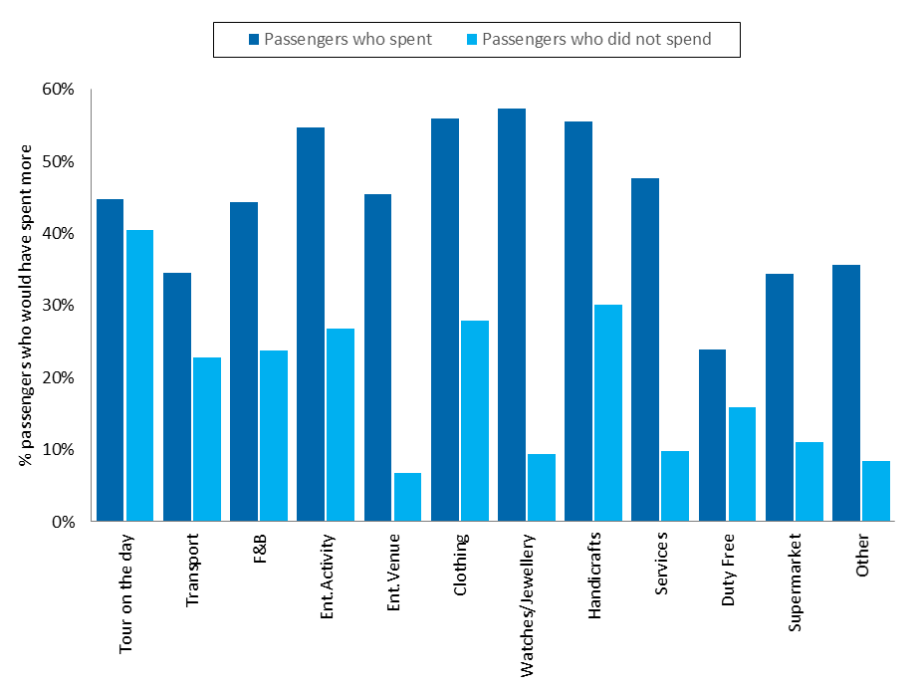
N=2061
Responses were similar at ports of PNG and SI, but passengers in SI are more likely to spend more in most items (if more options were available).
          - % passengers who would have spent more, by country
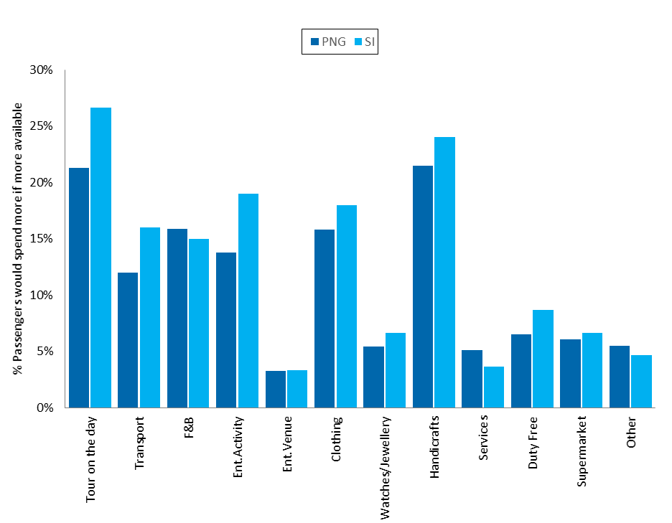
N=2061
Passengers who pre-booked tours spent significantly more than those that did not pre-book tours. The calculation assumed 30% of expenditure on pre-booked tours is retained by the cruise company.
          - Spend for passengers who booked/did not book tours ($AUD)
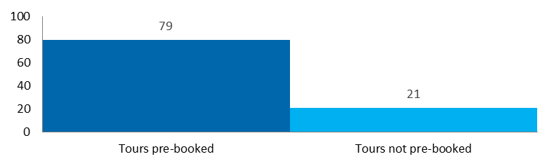
N=1758
Those passengers that pre-booked tours spent less on transportation, more in retail and handicrafts, but very much the same on food and beverage.
          - Pre-booked tours and mean spend on key items
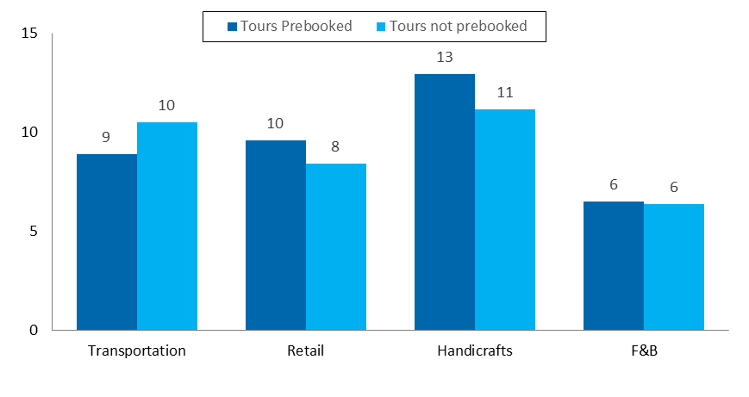
N=2061
Collected passengers data does not allow for detailed analysis of spending patterns based on passengers’ demographics. Consistently with BREA and Vanuatu 2014 Study, one survey per cabin was collected and one passenger was asked to report spending on behalf of all cabin/family members. Based on such data individual expenditure by gender or age cannot be identified.
91 per cent of passengers responding to the survey hold permanent residence in Australia. The sample sizes of passengers from other countries (i.e. UK, US and Canada) are too small for statistical spending comparison based on country of origin (calculated differences are not statistically significant).

Cruise crew expenditure
The number of collected survey responses from crew was insufficient to conduct quantitative expenditure analysis. Hence, to estimate total direct economic impact several assumptions are made for cruise crew expenditure. The assumptions are based on Vanuatu 2014 Study and qualitative insights gathered during research on two cruise ships visiting PNG and SI in November 2015 and January 2016.
For the purpose of analysis, ports are classified into two sizes:
- Small ports include Doini Island, Kiriwina and Kitava. It is assumed that the size and type of expenditure compares to that of Mystery Island in Vanuatu;
- Medium Ports include Alotau, Rabaul and Honiara. It is assumed that the size and type of expenditure compares to Lugaville in Vanuatu. Crew did not spend on duty free and entertainment activities in PNG and SI as there are no such businesses operating (or do not attract crew members) in these localities.
Assumed share of crew going ashore is 13 per cent for small ports and 26 per cent for medium ports. For comparison, the global average is 39 per cent.
            - Assumed share of crew going ashore per size of port
Port Size | Assumed Share of Crew Going Ashore
Small Ports (Doini Islands, Kiriwina, Kitava) | 13%
Medium Ports (Alotau, Rabaul, Honiara) | 26%
Source: Vanuatu 2014 Study
The analysis assumes crew members on average spend $5 per day at small ports and $28 per day at medium ports in PNG and SI. The main expenditure is in food and beverage, retail (i.e. supermarkets) and transports. To compare, global average crew expenditure at port per day is $93.
Currently PNG and SI lack pull factors for crew members to go and spend ashore. Based on global studies, crew members go ashore to access cheap communication services (internet and phone, on-board connection is expensive), food and beverage at restaurant and bars, entertainment/night clubs and transportation to take them to this facilities. They also tend to spend on clothes and electronics. All those facilities/products are scarce/not available in PNG and SI.
          - Crew Expenditure Breakdown
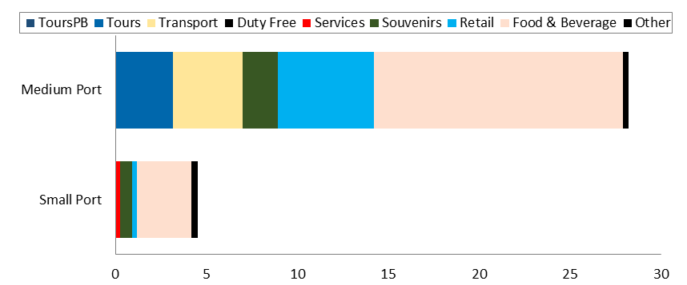

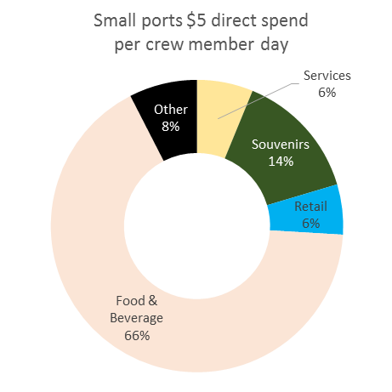 | 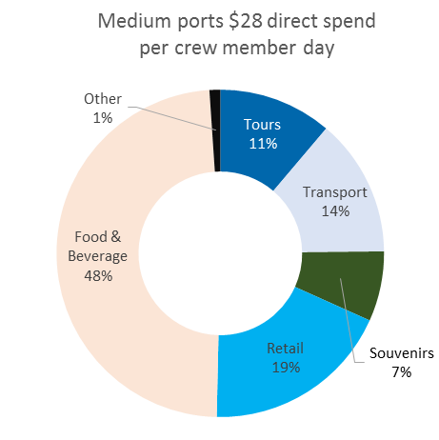

Direct expenditure of the cruise company
The majority of cruise company expenditure relates to fees that directly flow to the government.
Data for this assessment is based on Carnival Australia internal estimates. Care was taken to verify and triangulate information with stakeholders in PNG and SI, in particular shipping and logistics companies. A comprehensive overview proved difficult.
In Alotau, the average fee paid per cruise ship is estimated at $98,000, whereas Rabaul charges around $58,000 and Honiara $30,210. In Kiriwina and Kitava landing fees of some $12,000 are received directly by the communities. Doini Island, a privately owned island, charges $22,000.
Total fees include a range of charges paid to different government departments, port authorities, and shipping and logistics companies including: customs and immigration fees, quarantine fee, port fees, etc. It was assumed that customs and immigration fees and other national fees (such as the fees charged by the National Maritime Safety Authority in PNG) are charged at the first port of entry (i.e. Alotau and Honiara).
Based on a comparative example of fees paid by one large cruise ship at different ports, port fees, agency fee and quarantine fee are comparable between the three larger ports (Alotau, Rabaul and Honiara). However, fees paid for customs and immigration and National Maritime Safety Authority are much higher in PNG compared to SI. Together these fees account for 58 per cent of total fees paid in Alotau, compared to 9 per cent in Honiara
Other direct expenditure of the cruise company relates to expenses on goods and services. This includes corporate expenditure for operations (e.g. travel, accommodation and professional advisory fees). In PNG, these company expenditures were allocated evenly among Alotau and Rabaul based on number of calls in 2015.
Procurement of other goods is mostly centrally managed from home ports; there are currently no products sourced locally in PNG or SI for the larger vessels. A port agent in Honiara noted that smaller vessels sometimes purchase provisions from the port (e.g. eggs), smaller vessels also pay for garbage disposal. It has not been possible to quantify this extra expenditure in this study.
Figure 2.15 shows the average cruise company expenditure per call. A comparative example of fees paid by a large cruise ship at study ports is presented in Figure 2.16.
          - Average cruise company expenditure per call (Thousand $AUD)
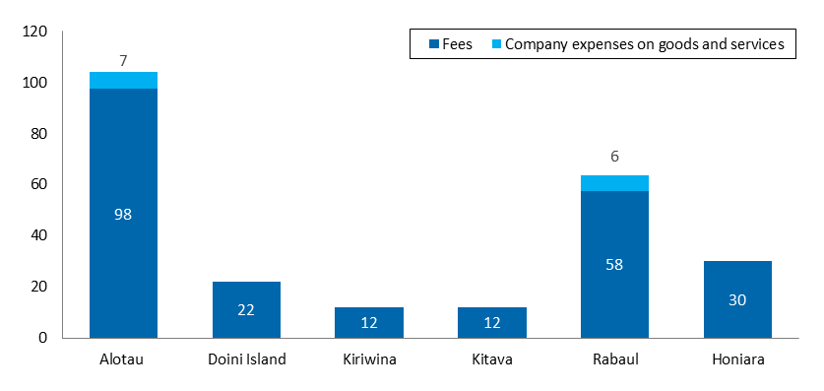
Source: Carnival Australia and PNG and SI cruise agents, internal data
          - Comparative example of fees paid by a large cruise ship (2,000 pax) at ports (Thousand $AUD)
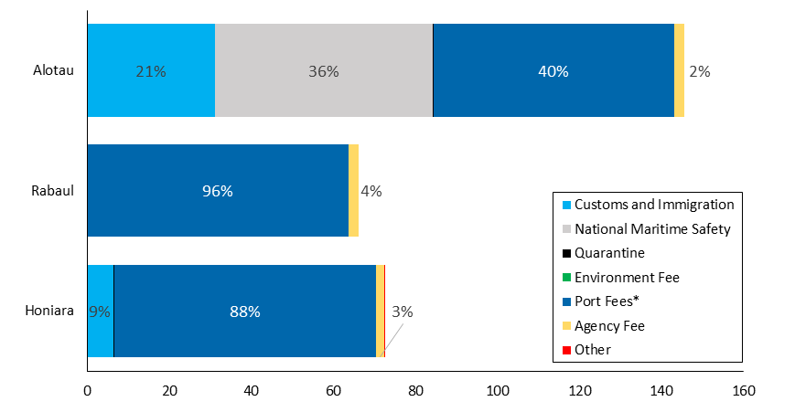
Note: *Port fees include anchorage, pilotage, ISPS, berthage, berth reservation, mooring gang service etc. Other includes professional service tax.
Source: Carnival Australia and PNG and SI cruise agents, internal data
Port Fee Challenges in PNG

Lack of coordination and a need to adopt international practices: Some stakeholders noted there is a level of confusion between various authorities collecting fees from visiting ships in PNG. Reportedly, each authority has a different method of charging fees, overtime, ad diem allowances, policies related to boarding vessels in designated and undesignated ports etc. A shipping agent noted PNG needs to conform with internationally accepted practices related to manifests, documentation and methods of charging vessels that are consistent with other destinations.

High fees: Based on data gathered, fees charged in PNG are significantly higher than those in SI. Some stakeholders and cruise ship operators noted recent high fees charges by National Marine Safety Authority might result in some cruise ships bypassing PNG in the future. Based on their calculations this especially applies for small (50-100 passengers) exhibition cruises that visit PNG once a year (e.g. Colombus, Amsterdam, The World). Ports in the Pacific region and around the world are under sustained pressure to keep costs to a minimum, specifically for cruise ships if tourist destinations are to remain competitive. A vast body of literature however recommends port fees should be set at a level that covers the expenses and investment needed to build and maintain a port as well as the local infrastructure to accommodate cruise passengers.

Legislation and customs rules: According to current legislation, the first port of entry for cruise ships in PNG must be a declared port (e.g. Alotau, Rabaul, and Port Moresby). By law cruise ships need to stop first at one of the declared ports before going to other destinations. However, other Pacific countries (e.g. Fiji, Solomon Islands) allow cruise ships to enter the country also through undeclared ports (an example of undeclared port in PNG is Conflict Island). This opens up more possibilities for cruise operators to better tailor their itineraries.

Comparison of key indicators
The survey questionnaires for passengers’ and crew members followed the methodology used by global studies on the cruise sector (BREA) as well as the 2014 Vanuatu study.
Table 2.4 compares key indicators from the different studies. Results of this study are broadly consistent with other studies. The main differences in scale of cruise tourism impact are due to lower number of cruise ship visits and lower number of spending opportunities at PNG and SI ports.
            - Comparison of key indicators among different cruise ship studies
Indicator | PNG | SI | Vanuatu | BREA 2015
Number of researched ports | 5 | 1 | 3 | -
Number of calls at researched ports per year | 60 | 13 | 201 | -
Average number of passengers per call | 1311 - 1927 | 530 | ~ 2081 | -
Average number of crew per call | 641 - 872 | 260 | - | -
% passengers going ashore | 93% - 97% | 94% | 91% - 97% | 94%
Average time spent ashore (hours) | 3.4 – 4.3 | 3.7 | - | 4.4
Average passengers spend per call ($) | 7 - 76 | 28 | 11 - 96 | 179
Average crew spend per call ($) | 5-28 | 28 | 19 - 70 | 93
Direct expenditure of cruise company per call ($) | 12,000 – 104,167 | 30,210 | 20,000 – 38,000 | -
Average total direct expenditure per call | 41,675 | 46,169 | 164,000 | -
Total direct expenditure per year at researched ports ($) | 5,667,686 | 600,201 | 33,000,000
Benefit to private beneficiaries (as a % of in direct and indirect impact) | 43% | 27% | 49% | -
Benefit to government (as a % of in direct and indirect impact) | 51% | 63% | 11% | -
Leakage (as a % of in direct and indirect impact) | 6% | 10% | 41% | -
Multiplier (on private beneficiaries) | 1.43 | 1.27 | 1.49
Value added ($ million) | 1 | 0.09 | 8.4
Value added as a share of GDP (%) | 0.01 | 0.01 | 0.01 | -
Employment opportunities | 203 | 21 | 1,170 – 3,250 | -

Indirect Economic Impact
Summary
The multiplier effect of the cruise ships tourism on private beneficiaries is estimated at 1.43 for PNG and 1.21 for SI. 2014 estimate for Vanuatu was 1.49. The effect summarises the total stimulus impact on businesses that can be expected from increases in cruise tourism activity. The multiplier impact on the whole economy is estimated at 1.04 for PNG and 1.07 for SI. This lower effect reflects the significance of the informal tourism economy in each country.
Total indirect economic impact in PNG is estimated at $ 5.9 million or 0.03 per cent of GDP. Value added from cruise tourism in PNG in 2015 is estimated at $1 million.
In SI total indirect economic impact is estimated at $ 0.6 million or 0.04 per cent of GDP. Value added is estimated at $0.09 million. Total value added is the value of direct and indirect impact that generates salaries and profits.
Indirect economic impact is a secondary effect of the spending of cruise passengers, crew members and cruise operators. It is a result of the ‘multiplier effect’ as the money spent circulates in the local economy where businesses purchase goods and services, pay wages, taxes, etc.
The impact was calculated by simulating the flow of the money in the economy through the value chain (including secondary effects). The cost structure of businesses (and their suppliers) was estimated from face-to-face interviews with businesses and in-country expert assessment. Country ‘input-output’ tables are normally used to calculate indirect effects on the economy. However, there is a significant data gap for the economies of PNG and SI.
Three types of impacts were estimated: i) private income for PNG and SI population; ii) government revenues (i.e. taxes); and iiI) leakage (i.e. money leaking the economy through imports and foreign ownership of businesses).
The Figures below presents a schematic version of indirect expenditure in PNG and SI for sampled ports. The left side of the figure presents the sum of direct and indirect impact by sector. The right side presents the final beneficiaries of this impact.
          - Indirect expenditure breakdown per sector in PNG (left) and per type of impact (right) (%)
          - Indirect expenditure breakdown per sector in SI (left) and per type of impact (right) (%)
Note: * Other includes port fees paid by cruise operators as well as other sectors of passengers’ and crew expenditure such as services (e.g. hair braiding and massage) and other (e.g. donations).
2nd annotates impact on second round of suppliers.

Overview

Categories of industry
The money flow was simulated through five main industries benefiting from cruise tourism in SI and PNG:
- Tour and entertainment services;
- Transport services;
- Specialist tourist retail such as handicrafts, souvenirs and artwork;
- General retail such as supermarkets; and
- Food & beverage services.
Direct expenditure to other industries is small and the analysis does not account for their multiplying effect. Different to Vanuatu 2014 Study, there is no duty free shops available in PNG and SI and service industry is limited in both countries.

Differences between locations surveyed
The islands of Kitava, Kiriwina significantly differ from the rest of the ports surveyed. These ports have limited services and no infrastructure. The islands function as subsistence economies and the inhabitants are farmers. Cruise companies pay the anchorage fee in which directly benefits the community. Businesses selling goods and services are ad-hoc, family owned businesses set up only when cruise ships arrive. The revenue from sales to cruise passengers complements subsistence farming and has not yet developed as an alternative source of close to full time employment.
The impact assessment assumes that revenues received from cruise ships are used entirely by local private beneficiaries (family consumption), there is no supply chain, no taxes payed (no government revenue) and there is no leakage from the economy (all the material is sourced locally from farming (e.g. wood, vegetables)).

Indirect impact by industry
Table 3.1 gives an overview of total indirect impact by key industry. The main industry benefiting from cruise tourism is Tours and entertainment services in both PNG and SI.
            - Indirect impact by industry ($AUD)
Industry | PNG | SI
Tours and Entertainment Services | 1,688,738 | 92,909
Transport Services | 243,473 | 64,027
Specialist tourist retail services (handicrafts, souvenirs and artwork) | 340,223 | 38,982
Food and beverage industry (restaurants and bars) | 203,993 | 25,235
General retail (supermarket, general store item) | 264,585 | 24,109
The ports of Alotau, Rabaul and Honiara are characterised by a larger business presence. The impact of direct expenditure in those ports was calculated by simulating the flow of the money in the economy through the value chain (including secondary effects). This section reports key findings per industry. A detail account of assumed cost structure per industry and country is provided in Annex 3.

Tours and Entertainment Services
Tours and entertainment services in Alotau, Rabaul and Honiara range from war and colonial history tours (e.g. Milne Bay Tour, Kokopo War Museum) to cultural tours, cultural performances and cooking classes. The operators were separated into two groups:
- Registered tour operators serve passengers who pre-booked tours through cruise companies or online. There are also registered tour operators offering services ashore at the wharfs. Those operators pay related taxes, insurance and other fees. Tours can be pre-booked through cruise companies for Alotau and Rabaul. In Honiara pre-booked tour are only available online through other operators.
- Unregistered tour operators also serve passengers while ashore. They do not pay related taxes, insurance and other fees. For instance, in Rabaul tour operators need to pay a fee of 200PGK per person per day to access the port area and need to comply with local insurance regulation to offer services at the wharf. As a result, only two local tour operators gained access to the port area but many other businesses are crowded outside the main port gates. Reportedly, some of these tour guides are officially unemployed and offer tours to earn some extra income. It is assumed that 40 per cent of tours ashore is purchased from unregistered operators.
Private beneficiaries receive a high share of direct expenditure because the revenue is mainly used to hire local tour guides and local transport providers.
            - Key findings of economic impact analysis of tours and entertainment services
 | Alotau | Rabaul | Honiara
Share of direct expenditure on pre-booked tours | 26% | 36% | 10%
Share of direct expenditure on tours ashore | 5% | 16% | 13%
Beneficiary of expenditure (% flow from every dollar spent)
Private beneficiaries | 87% |  | 88%
Government | 6% |  | 3%
Leakage | 7% |  | 9%

Transport Services
Transport services are limited to mini buses and taxis. These services are mainly hired by tour operators (accounted in secondary impact). They operate at wharfs and transport passengers on tours or in to towns.
The sector has a high leakage rates due to dependency on fuel imports. Cost of fuel accounts for a large portion of the costs to businesses (Table 3.3).
            - Key findings of economic impact analysis of transport services
 | Alotau | Rabaul | Honiara
Share of direct expenditure on transport services | 2% | 3% | 7%
Beneficiary of expenditure (% flow from every dollar spent)
Private beneficiaries | 40% |  | 38%
Government | 9% |  | 5%
Leakage | 51% |  | 57%

Specialist tourist retail services (handicrafts, souvenirs and artwork)
The majority of handicrafts sold are handmade and locally produced (e.g. wood carvings, baskets, drums, etc.). Vendors are often unemployed and/or have other jobs and set up ad-hoc stalls when cruise ships arrive. It was assumed that 80 per cent of business in this sector are not registered and do not pay taxes, social security and other related fees.
In Honiara, businesses set up a craft and souvenir market at the wharf offering a variety of products. Some craft stalls are supported by local industry groups such as the Solomon Islands Women Association that provides stalls for free. Imported souvenirs (e.g. T-shirts, caps) are only available in Rabaul.
The sector has a high distributional effect since 99 per cent of the money spent on special tourist retail, benefits private beneficiaries (Table 3.4).
            - Key findings of economic impact analysis of specialist tourist retail services
 | Alotau | Rabaul | Honiara
Share of direct expenditure on specialist tourist retail services | 3% | 4% | 10%
Beneficiary of expenditure (% flow from every dollar spent)
Private beneficiaries | 99% |  | 99%
Government | 0% |  | 0%
Leakage | 0% |  | 1%

Food and beverage service industry (restaurants and bars)
Based on qualitative research, most passengers are not particularly interested in food and drinks ashore as they are provided on-board. There are also food safety concerns which deter passengers from trying locally produced food.
Restaurant and bars (e.g. Honiara Yacht Club or Rapopo Plantation Resort in Rabaul) mainly serve local guests or other tourists. The reported intake from cruise tourists is below 10 per cent.
It is estimated that a relatively high share of expenditure flows to private beneficiaries, mainly because businesses buy the majority of goods at local supermarkets and markets. The main source of leakage is foreign business ownership, and hence leakage of profits (it is assumed 50% of profits leak offshore).
            - Key findings of economic impact analysis of food and beverage service industry
 | Alotau | Rabaul | Honiara
Share of direct expenditure on food and beverage | 4% | 3% | 6%
Beneficiary of expenditure (% flow from every dollar spent)
Private beneficiaries | 91% |  | 71%
Government | 2% |  | 3%
Leakage | 7% |  | 26%

General retail (supermarket, general store items)
The majority of products sold in general retail is imported. The ownership in the sector is heavily foreign: Chinese, Pilipino or Australian. It is assumed that 80 per cent of profits leak offshore. Hence the estimated leakage is high between 35 per cent and 48 per cent depending on the country.
            - Key findings of economic impact analysis of general retail industry
 | Alotau | Rabaul | Honiara
Share of direct expenditure on general retail | 2% | 3% | 5%
Beneficiary of expenditure (% flow from every dollar spent)
Private beneficiaries | 53% |  | 37%
Government | 12% |  | 16%
Leakage | 35% |  | 48%

Leakage and informal economy
Studies estimate leakage in Pacific islands is high due to limited production of the economies and import dependency (41 per cent in Vanuatu, 60 per cent in Fiji). However, in PNG and SI the direct impact of the cruise industry is predominantly in tours and entertainment and specialist tourist retail services (souvenirs) industries. Those industries are labour intensive and have low leakage due to high share of locally owned businesses and a minor share of imports in business costs (most of the souvenirs are produced locally, the main imports in the supply chain of tour industry are fuel and vehicles).
Share of the informal economy is considered high. Based on official statistics 75 and 85 per cent of employment in PNG and SI respectively comes from subsistence agriculture. Based on research observation, most of businesses operating in tour and entertainment and specialist tourist retail service industries are informal (do not pay tax).

Employment impact
Estimates of employment impact are based on ratio reported employment to turnover obtained during interviews with businesses on the field. The majority of employment generated through cruise tourism is part-time employment. Often this employment complements subsistence farming (subsistence farming employs 75 per cent of population in SI and 85 per cent in PNG). This is especially observed in smaller islands of Kiriwina and Kitava. It is also dominant in certain sectors such as specialist tourist retail sector (handicrafts, souvenirs, and artwork).
As a result, the reported impacts are not full time equivalent (FTE) but rather indicate the amount of employment opportunities (a mixture of full time and part time jobs depending on the sector) that cruise tourism generates.
It is estimated that 203 jobs in five ports were generated in PNG in 2015 as a result of cruise tourism (jobs for 0.6 per cent of working age population at this ports). Most jobs were generated in Rabaul (72) followed by Alotau (44) and Kiriwina (41).
In SI cruise ship tourism generated 21 jobs in Honiara in 2015 (for 0.06 per cent of working age population).
Specialist tourist retail sector (i.e. handicrafts and souvenirs) benefits most in terms of total employment opportunities despite the fact that this sector receives only about 6 per cent of total direct and indirect impact in both PNG and SI. Handicraft and souvenir business have many ‘employees’ and are mainly family run but the intake from cruise tourism is low and not consistent (businesses sell only when cruise ships arrive). For instance, based on qualitative research there are many handicraft sellers at Kiriwina, however the majority of sellers are subsistence farmers. Hence, the employment opportunity generated from cruise tourism seems large in number but only lasts for the day when the cruise ship arrives. There were 10 cruise ships in total in Kiriwina in 2015.
In line with the approach adopted in Vanuatu 2014 Study, the employment impact does not include employment resulting from government revenues derived from fees paid by cruise operators and other tax and duty collections.
            - Average number of employment opportunities per $10,000 of revenue per sector and estimated employment impact in PNG and SI 2015
Sector | Average number of jobs per $10,000 | PNG employment impact | SI employment impact
Tours and Entertainment Services | 0.31 | 52 | 3
General retail (supermarket, general store items) | 0.21 | 6 | 0.5
Food and beverage services (restaurants and bars) | 0.34 | 7 | 1
Transport (Taxi/bus/ground transportation) | 0.13 | 4 | 0.8
Specialist tourist retail (handicrafts, souvenirs, artwork) | 5.10 | 135 | 16
TOTAL |  | 203 | 21
% of working age population |  | 0.6% | 0.06%

          - Total employment opportunities by country by sector and per port

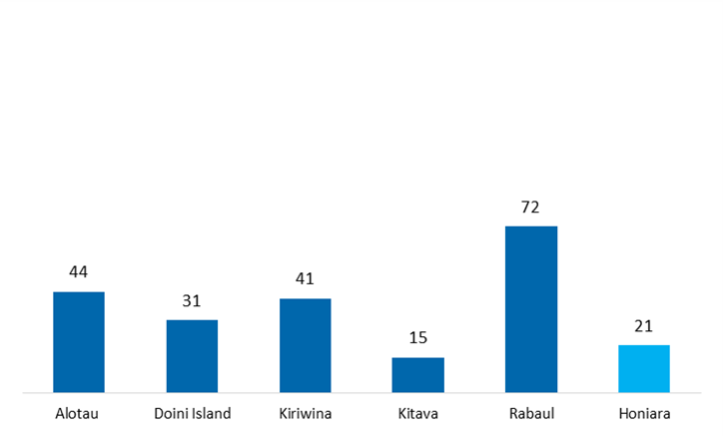

The method adopted to calculate employment impacts in the previous Vanuatu 2014 Study and BREA studies differ marginally from the approach adopted in this study. In this studies the employment impact was estimated by using the average full time salaries for employees in each sector. The Vanuatu study additionally assumed that more than 33% of employment is part time to derive estimate of employment opportunities. This study did not make use of full time salaries for employees in each sector due to lack of such data for PNG and SI and a high share of sectors operating in the informal economy. As a result, the employment impacts are based on a ratio of reported employment to turnover obtained during interviews with businesses in the field.

Opportunities for increasing the economic impacts of cruise tourism in Papua New Guinea and Solomon Islands
This section considers the opportunities which exist to increase the economic benefits of cruise tourism in PNG and SI. It also assesses the barriers to greater cruise tourism impacts, and explores the potential for further growth of cruise tourism in these countries.

Barriers to cruise tourism economic impacts
Summary of key barriers to cruise tourism economic impacts
Research carried out involving business interviews, in-depth cruise passenger interviews, and in –country workshop identified the following key challenges and barriers to increasing cruise tourism economic impacts:
- Basic port infrastructure is inadequate, limiting efficient access for larger cruise ships, specifically in Honiara (where a new wharf is now under construction), and in Kitava (jetty) and Alotau (water supplies).
- Destinations lacked basic facilities to attract cruise tourist ashore and encourage longer visits, with increase expenditure. This includes sanitation facilitates, shaded areas, seating and litter bins in most destinations, specifically in the port area.
- A tourism industry is not established in some destinations, requiring efforts to support businesses in developing their offer and working collaboratively with government, other businesses and cruise line to be prepared for the influx of tourist and maximise their economic impact. To differing degree, this issue is common to all ports.
- Businesses lack commercial awareness and there is disconnect between stakeholders which linked to the previous point, contributes to limited business preparedness and an undeveloped tourism offer.
- Cruise passengers lack confidence in the goods and services available, due to lack of information on quarantine procedures when returning home, limited transparency of pricing from some sellers of souvenirs and lack of product understanding (i.e. cultural value and production methods of handicrafts)
- Leakage of indirect expenditure could be reduced, by purchasing local throughout the supply chain; and
- The numbers of cruise tourists visiting PNG/SI is currently low compared to similar destinations. Security concerns and lack of destination information and marketing were the major factors highlighted which prevent increasing numbers of tourists visiting PNG and/or SI.

A summary of each identified problem is now provided in turn, summarising the responses received from cruise passengers, crew and businesses, and also drawing on the findings of in-country workshops held in Port Moresby and Honiara in March 2016.

Basic port infrastructure is inadequate, limiting access for larger cruise ships
A leading barrier to the development of cruise tourism in many of the ports is the lack of adequate infrastructure to permit efficient access for larger cruise ships. Additional infrastructure is also required in hub ports (i.e. Alotau and Honiara) to enable cruise ships extend their stay at small ports and to offer a more extensive cruising schedule.
In Honiara, the wharf must be sufficiently large to permit the largest cruise ships in the pacific region (maximum length size of 264 metres) to berth and take on-board fresh water supplies at 50 tonnes per hour and at a quality meeting WHO standards. At present, cruise ships must anchor offshore and tender passengers to shore, which is slow and inefficient. As passenger responses indicate, this inconvenience was one reason some passengers decided to stay on-board and limited the time ashore for many. The new wharf is current under construction, and will accept its first +200m cruise ship in September 2016.
In Alotau, there is need for the same standard of fresh water supplies to be available, as requested in Honiara as this is the port of call for many cruise ships from Australia. The ability to take on fresh water improves the comfort of the cruise for passengers and helps to open up other destinations in the area to cruise tourism.
In smaller ports of call, such as Kitawa, construction of a new jetty is required to enable disembarkation of two tenders simultaneously, therefore contributing to the more efficient transportation of passengers to and from larger cruise ships. Improvements are also required at Madang port to reinforce and extend the port berth to enable more regular and larger ships to dock in port.
Without these infrastructure improvements, the development of cruise tourism is hindered for cruise operators wishing to extend their cruise offer in PNG and SI using larger cruise ships. Passenger access to ports and comfort is also hindered.

A tourism industry is not established in some destinations
Kitava, Kiriwina and Doini are considered subsistence economies. Many people rely on fishing and agriculture for their livelihoods. Cruise tourism income is a rare source of cash to supplement otherwise low incomes. This income is important as it enables families to purchase essentials which they cannot barter, such as fuel, boat engine parts, and tools. The local economy is therefore small and has not developed sufficiently to maximise the opportunities that cruise tourism offers.
In the urban centres of Alotau, Rabaul and Honiara, which have more developed economies, the tourism industry is still considered to be in its infancy, as the number of cruise ship visits from larger ships are increasing from a low base, when compared to other Pacific Island destinations (i.e. Vanuatu and Fiji). As a consequence, there are features of tourism industry which limited the expenditure of passengers and the impacts of cruise tourism more generally:
- Many businesses are family owned limiting the indirect impacts of cruise tourism expenditure as revenue goes directly in to household budgets. Handicrafts and coconut drinks are typical products produced and sold to cruise passengers which require limited inputs to production, and therefore have limited economic impacts outside of the family.
- Family members may not be paid for their work and are unlikely to be fully employed by cruise tourisms related activities. As noted, many vendors see cruise tourism as a supplementary income, rather than a primary source of employment. The implication for the analysis is that while number of persons employed may be high, a limited number can be considered full time and wages are likely to be below average full-time equivalent earnings; and
- Without an established tourism industry in smaller ports, there may be a reluctance to see its longer term potential. There is a suggestion from one business that some vendors may see tourists as an opportunity to make a quick buck, opposed to a long term business opportunity. In part this reflects the short time cruises have been stopping in these ports, and also the infrequency of cruise ships which now stop. This short term mentality reduces the willingness of local businesses to invest in premises and the quality of their products/services, hampering the development of a more substantive tourism industry.
While these issues are more acute in the smaller ports, the tourism industry in Alotau, Rabaul and Honiara is no less under developed according to passenger and business feedback (See box below). The contrast of PNG and SI destinations with Port Vila on the second cruise illustrates the scale of gap in not only the number of businesses established to serve cruise passengers, but also in the level of cruise passenger expenditure and its economic impact.
If PNG and SI are to benefit from the opportunities of cruise tourism, a first step must be to establish an economy and tourist industry with the capacity to handle the influx of tourist in a sustainable way which maintains the unspoilt and uncommercial nature of the ports, drivers which passengers highlighted brought them to PNG and SI. Factors limiting the growth of businesses include limited access to capital to start-up a business, limited knowledge of financial management among business owners, limited awareness of tourism possibilities in remote areas and cultural challenges, such as issues with local women setting up businesses.

Summary of business feedback – tourism industry development
“The cruise tourism industry is very new and the local businesses are trying to keep up – they have not seen this kind of influx before” (Alotau)
“Tourism is still very up and down –people are still learning” (Alotau)
“Locals need to be passionate about what they make, rather than trying to make a quick buck” – dishonesty and overcharging of tourists” (Alotau)
“It is an exciting time for the area due to the cruise ships and the income is often all the income people get from selling carvings, etc.” (Kiriwina)
“They think cruise ships are great – it is the only way to make money – otherwise they just live of the land through farming” (Kiriwina)
“It will come – they are still getting their heads around it” (Rabaul)

Businesses lack commercial awareness
A major draw for cruise passengers visiting PNG and SI is the uncommercial and unspoilt nature of the destinations visited by cruise ships. However, the lack of commercial experience and awareness among businesses, has led to reduced expenditure by passengers compared to what they had planned in pre-visit focus groups. The lack of business acumen concerns what to produce, how to sell those products to cruise tourists and at what price. In part this also concerns the limited product offer highlighted in the qualitative findings, in terms of the tours and handicrafts available for tourist to spend money on.
The lack of a developed tourism industry in some destinations, also added to the problem as without an established businesses or premises to operate from, many sellers of handicrafts were found to travel from nearby villages to meet the cruise ship on arrival to sell products ad-hoc on mats, at irregular intervals and with limited information on the price of goods for sale. On the second cruise, researchers did note some improvement in business acumen with vendors displaying fixed prices in Doini, as well as providing straws for coconut drinks and the hygienic handling of food produce. However, this is not considered common practice, with a higher standard expected by passengers before they are willing to increase expenditure. Quotes from interviews highlighting this issue are provided in the box below.
Summary of business feedback – business commercial awareness
“ There is a lack of knowledge of what tourists want – there is a disconnect between what is on offer and what is there” (Tourist Authority, Alotau)
“Products can be very expensive as some carvings are priced at 440 Kina and these are not very popular – tourists are typically looking for smaller items around 20 Kina” (Alotau)
“Local people have little knowledge of how to sell or run businesses so they need help from government (which is starting to happen)” (Alotau)
“Need to educate the locals more on what is needed for tourists” (Rabaul)
The stop at Port Vila on the second cruise reinforced the scale of the problem. Casual observation of the researchers was that expenditure by cruise passengers was much higher in Port Vila compared to previous destinations visited. In part this was due to the fact that this was the last stop on the cruise, encouraging passenger to spend left over currency.

A disconnect exists between cruise operators and local businesses
A factor hindering the development of the tourism industry in PNG and SI is disconnect between cruise operators, local businesses and other stakeholders. According to interviews with businesses, the disconnect takes three forms:
- Limited communication of cruise schedules, resulting in many vendors missing the cruise ship visit, in particular on the smaller islands as travel is required from nearby villages. In larger towns, the lack of communication results in many vendors not opening up their premises or being ill prepared for the influx of tourists. The need for better communication and collaboration between local providers and cruise ships was highlighted by the majority of businesses interviewed in all destinations.
- Lack of a long term commitment by cruise operators to stop at ports, does not provide conditions conducive to investment by local businesses. While there are enterprising locals who wish to start their own business and existing businesses which may want to expand from a street stall to permanent premises, without commitment by cruise operators that they will receive a regular number of tourists, development is hampered.
- Limited coordination and collaboration of local businesses and communities. Workshops highlighted the fragmented nature of many efforts to inform businesses of forthcoming cruise stops and the local response to ensuring businesses are open, streets are clean and attractive, and support is provided in terms of providing currency exchange services or destination information to passengers.

Cruise passengers lack confidence in the goods and services available
Although less developed than some South Pacific Island destinations, PNG and SI does offer a choice attractions and goods and services which passengers can spend their money on, including organised tours, handicrafts, and food and drink. However, researchers observed that many passengers were reluctant to purchase the goods and services available. Several reasons were given by passengers for this:
- Passengers were uncertain regarding quarantine rules, deterring many consumers from making handicraft purchases. On the first cruise a video was provided to passengers and a quarantine box placed on board to provide passengers with information, including a presentation by a cruise representative. On the second cruise, more limited information was available to passengers and no quarantine box was provided. In short, passengers were not given nearly enough information to make informed purchasing decisions. Their concerns are not limited to losing souvenirs at customs as passengers also do not want to line up for inspection at customs and they are also concerned about damaging Australia’s ecosystem.
- There was scepticism whether the products available are genuine or traditionally manufactured. Where passengers thought that items of handicraft were mass produced or were not produced locally, this prevented many passengers from making purchases. Features of the handicrafts which received criticism concerned the finish of some items which were considered too consistent to be handmade, and the fact the same items would appear at multiple destinations at different prices, leading to greater scepticism and confusion.
- Prior to disembarking, passengers also stated that they are poorly informed of the spending opportunities and activities available at each destination (i.e. local markets, crafts, local tour guides, schedule of performances). On the first cruise, a printed document was left in cabins prior to each port of call. On the second cruise, no written information for Doini, Kiriwina, Kitava and Honiara was made available to passengers. In Alotau, Rabaul and Port Vila pamphlets were distributed on the first day of the cruise providing information on tours on sale through the cruise operator. Some information in this printed material was found to be out of data and not informative for passengers wishing to plan a day’s activities. A destination expert was also on board the second cruise to provide lectures about each stop. The content of the lectures focussed on history, culture and sightseeing overview, but limited practical information was provided on where things can be found at each destination, the prices of goods and services and the options available if wanting to take a local tour (see below).
Feedback from passengers found they were frustrated by a general lack of practical information and by some “misinformation” provided by the lecturer on some ports. Although many were willing to explore each port with an open mind, they lacked the basic information needed to navigate each destination, arrange activities and make the most of the opportunities available.
Each of the three factors ensured that passengers were not sufficiently confident and empowered to make the most of the spending opportunities in each port of call. A summary of the feedback from businesses and passengers is provided in the box below.
Summary of business and passenger feedback – passenger confidence
Quarantine uncertainty
“there needs to be better information on the quarantine laws so passengers and locals know exactly what they can bring on board” (Business, Alotau)
“Many passengers are willing to take the risk but many are not – especially with bigger, more expensive purchases” (Business, Rabual)
Destination information
“There should be do and don’t on what passengers bring for the children on the island – books, pens, and paper are good. Lollies and soft drinks are not” (Business, Kitava)
“Awareness needed about local providers – no information on the boat leaflets about them” (Business, Alotau)
“There is no tourist website for Rabaul – Needs to more advertising abroad which should be done by the local tourism board” (Business, Rabaul)
“There needs to be more information and more maps for tourists as well as easier transport – [the business] get very few visitors from the cruise ships” (Business, Rabaul)
There is an historical society in Rabual – the cruise ships should contact them to help train tour guides who currently only give basic or incorrect information” (Business, Rabaul)
“Passengers had not conducted detailed research prior to this trip and were unsure of what to expect” (Passenger focus groups and in-depth interviews)
“The current consensus was that these documents [cruise provided leaflets] contain some information but most passengers would like more” (Passenger focus groups and in-depth interviews)
“Passengers like bringing gifts for the local communities which are much appreciated (e.g. pens, paper, and toys). However, many were unaware this was an option.” (Passenger focus groups and in-depth interviews)
“Passengers would like more information about the products and services each port is renowned for” (Passenger focus groups and in-depth interviews)

Passenger expectations are often not met
Despite expressing a willingness to be ‘surprised’ by what each destination offered and not wanting destinations to become like Fiji as one passenger quoted, many passengers found that destinations did not meet their expectations for the following reasons:
- Limited awareness of passengers: where sites of interest and the opportunity to go on an arranged tour were known to passengers, many passengers felt that they were not informed of the options available to them. For example, it was not known that locally arranged tour guides and transport could be arranged at each destination, rather than booked solely through the cruise operator. In focus groups, passengers stated that they often booked through the cruise operator, although more expensive as they considered this a safer and a more convenient option. Nevertheless, passengers did state that would like to have been made aware of the alternatives and given the choice. In particular, this refers to Honiara where the second cruise did not arrange tours, in which case it would have been helpful to know what local alternatives were available. Businesses confirmed this view as they were willing to provide hire cars, drivers and other services to cruise passengers, if tourists came to them, requiring some promotion and/or information to be provided on-board the cruise ships.

- Where passengers participated in a tour or excursion around the destination, these trip itineraries left limited time to enjoy the scenery or learn from the experience. Many passengers felt rushed as they “ticked boxes”, leaving little time to engage with local communities and to purchase the goods and services available. While it is understandable that tourists want to spend more time to explore and experience a place of interest, the Consultant notes that the business model of the tour provider often requires that each trip maintains a strict schedule to enable the timely pick up of the next group of tourists. The feedback from passengers suggests the current balance is not quite right as passengers were only given to 5-10 minutes at each site on some excursions. On other trips, the number of stops was cut short and in one case the attraction was found to be closed, unknown to the tour guide.

- Prices were found to be higher than expected in PNG and SI, limiting cruise passenger expenditure. The expectation of many tourists was that PNG, in particular, is a relatively inexpensive country, with levels of expenditure planned accordingly. The reality was that the prices were broadly comparable to Australia for items such as drinks and food which came as a surprise to many. More information was requested by passengers to plan their trips and to adjust expectations.

- The range of activities available was often limited. Businesses highlighted the need to promote awareness of the activities and attractions available at each destination, including scuba diving, surfing, sailing, fishing, walking, etc. Passengers also stated that they were given insufficient information on which to base their expectations and from which to plan to do more at each destination, contributing to lower expenditure.

Insights from passengers and businesses concerning expectations are provided in the box below.
Summary of business and passenger feedback – passenger expectations
“Being able to deliver on the expectations of tourists through a range of products and training of the local people” (Alotau)
“Cruise ship could be very good for the hire car business but obviously there are many elderly passengers who don’t expect to drive – we would be happy to provide a driver if asked”
“Passengers would have liked to have known more about the opportunities to book local tour operators in Rabaul and Alotau (or local guides on island ports)” (Passenger focus groups and in-depth interviews)
The annual Canoe Festival was held in early November (Alotau). There was expectations from passengers that they would be able to see this festival (Passenger focus groups and in-depth interviews)

Destinations lacked basic facilities
A common problem expressed in focus groups was a lack of facilities on shore which deterred cruise tourists from leaving the cruise ship (i.e. to nearby villages) or to seek out attractions and businesses which could be appealing to tourists (e.g. cafes, restaurants, handicraft vendors). The lack of four facilities featured highly in cruise passenger feedback:
- Limited currency exchange facilities on-board and on-shore. On the first cruise, a limited amount of local currency was available on board, however it was noted by the cruise operator that the amount available had been reduced in recent years, due to the costs for the operator of holding this money. On the second cruise, no similar provision was made available. In the less commercial destinations of Kitava, Kiriwina and Doini, there was no exchange facilities available ashore, forcing some vendors to exchange $ for local currency, to enable passengers to make purchases. With limited local currency available to vendors, many passengers in focus groups considered they could have spent more. At larger destinations, passengers were frustrated by a lack of information to direct them where a bank or currency exchange facility is available, including opening times. Without this information, very few passengers were able to find and use these facilities, leaving many with limited local currency. The exception was Honiara where ForEx is available, ATMs are located close to the wharf and AUD is widely accepted.
- Lack of maps and directional information to guide passengers: related to the previous point, passengers noted it is difficult to find a map of a destination and or directions to basic amenities and services, for example banks, toilets, food and beverage retailers, attractions, points of interest, etc. This information was not available prior to arrival in port and limited signs and directions were available once ashore. As consequence, cruise passengers were reluctant to explore some destination and were unaware of opportunities for leisure and entertainment where they could have spent money. This was also considered a contributing factor to why many passengers returned to the cruise ship after only a short visit ashore and why on the second cruise, passengers had particular difficulty exchanging currency.
- Lack of sanitation facilities: once ashore, a particular concern for many passengers was the lack of sanitation facilities, particularly in the smaller ports of call. Even in the larger ports this was also considered a problem, due to limited direction and signage making it difficult for passengers to find these facilities where they were available. As the number of cruise and passengers visit PNG and SI, this is clearly a priority need.
- Lack of shaded areas: in Kitava, Kiriwina and Doini passengers found that there was not sufficient space available in the shade where passengers can comfortably sit down out or take cover from the midday sun. With many older passengers on both cruises surveyed this contributed to many staying on-board, returning to the ship after only a short time onshore.

Leakage of indirect expenditure
Leakage refers to the expenditure which flows out of an economy when purchasing goods and services where a proportion of the costs of production and profits flow to an overseas beneficiary. For example, fuel oil is often imported, in which case the amount a tour operator pays in fuel costs, minus taxes and some cost for the vendor goes to the overseas fuel supplier. The less leakage, the greater the impacts on the local economy as money is allowed to flow into local investment, employment and household expenditure.
Four sources of significant leakage are identified from the research:
- Cruise operator supply chain for goods and services. Each cruise takes on-board a large volume of goods and services at the destinations it visits and/or on before embarking on a cruise from its home port. Local content is currently not procured in PNG nor SI

- Cruise operator organised tours/excursions: Many passengers are encouraged to purchase tours through the cruise companies, as they are promoted on-board by the operators. These tours are often more expensive than the tours provided by local guides, and increase the leakage from the local economy, as a proportion of the price goes to the cruise operator as profit. Press articles suggest that this margin can be as high as 50%, we consider the margins charged on cruise organised tours to be closer to 30%. Placing local providers on a level playing field by allowing them to advertise on-board was suggested as a means to inform passengers of the alternatives, but also to increase the number of local tours booked and the income of local economies. A caveat, is that many passengers prefer to purchase cruise operator arranged tours for convenience, insurance and general safety reasons; cruise operators only work with local providers that meet their minimum standards.

- A high proportion of cruise passengers go ashore, but return early, reducing the size of the captive market for local economies. For example, feedback from the first cruise highlighted that while passengers went ashore in the morning, many went back on-board for lunch and did not return ashore in the afternoon. Businesses in Honiara and Rabual also stated in interviews that other than tour companies and vendors, local businesses are not getting many tourist through the door. Specifically this concerned cafes, restaurants and hotels. This in part reflect a number of issues including limited transportation, lack of prior information on a destination, passenger awareness and local business promotion. The Consultant notes that it may also not be in the interests of cruise operators for passengers to be spending more money on local food and drink. In Alotau, a local business made the following statement, suggesting that better information could be a solution:
“Cruise operators also tell tourists to be wary of buying local food… they once prepared 1,500 meals and sold about 30”, suggesting that more could be done to promote local business options.
- Foreign-owned businesses: As in the Vanuatu study, the research found that many businesses related to cruise tourism (shop owners, tour operators) are owned by expatriates. As a consequence, there is leakage of profits overseas which could otherwise be reinvested in local economies. In part, this is a reflection of the limited tourism industry and difficulties in starting up businesses in these countries, which can be addressed by supporting the development of local economies and increasing tourist numbers in the long term.

The numbers of cruise tourists visiting PNG/SI is currently low compared to similar destinations.
The reasons given by businesses and passengers as to why more people do not visit PNG and SI are:
- PNG has a negative reputation among some potential tourist, driven by crime in Port Moresby and the media. Not limited to cruise tourism, passengers and businesses both identified this negative perception as hindering tourism growth in PNG.
- There is limited promotion of PNG and SI as tourist destinations in the media, this also includes a lack of guidebooks, websites and other sources of information which inform and promote destinations. These sources are also helpful for tourists who have decided to visit PNG and SI, as they can find out more about the attractions, culture and activities available. Businesses further suggested that more could be made of the connections many people have with the region (i.e. family fought in the war). This can often be a reason for potential tourists to find out more and visit in the future. Nature attractions such as unspoilt beaches, volcanoes, and coral reefs could also be made better use of in promotional material.
Businesses on the smaller islands, indicated that improved coverage of the water based activities such as scuba diving would also be welcomed to bring in more tourists.
- Customs and immigration procedures in PNG could be improved. At present, cruise ships must use proclaimed ports for clearance, limiting cruise itineraries and the frequency of calls. Cruise operators consider this a competitive disadvantage compared to other Pacific Island destinations, which could be addressed by permitting cruise operator to bear the cost of using immigration services at non proclaimed ports and bringing the process in line with other countries, reducing the time spent and therefore increasing passenger time onshore.

Opportunities for increasing the economic impacts of cruise tourism in Papua New Guinea and Solomon Islands

Introduction

Overview
This section introduces and then assesses the costs and benefits of the shortlist of options selected to address the barriers/challenges preventing the full realisation of the economic impacts of cruise tourism in PNG and SI. Options are packages of actions which are taken together to benefit from synergies that reduce cost and/or maximise expected benefits.
The options are developed from a long list of actions developed from in-country workshops with businesses, donors and government stakeholders; passenger and business primary research from two cruises in November 2015 and January 2016; and the additional input of cruise operators and David Wignall Associates (DWA), port infrastructure and development experts. Proposed actions were grouped in to one of nine categories:
- Infrastructure investment actions;
- Product development of goods and services available to cruise tourists;
- Capacity building, referring to actions to improve the absorption of cruise tourism expenditure by local economies;
- Communication and collaboration between local stakeholders, businesses, government and cruise operators;
- Funding;
- Training and education needs;
- Passenger information and awareness;
- Standards and their awareness, to improve destination quality and enforcement of existing minimum standards; and
- Local impact.
Each proposed action was screened to determine whether it is a priority for today, enabling planned cruise schedules in PNG and SI to take place, or a priority for tomorrow to develop the potential of, and maximise the future benefits of cruise tourism in each country. This helped identify those actions which were considered most urgent and could be grouped together as options. This exercise also identified those actions which are considered so long term in nature that they are not priorities for this study. For example, developing a fly cruise offer in PNG and SI was considered a long term action which requires not only cruise ships to be based in PNG or SI, but also a high frequency of direct flights and sufficient airport capacity to be established, before a fly cruise offer can be developed. This includes improved road connections between port and airport. Consulted experts considered this action infeasible in the foreseeable future, but could be considered in 10 or more years’ time, once the necessary infrastructure is in place. For this reason, the action was screened out.
The long list of actions and the screening process is provided in Annex 5 for reference. The shortlist of proposed actions were then grouped as options, giving consideration to the ongoing actions of PHAMA, DFAT and local government to support cruise tourism in PNG and SI, and to an potential synergies. The final shortlist of options is then taken forward for Cost Benefit Analysis (CBA).

Methodology for assessing the costs and benefits of the proposed options
The CBA aims to quantify the costs and benefits of the proposed shortlist of options. The impacts are assessed over a 10 year period, reflecting the fact that many options require action in year 1 and result in benefits from years 2-10. This approach is consistent with the Vanuatu 2014 study.

A summary of the general assumptions used in the analysis is provided in Table 5.1. A more detailed description of methodology used to quantify each option, the assumptions and data sources used is provided in Annex 4. An elaborated summary accompanies the assessment of each option in the following sub-sections. The first sub-section presents the options concerning the Solomon Island and the second Papua New Guinea. The final sub-section provides the concluding remarks of the Consultant on the CBA.
            - Core assumptions of the Cost-Benefit Analysis
Assumption | Valuation |  | Details
Assumption | Solomon Islands | Papua New Guinea | Details
Assessment period | 10 years |  | Vanuatu 2014 study
Exchange rate | 0.18SBD:AUD | 0.47PGK:AUD | xe.com
Exchange rate | 1.3USD: AUD |  | xe.com
Discount rate | 1% | 2% | = Vanuatu study 2014 discount rate (7%), minus (-) average inflation rate 2011-14 of SI and PNG (5.95%/4.8%)
Construction costs | Occur in year 1 |  | Vanuatu 2014 study
Maintenance costs | Occur in years 2-10 |  | Vanuatu 2014 study
Estimated impacts are reported as the present value of the costs and benefits over the 10 year period in today money. That is by discounting the flow of costs and benefits in the years 1-10, we account for inflation which would otherwise mean $1 at present is only worth and can purchase goods of a value of $0.95 next year and even less the year after. The net impact of the costs and benefits is referred to as the net present value (NPV) of the options as it is the expected benefits of the option minus its expected costs. We also present this value as a ratio of benefits to costs. For example a 2:1 ratio would imply spending $1 results in benefits of $2. All values are reported in Australian Dollars ($AUD).

Solomon Islands

Option 1: Upgrade Honiara’s port infrastructure
A first priority for Honiara is the need to upgrade port capacity to handle large cruise ships. The main investment into a new wharf is underway, funded by the Japan International Cooperation Agency (JICA). $33.8 million has been provided to construct a 180 to 200m long wharf.
Cruise ships are currently required to anchor offshore, with passengers ferried to and from the port in smaller vessels, requiring a 20-30 minute journey in each direction. Disembarkation of the cruise ship is consequently much slower and less efficient than it could be, resulting in passengers spending less time onshore. For the full economic impact of cruise tourism to be realised by businesses in Honiara, a first step is to ensure current and future generations of cruise ship are able to moor directly at the port wharf, providing direct and efficient access to the town for passengers.
The new wharf under construction will berth 220m ships in October 2016, 264m pending the successful operation of 220m ships and potentially up to 300m ships in the future. The location and environmental conditions of the wharf are nevertheless not optimal and the original design was done for 200m cargo ships so using the facility for the larger cruise vessels is theoretically possible but needs to be tested.
A second priority is to ensure adequate fresh water supplies are available to cruise ships calling at Honiara. As a first stopping point for many cruises, fresh water supplies are needed to replenish supplies, before visits are made to smaller ports in the region. The alternative would be greater desalination of sea water on-board. Fresh water supply is one of the vital requirements for a ship berthing alongside. It also offers an additional revenue stream for port operators.
The specifications of the required actions are:
- Action 1: A wharf capable of handling future cruise ships of up to 264m in length, and current ships of 220m in length (already in construction); and
- Action 2: Water supplies to WHO standards of 50 tonnes per hour.
Both actions are required in time for the inaugural call of Pacific Eden to Honiara on 1 October 2016. These actions are considered the responsibility of the Solomon Islands Port Authority (SIPA).
The improvements, if implemented, are expected to encourage more cruise ships to call in Honiara and increase the time passengers spend ashore. It is estimated that in ten years cruise tourism alone will cover some 50 per cent of the costs of the investments needed under Options 1.
An additional benefit of the new wharf is increased capacity of Honiara’s port to handle larger cargo ships. The expected increased number and revenue from cargo ships is not quantified due to the lack of data. The result of the CBA for Option 1 are presented in the box below.
Costs
JICA’s ‘Project for Improvement of Honiara Port Facilities/2014.5’ is allocated $33.8mn, including the new wharf, with construction assumed to take place in year 1. DWA estimates the cost of improving the water supply available at Honiara to WHO standards to be $195,000 in year 1, plus maintenance costs of 2% of the initial cost per year thereafter.
Present value of costs: $48.5million
Benefits
Two benefits are quantified:
- Increased number of cruise calls to Honiara, including larger ships due to improved infrastructure. Based on Carnival Australia growth projections; and
- Time spent onshore by passengers is increased from 3.7 hours on average to 4.3 hours (best performing large port of call surveyed – Rabaul).
A third benefit, improved cargo handling from the new wharf, has not been quantified. The assessment is conservative, as in practice a new wharf would be expected to have a life cycle in excess of 10 years, which would see the benefits exceed the costs in time.
Present value of benefits: $49.3 million
Net Present Value (NPV)
$0.7m
Benefit-cost ratio
1.02:1

Option 2: Upgrade Honiara’s port amenities
Option 2 combines a number of actions concerning improvements to the port area for cruise passengers. The overarching objective is to make the port area more appealing to passengers, ensuring more passengers disembark and increase their expenditure in Honiara. The option also ensures that port facilitates are better equipped to handle the influx of passengers forecast to visit Honiara. The option includes the following actions:
- Action 1: Construct and maintain a sanitation block;
- Action 2: Provide covered areas, including seating for passengers, considered important to provide shade and cover in times of inclement weather;
- Action 3: Clear signage to enable cruise passengers to navigate from the port area to leading attractions and points of interest; and
- Action 4: Provision of litter bins and port beautification actions to make the area more attractive for cruise passengers.
For cost purposes it is considered beneficial if these actions are taken together to uplift the port area and its facilities in preparation for larger cruise visits starting 1 October 2016. Actions should be taken by SIPA in cooperation with the Honiara city council. The CBA analysis is summarised in the box below.
Costs
DWA provided estimates on the unit costs of constructing a sanitation block at Honiara ($52,000), covered areas and seating for passengers ($97,500), provision of signage ($19,500) and litter bins/beautification of the port area ($13,000). These are all consider one-off costs incurred in year 1. Maintenance costs of 10% of CAPEX are assumed for the sanitation block and other amenities, incurred in years 2-10.
Present value of costs: $0.3m
Benefits
The benefit of the port improvements is that by making the area more attractive to tourists, they are more likely to spend more time ashore and therefore increase their expenditure (assumed proportionally). Time spent ashore is assumed to increase from the current 3.7 hours on average to 4.3 hours, based on the best performing port (Rabaul). It is assumed spending increases proportionally with time (i.e. a 1% increase in time spent ashore increases spending by 1%) The number of calls to Honiara is assumed to remain constant at 7 calls per year from 2017.
Present value of benefits: $0.5m
Net Present Value (NPV)
$0.2m
Benefit-cost ratio
1.8:1

Option 3: Development of product offer in Honiara
Option 3 combines two actions to develop the product offer in Honiara:
- Action 1: Establish a more formalised cruise committee; and
- Action 2: Develop tours and excursions.
A lack of communication is a major barrier to cruise tourism development and its economic impact. This includes the sharing of passenger data and cruise schedules between cruise operators and local stakeholders, in addition to the dissemination of information within the local community.
A cruise committee currently exists in Honiara, meeting on an ad hoc basis, prior to each planned cruise arriving. We are also aware of individual businesses who broadcast cruise arrivals the day before to ensure businesses are open (specifically on Sunday calls) and are prepared to manage cruise arrivals on the day. However, the cruise committee would benefit from more formalised roles and responsibilities, including regular meetings, and providing a single point of contact for all information on cruise tourism in the SI.

The terms of reference for a more formalised cruise committee should include:

- Dissemination of information (cruise schedule, alert businesses to Sunday arrival);
- Share information on passenger expenditure and feedback;
- Collect the opinion of businesses, conduct passenger research once ashore to provide accurate market intelligence to inform future development and decision making;
- Work with cruise operators to develop the cruise offer;
- Planning and identifying future investment needs; and
- Function as the principle source of information to feed into leaflets, videos and other marketing/information materials.

The last bullet is important for a number of stakeholders including cruise operators, to ensure the information they provide to passengers is accurate and reliable, and also for websites promoting SI as a tourism destination. The suggested frequency of meeting is once per month, attended by all major stakeholders.
In addition, consultation highlighted the need for the development of tours and excursions to meet passenger demands. The analysis shows that economic impact of cruise tourism is greatest from passenger expenditure on tours and excursion in each destination. On the cruise trip surveyed, there was no tours available on-board. Tours will be available on Carnival cruise ships from May 2016 onwards.
Since the market is in its infancy, there is a need to improve the quality of tours. It is recommended that a capacity development training is organised for current and potential tour operators in Honiara. The CBA results are provided below.

Costs
A Standard Cost Model (SCM) approach was used to estimate the costs of committee meetings and the time needed to administer the sharing of information. These costs are assumed to be incurred in all years. The Consultant has used SI employee survey data on average wage costs and have estimated the time each activity involves, estimate the cost by multiplying these two numbers per activity. This is then multiplied by the number of persons involved in the activity and/or it frequency to estimate the total cost. Table A4.6 in Annex 4 provides more details on data used.
The cost of training were obtained via quotation from a business training provider for a 1-3 month business capacity course in SI. It is further assumed this training is provided in years 1 and 2 only, with a 20% administration fee charged on the training cost.
Present value of costs: $0.1m
Benefits
Through better communication and developed tour offer, it is assumed passengers visiting Honiara will spend more, achieving level of expenditure close to the level observed in Alotau. Conservatively, the analysis assumes the spending increases to 80% of the level reported in Alotau in years 3 and 4 (i.e. after training in years 1 and 2), and to 100% of the level reported in Alotau in years 5 to 10.
Present value of benefits: $1.58m
Net Present Value (NPV)
$1.47m
Benefit-cost ratio
15:1

Option 4: Development of the Solomon Islands cruise offer
Realising the economic potential of the SI as a cruise tourism destination, requires the expansion of the cruise offer from a single port of call (Honiara) to multiple ports in the Solomon Islands. Establishing multiple destination will in time scale up the economic impacts.
The core market for cruise tourism consists of 7-10 day schedules from Cairns. Destination ports must therefore be located within a day’s cruise of each other, and be sufficient in number to provide a 3-5 day package. With Honiara the home or focal port of call, the remaining destinations could include Gizo and Tavanipupu.
- Action 1 - Opening Gizo as destination for large vessels
To open Gizo as cruise tourism destinations, consultation with cruise operators identified the following needs:
  - A hydrographical study for the destination;
  - Additional bollards/large cleats to be added adjacent the sloping concrete ferry wharf at Gizo to permit ship tenders to safely berth alongside;
  - The red and white navigational beacon's and green starboard hand buoy as marked on official chart BA 1735 to be replaced to IALA standards at Gizo. This will assist ship tenders (lifesaving appliances) in making safe entrance/egress from the port area.
  - Encourage and support SIMSA to ensure the maintenance of navigational aids and an effective Marine Safety Information (MSI) system as required by IMO SOLAS.

- Action 2 - Opening Tavanipupu as destination for large vessels
Developing this destination would require investing in the following areas:
  - Preliminary weather monitoring
  - Hydrological survey of reef entrance to Tavanipupu;
  - Destination impact study
  - Landing facilities (i.e. jetty)
  - Beach shelters /huts

The CBA results are provided in the box below.

Costs
The actions required for the development of the SI cruise offer have been provided by DWA. The estimated unit costs are summarised in the table below for Gizo and Tavanipupu, each of which is assumed to be incurred in year 1.
Type of cost | Valuation ($)
Action 1: Gizo
Hydrography survey for the location | 52,000
Additional bollards/large cleats to be added adjacent the sloping concrete ferry wharf- to allow ships tenders to safely berth alongside | 19,500
The red and white navigational beacons and green starboard hand buoy as marked on official chart BA 1735 to be replaced to IALA standards (SIMSA). | 26,000
Public toilet facilities at or near the landing area. | 52,000
Action 2: Tavanipupu
Preliminary weather monitoring | 26,000
Hydrography survey for this location | 52,000
Destination impact study | 65,000
Landing facilities (i.e. jetty) | 325,000-650,000
Beach shelters /huts | 65,000

Consistent with earlier assessment, maintenance costs are assumed to equate to 10% of CAPEX incurred in years 2-10. Passenger expenditure in both destinations is assumed equivalent to average expenditure in Kitava, from the passenger survey results.
Present value of costs: $1.5m - $2.6m
Benefits
The benefit for both Gizo and Tavanipupu is that the number of cruise visit calls will increase as per the projections from Carnival Australia in the table below. The number of calls are in addition to the baseline of currently projected calls over the next 10 years (See Section A4.2.3 of Annex 4).
Projected additional calls by year | Gizo | Tavanipupu
Years 2-4 | 1-7 | 4-6
Year 5-8 | 3-12 | 6-12
Years 9-10 | 3-17 | 6-14

Present value of benefits: $ 4.5 - 12.7m
Net Present Value (NPV)
$3m – 10.1m
Benefit-cost ratio
1.7-8.6:1

Option 6: Improving information provision to passengers
A priority from consultation is the need to improve the quality and quantity of information informing passengers when making destination and purchasing decisions. Without this information, average expenditure is reduced per passenger, in part due to uncertainty regarding quarantine restrictions, especially in relation to handicrafts (in particular those with feathers and seeds).
The actions recommended to address low expenditure are:
- Action 1: Providing quarantine videos and leaflets to passengers;
- Action 2: Updating destination information provided by cruise operators to passengers;
- Action 3: Develop and provide maps of the port, city centre and areas of interest; and
- Action 4: Inform passengers of the opportunity to make donations.
Efforts should be coordinated closely with those of PHAMA on quarantine issues and the cruise committee/ donor organisation regarding donations and general information given to passengers. Cruise operators are also an important channel for communicating messages to passengers and should also be involved implementation. It is anticipated that the cruise committee would take the lead in this option.
The CBA results are provided in the box below.
Costs
Estimates of the costs of this option are based on:
- A quotation of $81,000 for the production of a three-minute video providing quarantine information;
- $0.1 per double sided leaflet produced for passengers. It is assuming all passengers receive a leaflet on each cruise.
- Three days of a person’s time on an average government salary (from SI Employment survey) per year to update map and destination information.

The updating of the information and provision of leaflets occurs in each and every year.
Present value of costs $ 0.1m
Benefits
The Consultant conservatively estimates that by being more informed, passengers on average spend 20% more on souvenirs and donations in years 3-10 than they do at present.
Present value of benefits: $ 0.7m
Net Present Value (NPV)
$0.6m
Benefit-cost ratio
6.7:1

Papua New Guinea

Option 1: Infrastructure improvements to existing ports of call
The following infrastructure actions were identified for ports of call in PNG to enable cruise ships to access each destination and efficiently disembark passengers:
- Action 1: Extension of a jetty in Kitava to enable disembarkation of two tenders simultaneously to facilitate the more efficient transportation of passengers to and from larger cruise ships.
- Action 2: Alotau provision of fresh water supplies for cruise ships to WHO standards. As the first port of call for cruise ships from Australia, development of this capability is considered a priority for cruise development in the region.
- Action 3: Madang reinforcement and extension of the port berth to enable more regular and larger ships to dock in port. Based on the assessment of DWA marine engineer this would entail construction of two sinker blocks and upgrades to fenders.
All three actions are included under this option and are considered the responsibility of the relevant port authority to implement.
The CBA results are provided in the box below.
Costs
The assumed unit costs are consistent with those used in the SI assessment, based on estimates provided by DWA. In year 1 this includes the construction of beach shelters/huts ($65,000) and extension of the existing jetty at Kitava ($195,000), the improvement of water supplies at Alotau to WHO standards ($195,000), and the construction of two sinker blocks and upgrades to fenders at Madang ($39,000).
Maintenance costs incurred in years 2-10, differ by capital asset, with 1-2% of CAPEX per year assumed in the case of landing facilities (i.e. jetty), 15-20% for beach shelters and 10% for water supply equipment.
Present value of costs: $ 0.7 m
Benefits
The benefits of these infrastructure improvements related to the increased attractiveness and accessibility of these destinations for cruise ships, the outcome of which is an increased number of call to Kitava (an additional four in years 2-4 and seven in years 5-10 according to Carnival Australia projections, Alotau (2 additional call in years 5-10), and Madang ( an additional three in years 2-4 and eight in years 5-10 ).
Present value of benefits: $ 3.1 m
Net Present Value (NPV)
$2.4m
Benefit-cost ratio
4.3:1

Option 2: Upgrade port amenities in PNG
Option 2 combines a number of actions concerning improvements to the port area for cruise passengers. The overarching objective is to make the port area more appealing to passengers, ensuring more passengers disembark and increase their expenditure. The action include the construction of:
- Action 1 - Construct a sanitation block near or at the wharf area in Kitava, Kiriwina;
- Action 2 - Provide covered areas, including seating for passengers in Kitava, Kiriwina
- Action 3 - Clear signage to enable cruise passengers to navigate from the port area to leading attractions and points of interest In Alotau and Rabaul. Although amenities exist, passengers do not know where to go to reach them (i.e. currency exchange and banks).
This is an option for local and national government to implement, helping to ensure cruise passengers maximise their impact on the local economy.
The CBA results are provided in the box below.

Costs
The costs of the three actions are assumed to equate to $52,000 for the construction of a sanitation block, and $97,500 for the construction of covered areas and seating for passengers in Kitava and Kiriwina. In Alotau and Rabaul improvement to signage are assumed to cost $19,500 all based on DWA estimates and occur in year 1.
Maintenance of the sanitation block is estimated to cost 10% of CAPEX in years 2-10 and 5% for the maintenance of covered seating areas.
Present Value of costs: $ 0.2 m
Benefits
The benefits to local economies of these improvements are likely to result from passengers spending more time ashore at each destination, increasing their total expenditure as a consequence. The changes assumed from the current situation are:
Passenger expenditure increases proportionally with increased time ashore
- In Kitava and Kiriwina, time spent is increased from to 3.4 hours to 3.6 currently, to 3.8 hours as observed in Doini Island from year 3 ; and
- In Alotau and Rabaul, passenger time spent ashore is assumed to increase by 15 minutes from year 3.
Present value of benefits: $1.6 m
Net Present Value (NPV)
$1.4m
Benefit-cost ratio
7.6:1

Option 3: Improvements to customs and immigration procedures
Two actions are proposed under this option:
- Action 1 - Legislative change to enable the cruise operators to use non proclaimed ports for clearance to plan itineraries more effectively and increase cruise frequency. This could be done by increasing the number of proclaimed entry/exit ports or using procedures like other Pacific island countries where they allow the operator to bear the cost of using immigration services at non proclaimed ports. Most of the costs associated with the new procedure (i.e. to fly customer officer to the non-declared port of entry) would be borne by cruise operators directly.
- Action 2 - Improve the process of clearing passengers in line with processes used in other Pacific countries. Currently the immigration process takes a long time (requiring passport copies to be taken for all passengers, which is cumbersome as passenger passports have to be collected by crew) and it reduces on shore time for the passengers who must wait for their passports to be returned before disembarking. In other jurisdictions, such as New Zealand, arrival formalities are performed at sea, with the authorities joining the vessels at the overseas port of departure. In other cases this is conducted on board the ship before passenger disembark. Done is a processing areas as passengers leave, this can also be efficiently carried out.
This option should be implement by PNG’s customs and immigration service. The CBA results are provided in the box below.

Costs
A Standard Cost Model (SCM) approach was used to quantify the cost of this option assuming:
- The time of 10 legislators for 1 month are required to undertake legislative change, at PNG government pay scale 18; and
- The cost of training equates 20 customs officer’s time for 1 month at PNG government pay scale 10.

Present Value of costs: $ 0.1m
Benefits
As in the previous options, the benefits are assumed proportional to the additional time passenger spend ashore due to less onerous customs procedures. The option is also assumed to increase the number of calls to Conflict Island, accessible under the new legislation. The detailed assumptions are:
- The number of calls to Conflict Island increases to 9 calls per year in years 3-10. Spending levels are assumed to be similar to passenger expenditure observed in Kitava; and
- Increase in time spent ashore in Alotau by 15 minutes in years 3-10, due to less time spent on customs procedures by passengers.

Present value of benefits: $ 0.9m
Net Present Value (NPV)
$0.8mn
Benefit-cost ratio
13.8:1

Option 4: Increased provision of foreign exchange services
An acute problem in PNG ports of call was the limited availability of foreign exchange facilities and consequently the limited expenditure of passengers in the economics they visited. Because of irregular calls having a forex on shore is costly, whereas the costs of a forex on board would be borne by cruise ship operators alone and are hence not costed as part of this assessment.
- Action 1 - Providing ATM near or at the wharf in Alotau.
Providing one ATM near or at the wharf in Alotau was considered sufficient to meet the demand for foreign exchange at current passenger influx. As Alotau is the first port of call for many cruises it was assumed that with availability of ATM machine at the wharf passengers spend over the entire trip in PNG would increase. The CBA results are provided in the box below.
Costs
A Standard Cost Model (SCM) approach was used to quantify the cost of this option assuming:
- The time of 10 legislators for 1 month are required to undertake legislative change, at PNG government pay scale 18; and
- The cost of training equates 20 customs officer’s time for 1 month at PNG government pay scale 10.

Present Value of costs: $ 0.03m
Benefits
As in the previous options, the benefits are assumed proportional to the additional time passenger spend ashore due to less onerous customs procedures. The option is also assumed to increase the number of calls to Conflict Island, accessible under the new legislation. The detailed assumptions are:
- The number of calls to Conflict Island increases to 9 calls per year in years 3-10. Spending levels are assumed to be similar to passenger expenditure observed in kKitava; and
- Increase in time spent ashore in Alotau by 15 minutes in years 3-10, due to less time spent on customs procedures by passengers.

Present value of benefits: $ 1.9m
Net Present Value (NPV)
$1.87m
Benefit-cost ratio
57:1

Option 5: Development of product offer in PNG
Option 5 combines two actions to develop the product offer in PNG:
- Action 1 - Establish a more formalised cruise committee
- Action 2 - Develop tours and excursions at smaller islands (Kitava, Kriwina)
A lack of communication is a major barrier to cruise tourism development and its economic impact. This includes the sharing of passenger data and cruise schedules between cruise operators and local stakeholders, in addition to the dissemination of information within local economies.
Establishing a cruise committee in each port composed of cruise tourism related stakeholders is one proposed action. The other is a role for tourism authorities to gather and disseminate information of national interest to improve communication, cooperation and collaboration at national level. The roles and responsibilities of the cruise committee should be consistent with those proposed for the SI. The terms of reference for which are:

- Dissemination of information (cruise schedule);
- Share information on passenger expenditure and feedback;
- Collect the opinion of businesses, conduct passenger research once ashore to provide accurate market intelligence to inform future development and decision making;
- Work with cruise operators to develop the cruise offer;
- Planning and identifying future investment needs; and
- Function as the principle source of information to feed into leaflets, videos and other marketing/information materials.
In addition, consultation highlighted the need for the development of tours and excursions to meet passenger demands. The analysis shows that economic impact of cruise tourism is greatest from passenger expenditure on tours and excursion in each destination. On the cruise trip surveyed, there was no tours available on-board in Kitava and Kiriwina and the local tour market is infant. It is recommended that a capacity development training is organised for current and potential tour operators in Kitava and Kiriwina.
The cost benefit analysis assumed the main cost under this option would be time spet by cruise committee members to perform their function as well as funding of the capacity building for the cruise operators in Kitava and Kiriwina. The main benefit would come from increased spending by passengers visiting PNG.

Costs
A Standard Cost Model (SCM) approach was used to estimate the costs of committee meetings and the time needed to administer the sharing of information. These costs are assumed to be incurred in all years. The Consultant has used SI employee survey data on average wage costs and have estimated the time each activity involves, estimate the cost by multiplying these two numbers per activity. This is then multiplied by the number of persons involved in the activity and/or it frequency to estimate the total cost. Table A4.6 in Annex 4 provides more details on data used.
The cost of training were obtained via quotation from a business training provider for a 1-3 month business capacity course in PNG. It is further assumed this training is provided in years 1 and 2 only, with a 20% administration fee charged on the training cost.
Present Value of costs: $ 0.2m
Benefits
Through better communication and developed tour offer, it is assumed passengers visiting Alotau will spend more achieving 80% of expenditure observed in Rabaul in years 3-10. In Kitava and Kiriwina passengers will spend 2 times more than the current spending on tours.
Present value of benefits: $ 3.1m
Net Present Value (NPV)
$2.9mn
Benefit-cost ratio
13:1

Option 6: Improving information provision to passengers
A priority from consultation is the need to improve the quality and quantity of information informing passengers when making destination and purchasing decisions. Without this information, average expenditure is reduced per passenger, in part due to uncertainty regarding quarantine restrictions, especially in relation to handicrafts ( in particular those with feathers and seeds).
The actions recommended to address low expenditure are:
- Providing quarantine videos and leaflets to passengers;
- Updating destination information provided by cruise operators to passengers;
- Develop and provide maps of the port, city centre and areas of interest; and
- Inform passengers of the opportunity to make donations.
Efforts should be coordinated closely with those of PHAMA on quarantine issues and the cruise committee/ donor organisation regarding donations and general information given to passengers. Cruise operators are also an important channel for communicating messages to passengers and should also be involved implementation. It is anticipated that the cruise committee would take the lead in this option. The estimated impacts are provided in the box below.
Costs
Estimates of the costs of this option are based on:
- A quotation of $81,000 for the production of a three-minute video providing quarantine information;
- $0.1 per double sided leaflet produced for passengers. It is assuming all passengers receive a leaflet on each cruise.
- Three days of a person’s time on an average government salary (from PNG Employment survey) per year to update map and destination information.

The updating of the information and provision of leaflets occurs in each and every year.
Present value of costs $ 0.1m
Benefits
The Consultant conservatively estimates that by being more informed, passengers on average spend 20% more on souvenirs and donations in years 3-10 than they do at present.
Present value of benefits: $ 3.2m
Net Present Value (NPV)
$3.1m
Benefit-cost ratio
27:1

Concluding remarks
The headline findings are (Table 5.1):
Providing an ATM at or near the wharf in Alotau as the first port of call for many cruises is found to have the highest benefit-cost ratio. In short, it was found that Papua New Guinean Kina is not frequently available currency for tourists visiting PNG and many traders in PNG do not accept alternative currency. Without currency exchange facilities on the cruise ship, this resulted in many passengers finding themselves unable to make purchases when visiting PNG ports, reducing the economic impact. Consequently, the low fixed cost of providing such an amenity is easily offset by increased passenger expenditure for the 10 years under assessment.
In the same vein, improving information provision to passengers in both PNG and SI is also estimated to have a large positive net impact, as relatively low cost actions to provide a 3 minute quarantine video, updated destination materials and a map of the ports were all considered to encourage cruise passengers to explore each port visited to better navigate the destinations, and have confidence in purchasing handicrafts, ultimately resulting in higher expenditure. Based on in-depth interviews passengers wanted to spend more, but lack the opportunities and confidence to do so, reducing the economic impact.
Increased cooperation and coordination between businesses, local communities, government and cruise operators, in particular in the development of future tours and excursion offers (which are the highest expenditure items for passengers), is also anticipated to generate significant net benefits. Businesses should be better prepared for cruise ship arrivals, have an improved range of products to offer to passengers, which are better priced and coordinated and, thus improving the passenger experience and expenditure. Key to this option in PNG and SI is the establishment of more formalised cruise committee in each port with assigned roles and responsibilities. For example, it is assumed these committees will take the lead in the broadcasting the arrival of cruise vessels to local businesses and providing destination information to cruise operators, ensuring information given to passengers is relevant and updated.
Improvements to customs and immigration procedures in PNG are estimated to generate significant benefits as speeded up and less onerous procedures frees up additional time for passengers to spend ashore. Benefits are estimated proportional to the extra time spent ashore, when more goods and services are likely to be purchased.
Improving port amenities, including the provision of shaded areas and seating, sanitation blocks and litter bins in many destinations is shown to have a significant net positive impact. The option makes the port area more attractive to passengers considering a trip ashore, and when disembarked increases the time they spend ashore, with a proportional increase in expenditure assumed in the analysis.
Opening up cruise destinations such as Gizo and Tavanipupu in SI, require significant upfront investments at high cost. For example, this includes jetties, upgrades to wharfs and hydrological surveys to be carried out before larger cruise ships can operate efficiently at these ports. However, over time the improvements enable much increased levels of expenditure from increased calls and numbers of passengers.
The new wharf at Honiara is already under construction and provides net benefits in a time frame of 25 years. The benefits to freight shipping from a new wharf are however not quantified in the assessment due to lack of data. The anticipated benefits would however be much greater, as cargo shipping is the largest user of the port. To enable more cruise tourists to visit Honiara, we consider this option a priority.

Summary of the costs and benefits of the proposed options
Option | Details | Present Value ($ million) |  | Net Present Value | Benefit-cost ratio
Option | Details | Costs | Benefits | Net Present Value | Benefit-cost ratio
Solomon Islands
Option 1: Upgrade Honiara’s port infrastructure | - Construct a wharf capable of handling future cruise ships of up to 264m in length, and current ships of 220m in length (already in construction); and  - Provide water supplies to WHO standards of 50 tonnes per hour. | 48.5 | 49.3 | 0.7 | 1.02
Option 2: Upgrade Honiara’s port amenities | - Construct and maintain a sanitation block;  - Provide covered areas, including seating for passengers, considered important to provide shade and cover in times of inclement weather;  - Improve signage to enable cruise passengers to navigate from the port area to leading attractions and points of interest; and  - Provide litter bins and port beautification actions to make the area more attractive for cruise passengers | 0.3 | 0.5 | 0.2 | 1.8
Option 3: Development of product offer in Honiara | - Establish a more formalised cruise committee; and  - Develop more tours and excursions. | 0.1 | 1.58 | 1.47 | 15
Option 4: Development of the Solomon Islands cruise offer | - Opening Gizo as destination for large vessels, requiring:  - A hydrographical study for the destination;  - Additional bollards/large cleats to be added adjacent the sloping concrete ferry wharf at Gizo to permit ship tenders to safely berth alongside;  - The red and white navigational beacon's and green starboard hand buoy as marked on official chart BA 1735 to be replaced to IALA standards at Gizo. This will assist ship tenders (lifesaving appliances) in making safe entrance/egress from the port area.  - Encourage and support SIMSA to ensure the maintenance of navigational aids and an effective Marine Safety Information (MSI) system as required by IMO SOLAS.  - Opening Tavanipupu as destination for large vessels, requiring:  - Preliminary weather monitoring  - Hydrological survey of reef entrance to Tavanipupu;  - Destination impact study  - Landing facilities (i.e. jetty)  - Beach shelters /huts | 1.5-2.6 | 4.5-12.7 | 3-10.1 | 1.7-8.6
Option 6: Improving information provision to passengers | - Providing quarantine videos and leaflets to passengers;  - Updating destination information provided by cruise operators to passengers;  - Develop and provide maps of the port, city centre and areas of interest; and  - Inform passengers of the opportunity to make donations. | 0.1 | 0.7 | 0.6 | 6.7
Papua New Guinea
Option 1: Infrastructure improvements to existing ports of call | - Extension of a jetty in Kitava to enable disembarkation of two tenders simultaneously to facilitate the more efficient transportation of passengers to and from larger cruise ships.  - Alotau provision of fresh water supplies for cruise ships to WHO standards. As the first port of call for cruise ships from Australia, development of this capability is considered a priority for cruise development in the region.  - Madang reinforcement and extension of the port berth to enable more regular and larger ships to dock in port. Based on the assessment of DWA marine engineer this would entail construction of two sinker blocks and upgrades to fenders. | 0.7 | 3.1 | 2.4 | 4.3
Option 2: Upgrade port amenities in PNG | - Construct a sanitation block near or at the wharf area in Kitava, Kiriwina;  - Provide covered areas, including seating for passengers in Kitava, Kiriwina  - Clear signage to enable cruise passengers to navigate from the port area to leading attractions and points of interest In Alotau and Rabaul. Although amenities exist, passengers do not know where to go to reach them (i.e. currency exchange and banks). | 0.2 | 1.6 | 1.4 | 7.6
Option 3: Improvements to customs and immigration procedures | - Legislative change to enable the cruise operators to use non proclaimed ports for clearance to plan itineraries more effectively and increase cruise frequency. This could be done by increasing the number of proclaimed entry/exit ports or using procedures like other Pacific island countries where they allow the operator to bear the cost of using immigration services at non proclaimed ports. Most of the costs associated with the new procedure (i.e. to fly customer officer to the non-declared port of entry) would be borne by cruise operators directly.  - Improve the process of clearing passengers in line with processes used in other Pacific countries. Currently the immigration process takes a long time (requiring passport copies to be taken for all passengers, which is cumbersome as passenger passports have to be collected by crew) and it reduces on shore time for the passengers who must wait for their passports to be returned before disembarking | 0.1 | 0.9 | 0.8 | 13.8
Option 4: Increased provision of foreign exchange services | - Providing ATM near or at the wharf in Alotau | 0.03 | 1.9 | 1.87 | 57
Option 5: Development of product offer in PNG | - Establish a more formalised cruise committee  - Develop tours and excursions at smaller islands (Kitava, Kriwina) | 0.2 | 3.1 | 2.9 | 13.1
Option 6: Improving information provision to passengers | - Providing quarantine videos and leaflets to passengers;  - Updating destination information provided by cruise operators to passengers;  - Develop and provide maps of the port, city centre and areas of interest; and  - Inform passengers of the opportunity to make donations | 0.1 | 3.2 | 3.1 | 27

ANNEXES

- Methodology
  - Selecting a Sample of Cruise Ships and Ports for Primary Data Collection
Only a handful of cruise ships (see Table A1.1) was calling in ports of PNG and SI during the study period November 2015 – March 2016. Based on purposive sampling, two ships were selected for research:
- P&Q Pacific Dawn departing Brisbane Australia on 7th of November and calling in PNG ports of Alotau, Kitava, Rabaul, Kiriwina and Doini; and
- Princess Cruises/Sea Princess departing Brisbane Australia on 22nd of January and calling in PNG ports of Alotau, Doini Island, Kiriwina, Kitava, Rabaul as well as Honiara in Solomon Islands and Port Vila in Vanuatu.
The sample ships aimed to cover a variety of ports and cruise operators increasing the robustness of the evidence base.
        - Known Calls in Papua New Guinea and Solomon Island During the Data Collection Period November 2015 – February 2016
 | Departure date | Number of Nights | Schedule | Maximum Number of Passengers | Number of Crew Members
P&Q Pacific Dawn | 7th November | 10 | Brisbane Australia 7th – Alotau PNG 10th – Kitava PNG 11th – Rabaul PNG 12th – Kiriwina Island PNG 13th– Doini Island PNG 14th – Brisbane Australia 17th | 2020 | 690
P&Q Pacific Jewell | 9th November | 11 | Sydney Australia 9th – Brisbane Australia 11th – Alotau PMILLIONG 14th – Kiriwina Island PNG 15th – Doini Island PNG 16th – Sydney Australia 20th | 2014 | 677
Princess Cruises/Sea Princess | 24th November | 10 | Brisbane Australia 24th – Alotau PNG 27th – Kitava PNG 28th – Rabaul PNG 29th – Doini Island PNG 1st – Alotau PNG 1st – Brisbane Australia 4th | 2272 | 875
Princess Cruises/Sea Princess | 22nd January | 14 | Brisbane Australia 22nd – Alotau PNG 25th – Doini Island PNG 26th – Kiriwina PNG 27th – Kitava PNG 28th – Rabaul PNG 29th – Honiara Solomon Islands 31st –Port Vila Vanuatu – Brisbane Australia | 2272 | 875
P&Q/Pacific Aria | 16th of February | 13 | Brisbane Australia – Alotau PNG – Madang PNG – Wewak PNG – Rabaul ONG – Kiriwina PNG – Doini PNG – Brisbane Australia | 1627 | 560
Hapag-Lloyd Cruises / ms Europa | 22nd February | 24 | Noumea New Caledonia – Gizo Solomon Islands – Rabaul PNG – Vitu Islands PNG – Madang PNG – Sepik PNG – Jayapura Indonesia – Pulau Aibai Indonesia – Koror Palau – Bohoi Philippines – Boracay Philippines – Cuilion Islands Philippines – Manila Philippines | 408 | 285
The Yachts of Seabourn /Seabourn Odysseys | 24th February | 15 - 97 | 24th of February in Guadalcanal, Solomon Islands  (from Florida, Australia) | 450 | 330
Source: http://www.cruisetimetables.com/
  - Survey with Passengers’ and Crew Members
A survey with passengers’ and crew members collected data for onshore spending and visit satisfaction. For the purpose of comparison, survey questionnaire followed the structure and questions used for BREA and Vanuatu 2014 studies.
The following protocol was applied at each port of call of the two selected cruise ships:
- Paper-based surveys were distributed in passengers cabins by crew members at each port of call;
- The surveys were collected by crew members from passengers cabins the following day;
- Surveys were distributed before each port of call of the cruise;
- By completing a survey after each port visit and leaving it in cabin for collection, passengers entered a promotion to win the ‘ultimate cruising package’ to be enjoyed on the last day of the cruise;
- A leaflet was distributed along with the surveys to passengers. The leaflet included details of promotion and details for recruitment to later stages of passengers’ research (see A1.3 Additional Qualitative Research with Passengers);
- A sample size of 100 passengers per port was targeted to ensure robust results.

  - Additional Qualitative Research with Passengers
TNS team set out a 5-step plan to passenger research in our proposal, to build an in-depth understanding of passenger/crew expenditure at each port. The plan was revised after comments were received from the Client during the Inception phase.
The final agreed method for passenger research is as follows:
- In-depth Interviews (Phase 1)
  - Approximately 20-30 interviews are conducted per cruise during the first three days 1-3 after departing Australia, each lasting around 20 minutes;
  - The purpose of the Phase 1 is to discuss expectations of spending at the ports prior to arrival and what aspects they are looking forward to;
  - Vouchers are provided by Carnival Australia to incentivise passenger participation.

- In-depth Interviews (Phase 2)
  - Phase 2 interviews are carried out once passengers/crew have visited a port, and used to collect instant qualitative feedback on the experience and spend at each port.
  - The team conducts approximately 5-10 interviews per cruise, each lasting approximately 10-15 minutes.
  - Vouchers are provided by Carnival Australia to incentivise passenger participation.

- Focus Groups
  - Four focus groups take place on each ship during days 7-10 on the return trip to Australia.
  - Passengers discuss overall experiences of the ports and what they have spent money on. Discussions focuses on what demands/expectations passengers had when visiting ports which were not met and what they would be willing to spend if the tourism offer was enhanced.
  - Groups are segmented by travel group and life-stage to capture differences in demands and expectations of the ports in question.
  - Vouchers are provided by Carnival Australia to incentivise passenger participation.

- In-depth Interviews (Phase 3)
  - The final phase interviews will take place on days 7-10 as the cruise returns to Australia
  - The team will conduct approximately 20-30 interviews per cruise, each lasting approximately 10-15 minutes to discuss overall experiences of the ports and what they spent their money on.
  - Incentives should be considered to encourage participation by passengers and crew.
  - If necessary, the approach will be revised again after data collection from the first ship is completed.
  - Business research
When passengers were visiting the port, researchers carried out interviews with 5-10 businesses per day using a short survey. The survey took between 10-25 minutes to complete, requesting information on the basic costs structure of businesses, levels of employment and their suppliers to enable a reliable mapping of the value chain.
The format of the business interviews proved slightly challenging with some businesses due to low business acumen. As a result, specific questions around business costs were not always answered (in detail). Business owners were instead able to provide personal views on opportunities and challenges regarding cruise ship tourism and its impact on their business.
  - Cruise operator and shipping agent data
Administrative data was collected from:
- Cruise operators (i.e. Carnival Australia) including:
  - Number of port calls per year, by how many vessels;
  - Number of passenger visits per year to PNG and SI;
  - Size of vessels and crews;
  - Itineraries, including day trips/excursions/entertainment;
  - Take-up of excursions/tours/entertainment by passengers ;
  - Cost of itineraries - to cruise/passenger (if pre-booked or discounted);
  - Taxes, fees and surcharges paid by cruise at each port, including fuel costs;
  - Value of goods and services taken on board vessel at each port, by vessel/itinerary; and
  - Local staff used by cruise (on board or in port services if known).
We also gathered opinions/ data on:
  - Projected future demand for cruises
  - Expected future schedules and itineraries in PNG and SI;
  - Expected changes in vessel size;
  - Expected changes to passenger offering (i.e. facilities, activities, trips/excursions); and
  - Required infrastructure developments in the countries to support future cruise tourism growth.

Other large cruise operators were also contacted (i.e. Royal Caribbean Cruises and Norwegian Cruise Lines) but they didn’t have cruise ships visiting PNG or SI in 2015.

- Shipping agents handling cruise ships in PNG and SI:
  - Number and type of cruise ships handled at each port in 2015;
  - Examples of port fees charged to the cruise operator.
  - Main differences with previous studies
During the Vanuatu study, the survey with passengers’ and crew members was administrated by the hotel operation staff on board of the cruise ships. There was no direct presence of researchers on-board. However, a small number of cruise ships visiting PNG and SI during the study period of present study and a large number of ports required a different approach.
As a result, two experienced market researchers were present on board of two cruise ships to encourage passengers’ participation in more than one survey and conduct other qualitative research (see A1.3 Additional Qualitative Research with Passengers). Quantitative findings of the current study are hence enforced with qualitative insights gathered during field work.

- Quantitative analysis of passengers’ spending drivers
Table below summarises the correlation between the potential driving factors and mean spend, and compares them with the Vanuatu 2014 study. The factor that is strong and positively correlated to mean spend indicates (but does not establish with certainty) that the factor causes more spending.
        - Summary table: Drivers of Expenditure
Factor | Vanuatu (Previous Study) | Papua New Guinea  (This Study) | Solomon Islands  (This Study)
Income
Income | Little influence | Weakly Positive | No correlation
Satisfaction
Variety of things to see and do | Strongly Positive | Strongly positive | Strongly positive
Satisfaction for shopping opportunities | Strongly Positive | Weakly Positive | Positive
Likelihood of Returning in next three years | Strongly Positive | No correlation | Weakly positive
Time ashore/Awareness of activities
Time ashore | Positive up to 7 hours | Positive up to 6 hours | Positive up to 5 hours
Awareness of on shore tours/activities | No correlation | Positive | No correlation
Availability of options
If more options were available, those who spent would have spent more on… | Would have spent more on clothing, watches/jewellery, and souvenirs. | Would have spent more on clothing, watches/jewellery, handicrafts/souvenirs, and entertainment
If more options were available, those who did not spend would have spent more on… | Would have spent more on clothing, souvenirs | Would have spent more on tours on the day, handicrafts/souvenirs
Pre-purchased tour
Pre-purchased tour | Spend less in transport and more in souvenirs if tours were pre-purchased | Spend less in transport, more in souvenirs if tours were pre-purchased. Spend about the same in F&B

- Cost Structures and Assumptions
This annex outlines our draft assumptions behind the indirect impact assessment on the economy of Papua New Guinea and Solomon Islands:
It shows assumed cost structure for each of the industries covered in the Study;
It maps out the assumed flow of the money into one of the three final categories: local beneficiaries, government and leakage; and
Summarizes the sources for assumptions.
These assumptions and cost structures were applied to ports of Alotau, Doini Island, Kitava, Kiriwina and Rabaul in Papua New Guinea and Honiara port in Solomon Islands.
  - Tours and Entertainment Services
        - Comparison of Assumptions for Tours and Entertainment Services Industry in Selected Countries
 | Papua New Guinea | Solomon Islands | Vanuatu  (activity based tour operators) | Vanuatu (tour operators – transfer)
Cost Structure
Staff costs | 11% | 11% | 30% | 15%
Goods and materials | 4% | 0% | 4% (electricity/water/gas)
Equipment | 5% | 0% | 15% (loan repayment) | 5% (loan repayment)
Services | 8% | 2% | 10% (transfers)
Fuel/transport | 9% | 38% | 10% | 15%
Property Rental / Ownership | 10% | 21% | 10% (asset investment) | 25% (asset investment and electricity/water/gas)
Insurance | 8% | 8%
Other | 16% | 0% | 10% | 20%
Profit margin | 30% | 19% | 11% | 20%
Labour
Average Salary (PGK) | 7,143 | na | - | -
Labour Intensity (FTE per 1000 $) | 0.31 | Assumed PNG Labour intensity | - | -
Source: ICF and Vanuatu 2014 Study

Assumption | Source for Papua New Guinea | Source for Solomon Islands
Cost structure | TNS and ICF business survey
Share of local goods, equipment and services | 100% based on TNS and ICF business survey. Services supplied by local transport providers (mini bus) and hiring local tour guides.
GST | 10% applied to staff costs and profit. VAT on intermediate consumption refunded to business operators so not calculated. It is further assumed only 50% ashore tour providers are registered and pay VAT as there are many ad-hoc tour guides offering services. | GST (goods and service tax rates applied) 10% Services tax applied to staff costs. GST on intermediate consumption refunded to business operators so not calculated (10% tax on domestic goods and 15% tax on imported goods not accounted). It is further assumed only 50% of ashore tours providers are registered and pay GST as there are many ad-hoc tour guides offering services.
Insurance | 100% of insurance costs are assumed to be imported, with no import duties applied
Income tax | 42% tax rate applied on average salary only for registered tour operators. | 11% tax rate applied on average salary only for registered tour operators.
Social Security | Not applied – most businesses in tours and entertainment sector employ less than 15 employees. | For registered businesses contribute 7.5% of salary cost and deduct 5% from private beneficiaries (employee salary).
Corporate taxes | No corporate tax applied to profits of family businesses. 30% tax rate for residents and 48% for non-residents.  Share of locally owned businesses assumed 100% | No corporate tax applied to profits of family businesses. 30% tax rate for residents and 35% for non-residents. Share of locally owned businesses assumed 100%.
Employment | Employment impact has been calculated by calculating the total number of staff employed in the industry per country and dividing this by the total industry income (for year 2015).
2nd round of suppliers | The main suppliers are transport companies (buses, taxis). It is assumed that 100% of the money spent on fuel/transport and rent/ownership is further multiplied through the local transport sector.

  - Transport Services (taxi/bus/ground transportation)
        - Comparison of Assumptions for Transport Services Industry in Selected Countries
 | Papua New Guinea | Solomon Islands | Vanuatu
Cost Structure
Staff costs | 11% | PNG cost structure assumed | 16%
Goods and materials | 0% |  | 51% (cost of products)
Equipment | 8% |  | 5% (rent/loan repayment)
Services | 0% |  | 8% (electricity/water/gas)
Fuel/transport | 37%
Property Rental / Ownership | 0%
Insurance | 12%
Other | 0% |  | 12%
Profit margin | 32% |  | 8%
Labour
Average Salary (PGK) | 2,750 | na | -
Labour Intensity (FTE per 1000 $) | 0.13 | Assumed PNG Labour intensity | -
Source: ICF and Vanuatu 2014 Study

Assumption | Source for Papua New Guinea | Source for Solomon Islands
Cost structure | TNS and ICF business survey
Share of local goods, equipment and services | 100% based on TNS and ICF business survey
VAT | 10% applied to staff costs and profit. VAT on intermediate consumption refunded to business operators so not calculated. It is further assumed only 50% ashore tour providers are registered and pay VAT as there are many ad-hoc tour guides offering services. | GST (goods and service tax rates applied) 10% Services tax applied to staff costs. GST on intermediate consumption refunded to business operators so not calculated (10% tax on domestic goods and 15% tax on imported goods not accounted). It is further assumed only 50% of ashore tours providers are registered and pay GST as there are many ad-hoc tour guides offering services.
Insurance | 100% of insurance costs are assumed to be imported, with no import duties applied
Income tax | 42% tax rate applied on salaries for registered businesses. (90% of businesses are assumed to be registered) | 11% tax rate applied on salaries for registered businesses. (90% of businesses are assumed to be registered)
Social Security | Not applied – most businesses in transport sector employ less than 15 employees. | For registered businesses contribute 7.5% of salary cost and deduct 5% from private beneficiaries (employee salary).
Fuel | 10% ad valorem import tax on fuel.  100% of fuel is imported to the economy. | 10% ad valorem import tax on fuel.  100% of fuel is imported to the economy.
Corporate taxes | No corporate tax applied to profits of family businesses. 30% tax rate for residents and 48% for non-residents.  Share of locally owned businesses assumed 80% | No corporate tax applied to profits of family businesses. 30% tax rate for residents and 35% for non-residents. Share of locally owned businesses assumed 80%
Employment | Employment impact has been calculated by calculating the total number of staff employed in the industry per country and dividing this by the total industry income (for year 2015).
2nd round of suppliers | It is assumed that the multiplier effect through the second round of suppliers is zero– major supply comes through imported goods (fuel, vehicles)

  - Specialist Tourist Retail Industry (handicrafts, souvenirs, artwork)
        - Comparison of Specialist Tourist Retail Industry in Selected Countries
 | Papua New Guinea | Solomon Islands | Vanuatu
Cost Structure
Staff costs | 0% | PNG cost structure assumed
Goods and materials | 20% |  | 65% (material/Cost of Products)
Equipment | 0%
Services | 0% |  | 5% (electricity)
Fuel/transport | 14%
Property Rental / Ownership | 12% |  | 10% (rent)
Insurance | 0%
Other | 0% |  | 5%
Profit margin | 54% |  | 15%
Labour
Average Salary (PGK) | 1,100 |  | -
Labour Intensity (FTE per 1000 $) | 0.14 |  | -
Source: ICF and Vanuatu 2014 Study

Assumption | Source for Papua New Guinea | Source for Solomon Islands
Cost structure | TNS and ICF business survey
Share of local goods, equipment and services | 100% of based on TNS and ICF business survey. The majority of handicrafts and art work is produced locally.
VAT | No VAT rates applied. | No GST rates applied/
Insurance | 100% of insurance costs are assumed to be imported, with no import duties applied
Income tax | No tax rate applied. | No income tax applied. Most of the souvenir sellers have other jobs or are unemployed and do not normally pay taxes from these activity.
Social Security | Not applied – most businesses employ 15 or less employees. | Not applied.
Corporate taxes | Not applied. | Not applied.
Employment | Employment impact has been calculated by calculating the total number of staff employed in the industry per country and dividing this by the total industry income (for year 2015).

  - Food and Beverage Services Industry (restaurants and bars)
        - Comparison of Assumptions for Food and Beverage Services Industry in Selected Countries
 | Papua New Guinea | Solomon Islands | Vanuatu
Cost Structure
Staff costs | 16% | 18% | 15%
Goods and materials | 32% | 19% | 52% (cost of product (food/beverages))
Equipment | 5% | 3%
Services | 6% | 0% | 5% (electricity, water, gas)
Fuel/transport | 4% | 6% | 3%
Property Rental / Ownership | 12% | 0% | 9%
Insurance | 2% | 2%
Other | 4% | 15% | 1%
Profit margin | 18% | 38% | 15%
Labour
Average Salary (PGK) | 11,111 |  | -
Labour Intensity (FTE per 1000 $) | 0.34 |  | -
Source: ICF and Vanuatu 2014 Study

Assumption | Source for Papua New Guinea | Source for Solomon Islands
Cost structure | TNS and ICF business survey
Share of local goods, equipment and services | 100% based on TNS and ICF business survey. Supplies come from local markets and supermarkets.
VAT | 10% applied to staff costs and profit. VAT on intermediate consumption refunded to business operators so not calculated. It is further assumed 100% of businesses are registered. | GST (goods and service tax rates applied) 10% Services tax applied to staff costs. GST on intermediate consumption refunded to business operators so not calculated (10% tax on domestic goods and 15% tax on imported goods not accounted). It is further assumed 100% of businesses are registered.
Insurance | 100% of insurance costs are assumed to be imported, with no import duties applied
Income tax | 42% tax rate applied on salaries for registered businesses (100% of businesses assumed to be registered) | 11% tax rate applied on salaries for registered businesses. (100% of businesses assumed to be registered)
Social Security | Most of businesses employ more than 15 employees. Calculated contributions to government are 6% of the salary (from the employee) and 8.4% of salary for the employer. | For registered businesses contribute 7.5% of salary cost and deduct 5% from private beneficiaries (employee salary).
Corporate taxes | No corporate tax applied to profits of family businesses. 30% tax rate for residents and 48% for non-residents.  Share of foreign owned businesses assumed 50%. | No corporate tax applied to profits of family businesses. 30% tax rate for residents and 35% for non-residents. Share of locally owned businesses assumed 50%.
Employment | Employment impact has been calculated by calculating the total number of staff employed in the industry per country and dividing this by the total industry income (for year 2015).
2nd round of suppliers | The main suppliers are local supermarkets. It is assumed that 100% of the money spent on goods and material is further multiplied through the local retail industry.

  - General Retail Industry (supermarket, general store items)
        - Comparison of Assumptions for General Retail Industry in Selected Countries
 | Papua New Guinea | Solomon Islands | Vanuatu
Cost Structure
Staff costs | 30% | Assumed PNG cost structure | 20%
Goods and materials | 43% |  | 43% (cost of products)
Equipment | 0%
Services | 1% |  | 12% (electricity/water/gas)
Fuel/transport | 5%
Property Rental / Ownership | 1% |  | 10% (rent/loan payment)
Insurance | 0%
Other | 0% |  | 5%
Profit margin | 20% |  | 10%
Labour
Average Salary (PGK) | 1,857 |  | -
Labour Intensity (FTE per 1000 $) | 0.21 |  | -
Source: ICF and Vanuatu 2014 Study

Assumption | Source for Papua New Guinea | Source for Solomon Islands
Cost structure | TNS and ICF business survey
Share of local goods, equipment and services | Most of the goods sold at supermarkets are imported. This was assumed at 95%.
Import duties on goods | An average 20% import duty is assumed
VAT | 10% applied to staff costs and profit. VAT on intermediate consumption refunded to business operators so not calculated. 100% of businesses assumed to be registered. | GST (goods and service tax rates applied) 10% Services tax applied to staff costs. GST on intermediate consumption refunded to business operators so not calculated (10% tax on domestic goods and 15% tax on imported goods not accounted). 100% of businesses assumed to be registered.
Insurance | 100% of insurance costs are assumed to be imported, with no import duties applied
Income tax | 42% tax rate applied on salaries for registered businesses | 11% tax rate applied on salaries for registered businesses.
Social Security | Most of businesses employ more than 15 employees. Calculated contributions to government are 6% of the salary (from the employee) and 8.4% of salary for the employer. | For registered businesses contribute 7.5% of salary cost and deduct 5% from private beneficiaries (employee salary).
Corporate taxes | 30% tax rate for residents and 48% for non-residents.  Share of foreign owned businesses assumed 80% (Most of the supermarkets are owned by Chinese and Pilipino expats). | 30% tax rate for residents and 35% for non-residents. Share of locally owned businesses assumed 70%. Retail trade is predominantly Chinese owned.
Employment | Employment impact has been calculated by calculating the total number of staff employed in the industry per country and dividing this by the total industry income (for year 2015).  To capture the potential for part-time employment, a range has been calculated based on the assumption of 33% of FTE to be consistent with Vanuatu study.

  - Kitava and Kiriwina and Doini Islands
The islands of Kitava, Kiriwina and Doini Islands differ from the rest of the ports surveyed. Kitava and Kiriwina function as subsistence economies and the inhabitants are farmers. Doini Island is a privately owned island. In Kitava and Kiriwina, businesses selling goods and services are ad-hoc, family owned businesses set up only when cruise ships arrive. As a result, the impact assessment assumed the revenues received from cruise ships are used entirely by private beneficiaries (family consumption), there is no supply chain, no taxes are payed (no government revenue) and nothing leaks the economy (all the material is sourced locally from farming (e.g. wood, vegetables)).
Assumption | Source for Papua New Guinea
Cost structure | There is no formal economy. It is assumed that 100% of the revenues are used for family consumption.
Share of local goods, equipment and services | 100% of their materials (i.e. wood, vegetables) is sourced locally. It is assumed there is no leakage.
Import duties on goods | No taxes are payed.

- Assumptions for Cost Benefit Analysis
  - General assumptions
The cost benefit analysis covers a 10-year period for all options. The discount rates used for options in Solomon Islands and Papua New Guinea are 7% (as assumed in the 2014 Vanuatu Report) minus the inflation rates of the respective countries. The inflation rates of Solomon Islands and Papua New Guinea are 5.95% and 4.8% respectively- these are the average inflation rates over 2011-2014.
For options which involve infrastructure constructions, it is assumed that all construction costs will be paid in year 1, and the associated maintenance costs will be incurred from years 2 to 10.
        - General Assumptions
Type of Assumption | Valuation | Source
Period for cost benefit analysis | 10 years | Vanuatu 2014 Study
SBD:AUD Exchange Rate | 0.18 | xe.com
PGK:AUD Exchange Rate | 0.47 | xe.com
USD:AUD Exchange Rate | 1.30 | xe.com
SI Discount Rate | 1% | Vanuatu 2014 Study, World Bank
PNG Discount Rate | 2% | Vanuatu 2014 Study, World Bank

  - Options for Solomon Islands
Option 1 – Upgrade Honiara's port infrastructure
Action 1 – A wharf capable of handling cruise ships of up to 264m in the future, and currently those of 220m in length
Action 2 - Water supplies to WHO standards of 50 tonnes per hour
        - Costs
Type of Cost | Valuation | Source
- New wharf | $33,800,000 | - JICA funding program
- Water supply to WHO standard of 50 tonnes per hour | - $195,000 | - DWA estimate
- Maintenance | - 2% of initial cost per year | - DWA estimate
        - Benefits
Type of Benefit | Valuation | Source
- Increased number of calls at Honiara | Year 1 & 2 7 additional calls  Year 3 to 5 15 additional calls  Year 6 to 10 20 additional calls | - ICF estimate based on Carnival Australia growth projections
- Increase in spend from more hours ashore | Hours ashore increase from 3.7 to 4.3 (current level observed in Rabaul). | - ICF estimate
Additional assumptions
- Wharf under construction is 180-200m long
- Cost for water supplies to reach WHO standards assumes worst case provision, and includes package water treatment, storage and pump
- Assume passenger spend increases proportionally with the increase in time spent ashore;Time spent to be increased from the current 3.7 hours to 4.3 hours as observed in Rabaul
Option 2 – Upgrade Honiara's port amenities
Action 1 – Construct a sanitation block near or at the wharf area
Action 2 – Provide covered areas, including seating for passengers
Action 3 – Clear signage to enable cruise passengers to navigate from the port area to leading attractions and points of interest
Action 4 – Provision of litter bins and port beautification actions to make the area more attractive for cruise passengers
        - Costs
Type of Cost | Valuation | Source
Construction of a sanitation block | 52,000 | DWA estimate
Maintenance of sanitation block per year | 10% of CAPEX | DWA estimate
Construction of covered areas and seating for passengers | 97,500 | DWA estimate
Signage provision | 19,500 | DWA estimate
Litter bins and port beautification action | 13,000 | DWA estimate
Maintenance (other than sanitation block) | 10% of CAPEX | DWA estimate
        - Benefits
Type of Benefit | Valuation | Source
Increase in expenditure from more hours ashore in years 2-10 | Hours ashore increase from 3.7 to 4.3 (current level observed in Rabaul). | ICF estimate
Additional assumptions
- Cost of covered areas and seating for passengers includes purchase, delivery and erection of four 4m by 4m shelters, self-erected on site
- Assume passenger spend increases proportionally with the increase in time spent ashore; Time spent to be increased from the current 3.7 hours to 4.3 hours as observed in Rabaul

    - Option 3 – Development of product offer in Honiara
Action 1 – Establish a more formalized cruise committee
Action 2 – Development of tours and excursions
        - Costs
Type of Cost | Valuation | Source
Time spent by members on meetings | Once per month x 5 members x  1 hour x average wage per hour | ICF estimate and 2010 SI Employee survey
Time spent to share information | 2 hours per cruise ship x  average wage per hour | ICF estimate and 2010 SI Employee survey
Time spent to collect opinion from businesses and to develop offer with cruise operators | 80 days x  average government wage per day | ICF estimate and 2010 SI Employee survey
Cost of training | Two 1-3 months trainings provided in Year 1 and Year 2, 22,000 each | Quote for a 1-3 month international business capacity course
Administration costs | 20% of trainer cost | Vanuatu 2014 Study
        - Benefits
Type of Benefit | Valuation | Source
Increased cruise passengers' spend in years 3-4 | Increases to 80% spending observed in Alotau | ICF estimate
Increased cruise passengers' spend in years 5-10 | Increases to spending observed in Alotau | ICF estimate
Additional assumptions
- Wage of committee members assumed to be the average wage of management level in Solomon Islands
- Government wage assumed to be the average wage of skilled worker in Solomon Islands
- Meetings of the committee are ongoing, i.e. costs are incurred throughout 10 years.
- 1-3 months capacity building programmes take place twice, once in Year 1 and once in Year2

Option 4 – Development of the Solomon Islands cruise offer
Action 1 - Opening Gizo as destination for large vessels
        - Costs
Type of Cost | Valuation | Source
Hydrography survey for the location | 52000 | DWA estimate
Additional bollards/large cleats to be added adjacent the sloping concrete ferry wharf- to allow ships tenders to safely berth alongside | 19500 | DWA estimate
The red and white navigational beacons and green starboard hand buoy as marked on official chart BA 1735 to be replaced to IALA standards (SIMSA). | 26000 | DWA estimate
Public toilet facilities at or near the landing area. | 52000 | DWA estimate
Maintenance | 10% of CAPEX | DWA estimate
        - Benefits
Type of Benefit | Valuation | Source
Additional calls at Gizo in years 2-4 | 1-7 additional calls | Carnival Australia and ICF estimate
Additional calls at Gizo in years 5-8 | 3-12 additional calls | Carnival Australia and ICF estimate
Additional calls at Gizo in years 9-10 | 3-17 additional calls | Carnival Australia and ICF estimate
Additional assumptions
- Cost of hydrography survey is based on a 5-day survey at location and processing by SIHU
- Baseline calls at Gizo is 3; 4-6 calls expected in 2018-2019 and between 12-20 calls could be expected in 2020-2026
- Similar impact per passenger as observed in Kitava

Action 2 - Opening Tavanipupu as destination for large vessels
        - Costs
Type of Cost | Valuation | Source
Preliminary weather monitoring | 26000 | DWA estimate
Hydrography survey for this location | 52000 | DWA estimate
Destination impact study | 65000 | Vanuatu 2014 Study
Landing facilities (i.e. jetty) | 325000-650000 | DWA estimate
Beach shelters /huts | 65000 | DWA estimate
Maintenance | 15-20% of CAPEX | DWA estimate
        - Benefits
Type of Benefit | Valuation | Source
Calls at Tavanipupu in years 2-4 | 4-6 calls | Carnival Australia and ICF estimate
Calls at Tavanipupu in years 5-8 | 6-12 calls | Carnival Australia and ICF estimate
Calls at Tavanipupu in years 9-10 | 6-14 calls | Carnival Australia and ICF estimate
Additional assumptions
- Preliminary weather monitoring involves satellite data analysis
- Cost of hydrography survey based on a 5-day survey at location and processing by SIHU
- Landing facilities include 2 berths for ships tenders; valuation highly dependent on location for anchoring and access
- Two 4m by 4m beach shelters, self-erected on site
- Baseline calls at Tavanipupu is 0; 4-6 calls expected in 2018-2019 and 12-14 calls could be expected in 2020-2026
- Similar impact per passenger as observed in Kitava

Option 5 – Improving information provision to passengers
Action 1 – Providing quarantine videos and leaflets to passengers
Action 2 – Updating destination information provided by cruise operators to passengers
Action 3 – Develop and provide maps of the port, city centre and areas of interest
Action 4 – Inform passengers of opportunity to make donations
        - Costs
Type of Cost | Valuation | Source
Quarantine videos | 81000 | Price quote for a three-minute video production
Distribution of leaflets and promotion material to passengers | $0.1 for each double sided leaflet  x total passengers | ICF estimate
Time spend to update information | 3 days per year  x average government salary | ICF estimate, 2010 Employment survey SI
        - Benefits
Type of Benefit | Valuation | Source
Increase spend on souvenirs in years 3-10 | Increase by 20% | ICF estimate
Increase spend on donations in years 3-10 | Increase by 20% | ICF estimate
Additional assumptions
- Three-minute video production
- Each passenger receives one leaflet, and total passengers assumed to be baseline number of passengers to Honiara (passengers numbers expected in 2017)
- Average wage assumed to be average wage of skilled worker in Solomon Islands

  - Options for Papua New Guinea
Option 1 – Infrastructure improvements to existing ports of call
Action 1 – Extension of a jetty in Kitava to enable disembarkation of two tenders simultaneously to facilitate the more efficient transportation of passengers to and from larger cruise ships.

        - Costs
Type of Cost | Valuation | Source
Extension of the existing jetty | 195000 | DWA estimate
Beach shelters /huts | 65000 | DWA estimate
Maintanace (landing facilities) | 1-2% of CAPEX per year | DWA estimate
Maintanace (beach shelters) | 15-20% of CAPEX per year | DWA estimate

        - Benefits
Type of Benefit | Valuation | Source
Increased number of calls at Kitava in years 2-4 | 4 additional calls | Carnival Australia
Increased number of calls in years 5-10 | 7 additional calls | Carnival Australia
          - Existing jetty at Kitava
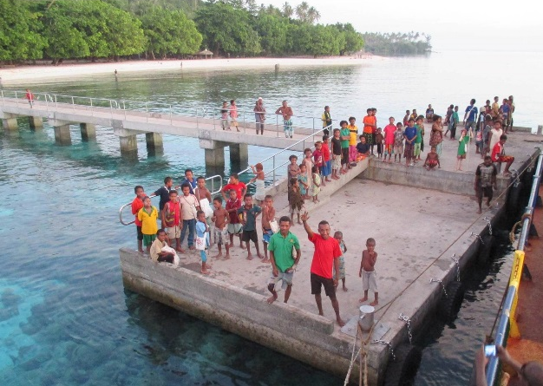
Additional assumptions
- Two 4m by 4m beach shelters, self-erected on site
- Baseline number of calls is 13; with the jetty extension, 17 calls expected in 2018-2020 and 20 calls expected in 2021-2026

Action 2 – Water supplies to WHO standards of 50 tonnes per hour at Alotau

        - Costs
Type of Cost | Valuation | Source
Water supply to WHO standard of 50 tonnes per hour | $195,000 | DWA estimate
Maintenance | 10% of CAPEX | DWA estimate

        - Benefits
Type of Benefit | Valuation | Source
Increased number of calls at Alotau in years 5-10 | 2 additional calls | Carnival Australia, ICF estimate

Additional assumptions
- Cost for water supplies to reach WHO standards assumes worst case provision, and includes package water treatment, storage and pump
- Revenue from water supply has not been taken into account
- Number of calls at Alotau is likely to decline in the medium to long term without this action; assumes 2 additional calls with freshwater supply

Action 3 – Reinforcement and extension of the port berth in Madang to enable more regular and larger ships to dock in port and construction of a sanitation block

        - Costs
Type of Cost | Valuation | Source
Construction of two sinker blocks and upgrades to fenders | 39000 | DWA estimate

        - Benefits
Type of Benefit | Valuation | Source
Increased number of calls in Madang Year 2 - 4 | 3 additional calls | Carnival Australia
Increased number of calls at Madang in years 5-10 | 8 additional calls | Carnival Australia

Additional assumptions
- Baseline is 2-4 calls; 10-12 calls expected from year 4 with reinforcement and extension of port
- Similar impact per passenger as observed in Kitava
Option 2 – Upgrade port amenities
Action 1 – Construct a sanitation block near or at the wharf area in Kitava and Kiriwina
Action 2 – Provide covered areas, including seating for passengers in Kitava and Kiriwina
Action 3 – Clear signage to enable cruise passengers to navigate from the port area to leading attractions and points of interest in Rabaul and Alotau

        - Costs
Type of Cost | Valuation | Source
Construction of a sanitation block | 52,000 | DWA estimate
Maintenance of sanitation block per year | 10% of CAPEX | DWA estimate
Construction of covered areas and seating for passengers | 97,500 | DWA estimate
Signage provision | 19,500 | DWA estimate
Maintenance (other than sanitation block) | 5% of CAPEX | DWA estimate

        - Benefits
Type of Benefit | Valuation | Source
Increase in passenger spend from more hours ashore in Alotau and Rabaul from year 3 | Increase by 15 minutes | ICF estimate
Increase in passenger spend from more hours ashore in Kitava and Kiriwana from year 3 | Increase to current level observed in Doini Island | ICF estimate

Additional assumptions
- Cost for covered areas and seating for passengers includes purchase, delivery and erection of four 4m by 4m shelters, self-erected on site
- Assume passenger spend increases proportionally with the increase in time spent ashore; time spent to be increased from the current 3.4 and 3.6 hours (at Kitava and Kiriwana respectively) to 3.8 hours, as observed in Doini Island

Option 3 – Improvements to customs and immigration procedures
Action 1 – Legislative change (use of non-proclaimed ports for clearance)
Action 2 – Improve process of clearing passengers

        - Costs
Type of Cost | Valuation | Source
Time spent to undertake legislative change | 10 legislators x 1 month | ICF estimate, PNG government pay scale 18
Cost of training for customs officers | 20 customs officers x 1 month | ICF estimate, PNG government pay scale 10

        - Benefits
Type of Benefit | Valuation |  | Source
Increased number of calls at Conflict Island in years 3-10 | Increases to 80% spending observed in Alotau |  | ICF estimate
Increase in passenger expenditure in Alotau from more hours ashore in years 3-10 | Increase by 15 mins | ICF estimate

Additional assumptions
- Wage of legislators assumed to be PNG government pay scale point 18
- Wage of customs officers assumed to be PNG government pay scale point 10
- Impact per passenger in Conflict Island similar to impact observed in Kitava
- Assume passenger spend increases proportionally with the increase in time spent ashore

Option 4 – Increased provision of foreign exchange services
Action 1 – Providing ATM and a Forex booth near or at the wharf in Alotau

        - Costs
Type of Cost | Valuation | Source
ATM machine | 18850 | Quote to for purchase and installation of ATM machine
Maintenance cost | 10% of initial cost | Vanuatu 2014 Study

        - Benefits
Type of Benefit | Valuation | Source
Increased passenger spend in Alotau from year 2 | Additional $25 spend x 20% passengers who utilise service | ICF estimate

Option 5 – Development of product offer in PNG
Action 1 – Establish a more formalized cruise committee
Action 2 – Development of tours and excursions

        - Costs
Type of Cost | Valuation | Source
Time spent by members on meetings | Once per month x 5 members x  1 hour x average wage per hour | ICF estimate
Time spent to share information | 2 hours per cruise ship x  average wage per hour | ICF estimate
Time spent to collect opinion from businesses and to develop offer with cruise operators | 80 days x  average government wage per day | ICF estimate
Cost of training | $22,000 | Quote for a 1-3 month training course
Administration costs | 20% of trainer cost | Vanuatu 2014 Study

        - Benefits
Type of Benefit | Valuation | Source
Increased spending on tours and pre-booked tours in Alotau in years 3-10 | Increase to 80% of current Rabaul level | ICF estimate
Increased spending on pre-booked tours in Kitava and Kiriwina in years 3-10 | 2 times current tours spending | ICF estimate

Additional assumptions
- Average wage of committee members assumed to be assumed to be PNG government pay scale point 18
- Government wage assumed to be PNG government pay scale point 10
- Meetings of the committees is an ongoing activities, i.e. costs are incurred throughout 10 years, assumed 4 cruise committees operate
- Trainings for business operators occur in year 1 - 2 trainings and year 2 – 2 trainings
- 70% of pre-booked tours spending goes into the economy

Option 6 – Improving information provision to passengers
Action 1 – Providing quarantine videos and leaflets to passengers
Action 2 – Updating destination information provided by cruise operators to passengers
Action 3 – Develop and provide maps of the port, city centre and areas of interest
Action 4 – Inform passengers of opportunity to make donations
        - Costs
Type of Cost | Valuation | Source
Quarantine videos | 81000 | Price quote for a three-minute video production
Distribution of leaflets and promotion material to passengers | $0.1 for each double sided leaflet  x total passengers | ICF estimate
Time spend to update information | 3 days per year  x average government salary | ICF estimate

        - Benefits
Type of Benefit | Valuation | Source
Increase spend on souvenirs in years 3-10 | Increase by 20% | ICF estimate
Increase spend on donations in years 3-10 | Increase by 20% | ICF estimate
Additional assumptions
- Three-minute video production
- Each passenger receives one leaflet, and total passengers assumed to be baseline number of passengers to Alotau
- Government wage assumed to be PNG government pay scale point 10

Assessment of the Economic Impact of Cruise Ships to Vanuatu, World Bank, August 2014
Alotau, Rabaul, Kitava, Kiriwina, Doini Islands
Honiara
Extrapolation accounted for 76 calls at other than researched PNG ports. Passengers, crew and cruise line operators expenditure were adjusted accordingly, to account for a much smaller average vessel size (150 – 300 passengers).
Extrapolation accounted for 47 calls at other SI destinations. Passengers, crew and cruise line operators expenditure were adjusted accordingly, to account for a much smaller average vessel size (150 – 300 passengers).
Services include hair braiding and massage.
Services include hair braiding and massage.
BREA 2014-2015
To account for differences in average passenger capacity and vessels size, Carnival estimates on port fees paid were re-weighted for ports where average passengers capacity was <700 pax (i.e. Honiara). It was assumed port fee per passenger are twice as high for smaller vessels (<700 pax) if compared to bigger vessels. This assumption is based on the results of Anonymous Survey of Cruise Operators Expenses conducted by Seaports in 2014.
Costs and benefits of investments are estimated over 10 years. Costs and benefits of investment in Honiara’s wharf is estimated over 25 years reflecting the longer life to asset and the fact that this is investment is ongoing.
Cruise Line International Association (CLIA) 2014 Deployed Survey among 18 international brands shows 6% of the global capacity was deployed in Australia/New Zealand and Pacific. CLIA 2014 Australia Cruise Industry Source Market Report shows 39 per cent of the Australian cruise market is in South Pacific.
SPTO website Accessed at www.spto.org
Assessment of the Economic Impact of Cruise Ships to Vanuatu, World Bank, August 2014
Business Research & Economic Advisors (BREA) conducted several Economic Contribution of Cruise Tourism to the Destination Economies studies, the latest was published in October 2015. The scope of the study concerns the Caribbean, Mexico and Central and South America.
A large share of passengers pre-book tours if those are available (Alotau, Rabaul). Due to leakage through profits taken by intermediaries (cruise operators) it was assumed that 70 per cent of this spending effects the local economy.
It should be noted that the data for Honiara was gathered on a Sunday when some businesses where closed.
USD 128 based on BREA 2014 - 2015
Vanuatu 2014 Study
BREA 2014-2015
Ibid.
Comparative table of correlations is included in Annex 2.
BREA 2014-2015
USD 67 Ibid.
Ibid.
To account for differences in average passenger capacity and vessels size, Carnival estimates on port fees paid were re-weighted for ports were average passengers capacity was <700 pax (i.e. Honiara). It was assumed port fee per passenger is twice as high for smaller vessels (<700 pax) if compared to bigger vessels. This assumption is based on the results of Anonymous Survey of Cruise Operators Expenses conducted by Seaport in 2014.
See for instance Brida, JG & Zapata, S (2010) Cruise tourism: economic, socio-cultural and environmental impacts.
World Bank Indicators (2013)
Source: World Bank
Calculated benefit cost ratio is 0.5:1
NPV= Present Value of Benefits-Costs
Purchase, delivery and erection of four 4m by 4m shelters, self-erected on site
Cost of hydrography survey based on a 5-day survey at location and processing by SIHU
Cost of hydrography survey based on a 5-day survey at location and processing by SIHU
Landing facilities include 2 berths for ships tenders; valuation highly dependent on location for anchoring and access
Two 4m by 4m beach shelters, self-erected on site
NPV= Present Value of Benefits-Costs
NPV= Present Value of Benefits-Costs
Costs and benefits of investments are estimated over 10 years. Costs and benefits of investment in Honiara’s wharf is estimated over 25 years reflecting the longer life to asset and the fact that this is investment is ongoing.
http://www.customs.gov.pg/06_legislation_and_publications/1_legislation/09_Import_Export_Tariff_2012_Version.pdf

